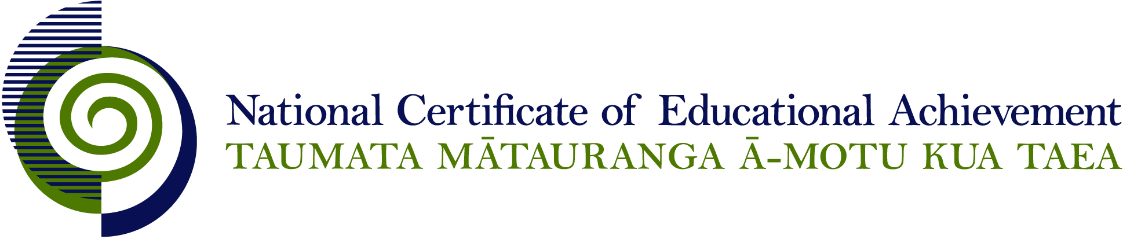

NCEA Level 3 Accounting

Conditions of Assessment

General Information

Subject Reference | Accounting
Domain | Accounting - Generic
Level | 3

This document provides guidelines for assessment against internally assessed standards. Guidance is provided on:
- appropriate ways of, and conditions for, gathering evidence
- ensuring that evidence is authentic
- any other relevant advice specific to an achievement standard.

NB: It is expected that teachers are familiar with additional generic guidance on assessment practice in schools published on the NZQA website. This should be read in conjunction with these Conditions of Assessment.

For All Standards

Internal assessment provides considerable flexibility in the collection of evidence. Evidence can be collected in different ways to suit a range of teaching and learning styles and a range of contexts of teaching and learning. Care needs to be taken to allow students opportunities to present their best evidence against the standard(s) that are free from unnecessary constraints.

It is recommended that the design of assessment reflects and reinforces the ways students have been learning. Collection of evidence for the internally assessed standards could include, but is not restricted to, an extended task, an investigation, digital evidence (such as recorded interviews, blogs, photographs or film) or a portfolio of evidence.

It is also recommended that the collection of evidence for internally assessed standards should not use the same method that is used for any external standards in a programme/course, particularly if that method is using a time bound written examination. This could unfairly disadvantage students who do not perform well under these conditions.

A separate assessment event is not needed for each standard. Often assessment can be integrated into one activity that collects evidence towards two or three different standards from a programme of learning. Evidence can also be collected over time from a range of linked activities (for example, in a portfolio).This approach can also ease the assessment workload for both students and teachers.

Effective assessment should suit the nature of the learning being assessed, provide opportunities to meet the diverse needs of all students and be valid and fair.

Where manageable, and after further learning has taken place, students may be offered a maximum of one further opportunity for assessment against an assessment standard within a year.

Authenticity of student evidence needs to be assured regardless of the method of collecting evidence. This needs to be in line with school policy. For example, for an investigation carried out over several sessions, this could include teacher observations or the use of milestones such as meetings with students, journal or photographic entries recording progress etc.

Specific Information for Individual Internal Achievement Standards

Achievement Standard Number | 91405 Accounting 3.2
Title | Demonstrate understanding of accounting for partnerships
Number of Credits | 4
Version | 1

To ensure sufficient evidence is gathered, it is strongly recommended that tasks incorporate a broad range of the partnership accounting elements listed in EN3.

A resubmission opportunity is not possible for any entry in the accounting records where the student work has been marked to indicate correct and/or incorrect evidence. It is expected that resubmissions for an entry in the accounting records will require a separate assessment grid which is not made available to the student until after the resubmission.
Achievement Standard Number | 91407 Accounting 3.4
Title | Prepare a report for an external user that interprets the annual report of a New Zealand reporting entity
Number of Credits | 5
Version | 1

The entity needs to have public accountability, for example, a regional council or a publicly listed company.

A current annual report is an annual report for the financial year ended the year before the current calendar year or for the year ended within the current calendar year. For example, a 2014 annual report may be assessed in 2014 or 2015. To ensure authenticity of student work it is advised that a different annual report is used each year.

This activity is primarily completed in the student’s own time. It is envisaged that this will take several weeks of in- and out-of-class time to complete.

The report needs to include acknowledgment of sources used by the student, so that the assessor can authenticate the information, where required.

A reassessment opportunity may not be feasible because of the extended time required for this assessment. Effective assessment practice would include regular teacher conferencing at all stages of the report writing - planning, data gathering, drafting, revising, editing, and proofreading process to support students to meet all assessment criteria.

Achievement Standard Number | 91409 Accounting 3.6
Title | Demonstrate understanding of a job cost subsystem for an entity
Number of Credits | 4
Version | 1

The context may be a service or manufacturing entity.

Any assessment task that assures the authenticity of student work is acceptable.

