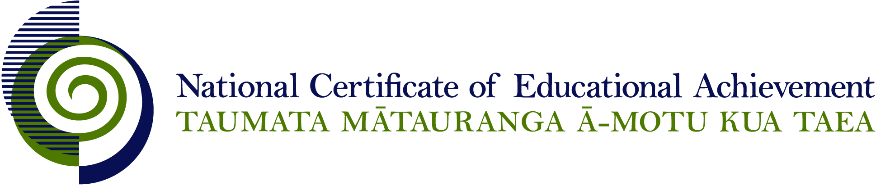

NCEA Level 3 Economics

Conditions of Assessment

General Information

Subject Reference | Economic Theory and Practice
Domain | Economics
Level | 3

This document provides guidelines for assessment against internally assessed standards. Guidance is provided on:
- appropriate ways of, and conditions for, gathering evidence
- ensuring that evidence is authentic
- any other relevant advice specific to an achievement standard.

NB: It is expected that teachers are familiar with additional generic guidance on assessment practice in schools published on the NZQA website. This should be read in conjunction with these Conditions of Assessment.

For All Standards

Internal assessment provides considerable flexibility in the collection of evidence. Evidence can be collected in different ways to suit a range of teaching and learning styles and a range of contexts of teaching and learning. Care needs to be taken to allow students opportunities to present their best evidence against the standard(s) that are free from unnecessary constraints.

It is recommended that the design of assessment reflects and reinforces the ways students have been learning. Collection of evidence for the internally assessed standards could include, but is not restricted to, an extended task, an investigation, digital evidence (such as recorded interviews, blogs, photographs or film) or a portfolio of evidence.

It is also recommended that the collection of evidence for internally assessed standards should not use the same method that is used for any external standards in a programme/course, particularly if that method is using a time bound written examination. This could unfairly disadvantage students who do not perform well under these conditions.

A separate assessment event is not needed for each standard. Often assessment can be integrated into one activity that collects evidence towards two or three different standards from a programme of learning. Evidence can also be collected over time from a range of linked activities (for example, in a portfolio).This approach can also ease the assessment workload for both students and teachers.

Effective assessment should suit the nature of the learning being assessed, provide opportunities to meet the diverse needs of all students and be valid and fair.

Where manageable, and after further learning has taken place, students may be offered a maximum of one further opportunity for assessment against an assessment standard within a year.

Authenticity of student evidence needs to be assured regardless of the method of collecting evidence. This needs to be in line with school policy. For example, for an investigation carried out over several sessions, this could include teacher observations or the use of milestones such as meetings with students, journal or photographic entries recording progress etc.

Specific Information for Individual Internal Achievement Standards

Achievement Standard Number | 91401 Economics 3.3
Title | Demonstrate understanding of micro-economic concepts
Number of Credits | 5
Version | 1

Approaches to Assessment
Suggested approaches to accumulating assessment evidence include:
- students surveying consumers to determine their marginal utilities for different quantities consumed of products to derive demand schedules and linked to consumer equilibrium
- classroom simulations to show how fixed resource inputs result in diminishing marginal returns, link to marginal cost curves and the upward sloping supply curve
- conducting student surveys of consumers to determine elasticities of different products and to provide advice to businesses/government about pricing decisions
- interviewing business owners to determine barriers to entry for firms in different industries to assist analysis of market structures
- use media articles/industry studies to analyse resource allocation in sunset/sunrise industries.

Achievement Standard Number | 91402 Economics 3.4
Title | Demonstrate understanding of government interventions where the market fails to deliver efficient or equitable outcomes.
Number of Credits | 5
Version | 3

To meet the evidence requirement for this achievement standard, the assessment activity requires only one situation (consumption externalities, production externalities, public goods etc.) as a context for government interventions. The evidence should also include at least one economic model used in an appropriate context.

Approaches to Assessment
Suggested approaches to accumulating assessment evidence include:
- students in groups preparing a PowerPoint or digital media presentation explaining specific government interventions to correct a situation where the market fails to deliver efficient or equitable outcomes.
- groups completing graphic organisers/writing frames to present the case for and against specific government interventions and their impacts on equity and efficiency for a situation where the market fails to deliver efficient or equitable outcomes. Student presentations using appropriate technologies (like podcast, movie-maker) showing their suggested solution for a situation where the market fails to deliver efficient or equitable outcomes.
- using media articles/case studies to analyse a situation where the market fails to deliver efficient or equitable outcomes.
- students survey public opinion on the equity and efficiency of government policies.

