Internal Assessment Resource
Biology Level 2

This resource supports assessment against:
Achievement Standard 91160 version 2
Investigate biological material at the microscopic level
Resource title: Biology through a microscope
3 credits
This resource:
- Clarifies the requirements of the standard
- Supports good assessment practice
- Should be subjected to the school’s usual assessment quality assurance process
- Should be modified to make the context relevant to students in their school environment and ensure that submitted evidence is authentic

Date version published by Ministry of Education | February 2015 Version 2  To support internal assessment from 2015
Quality assurance status | These materials have been quality assured by NZQA.  NZQA Approved number: A-A-02-2015-91160-02-5412
Authenticity of evidence | Teachers must manage authenticity for any assessment from a public source, because students may have access to the assessment schedule or student exemplar material.  Using this assessment resource without modification may mean that students’ work is not authentic. The teacher may need to change figures, measurements or data sources or set a different context or topic to be investigated or a different text to read or perform.

Internal Assessment Resource
Achievement Standard Biology 91160: Investigate biological material at the microscopic level
Resource reference: Biology 2.8A v2
Resource title: Biology through a microscope
Credits: 3
Teacher guidelines
The following guidelines are supplied to enable teachers to carry out valid and consistent assessment using this internal assessment resource.
Teachers need to be very familiar with the outcome being assessed by Achievement Standard Biology 91160. The Achievement Criteria and the Explanatory Notes (EN) contain information, definitions, and requirements that are crucial when interpreting the standard and assessing students against it.
Context/setting
In the investigation of biological material at the microscopic level, the emphasis of is for the student to use a light microscope to prepare a portfolio containing three annotated microscope drawings that match their prepared slides. They also need to identify specialised features in cells viewed, and give reasons for how or why these enable cells to carry our specific functions. This assessment task has been written to work in conjunction with the teaching and learning required for the external assessment against AS 91156, “Demonstrate understanding of life processes at the cellular level.”
Conditions
Students will work individually.
This assessment task is designed to take place in 3 periods of class time.
Teacher note: Select appropriate biological material (two different plant tissues and a unicellular organism) and a time frame which suits your context and students, and ensures they have enough time to complete the assessment.
Resource requirements
- Suitable plant tissues e.g. Arabidopsis thaliana plant, Geranium or Rhubarb leaves
- Paramecium culture
- light microscopes, three magnifications up to X 400
- clean microscope slides
- cavity slides
- coverslips
- iodine
- toluidine blue
- paint brushes
- petri dishes
- paper towels
- razor blades
- methyl cellulose.
Additional information
It is expected that sufficient teaching will cover the relevant skills required for preparing slides for view, viewing slides of different plant tissues and unicellular organisms using a light microscope and the conventions for biological drawings before the assessment begins.
The use of a marking grid would aid the tracking of achievement of the practical aspects involving the preparation and viewing of slides. For example, a grid showing the specific microscope slide preparation and viewing criteria for each of the three slides prepared for view. The criteria must be consistent with the assessment schedule and can be abbreviated by code.
Biological material chosen must have a specialised feature (EN 2). This will therefore exclude an onion leaf tear.
Further information about the Conditions of Assessment related to this achievement standard can be found at http://ncea.tki.org.nz/Resources-for-Internally-Assessed-Achievement-Standards.

Internal Assessment Resource
Achievement Standard Biology 91160: Investigate biological material at the microscopic level
Resource reference: Biology 2.8A v2
Resource title: Biology through a microscope
Credits: 3
Achievement | Achievement with Merit
Investigate biological material at the microscopic level. | Investigate in-depth biological material at the microscopic level.
Student instructions
Introduction
This is a closed book assessment activity that requires you to individually investigate biological material at the microscopic level. You will prepare and view slides, and draw annotated diagrams of, Arabidopsis thaliana, Geranium sp and Paramecium sp at the microscopic level which you will present in a portfolio.
Teacher note: Amend these details as necessary, if you choose any other two suitable accessible plants and one unicellular organism that have a specialised feature to study. Examples include: Leaf tear – purple daisy (Dimorphotheca ecklonis); Whole leaf – Elodea; Stem/Root cross-section (stain with toluidine blue) – Palus sp; unicellular organisms – euglena.
Note that onion leaf tear has no specialised feature.
You will have 3 hours to complete this task.
Teacher note: Amend this time frame to suit your context and students, and ensure that they have enough time to complete the assessment.
You will be assessed on:
- your ability to appropriately prepare and view microscope slides using a light microscope to enable accurate biological drawings of three samples of the different biological materials provided
- the consistency of the biological drawings, using accepted conventions, with the material used in your portfolio
- your ability to explain, in annotations of your drawings, how or why observed specialised features enable the cells to carry out their specific function(s).
Teacher note: Amend these details if you require students to write the explanations separately, rather than as annotations on the diagram.

Task
Produce a portfolio which contains annotated biological drawings of three samples of different biological material using the techniques you have learned.
In order to complete your drawings, using the techniques you have learned with light microscopes, you will need to:
- prepare microscope slides of the biological materials provided for viewing, and
- view the material using a light microscope so that you can identify two specialised features for each drawing, such as:
  - arrangement of cells or cell types within a tissue
  - the presence or absence of a specific organelle
  - quantity or distribution of organelles within a cell.
Your portfolio will contain three biological drawings, for a slide from each of:
- an epidermal leaf tear of Arabidopsis thaliana
- a Geranium sp. leaf cross section and
- a Paramecium sp.
Teacher note: Amend these details to suit your chosen samples of biological matter.
When you are ready, raise your hand to show your teacher:
- each microscope slide preparation
- the focussed slide and your biological drawing of it, before you add this to your portfolio.
Your biological drawings should clearly show visible, specialised features and must be consistent with what you see.
- Your teacher will check to make sure your slide has been correctly prepared and focussed, and that your biological drawing is an accurate representation of what your slide shows.
Annotate each drawing by labelling at least two special features.
- State the function of each feature and explain how or why each enables the cell or tissue to carry out its specific function(s) effectively.
Teacher note: Amend this instruction if you require students to write their explanations separately, rather than as annotations on the drawings.
Assessment schedule: Biology 91160 Biology through a microscope
Evidence/Judgements for Achievement | Evidence/Judgements for Achievement with Merit
The student is able to investigate biological material at the microscopic level.  The evidence from the teacher check and portfolio includes:  - Appropriate preparation of three slides of biological material from two different plant tissues and one unicellular organism for viewing under a light microscope  - For example: clean slide, use of coverslip, few or no air bubbles, excess liquid removed, correct stain where appropriate, thin/flat section, use of methyl cellulose where appropriate.  - Clear focussing of the three slides to view biological material from two different plant tissues and one unicellular organism using a light microscope to enable detail of cell structures and components to be determined  - Recording observations of biological material in at least two slides using the conventions for biological drawings. [See Appendix A]  - For example:  - each biological drawing is consistent with the prepared slide of the biological materials viewed, but may contain some errors in applying conventions or minor inaccuracies in representation e.g. not all lines joined or organelles not to scale  - has an appropriate title that identifies the biological material used  - show the magnification used e.g. x 400  - cells have recognisable shapes and are drawn in proportion  - is a pencil drawing  - is not sketchy, no lines crossing over, clear bold lines  - has no shading/cross hatching/stipples  - has no gaps between cells  - Identifying/labelling two observed specialised features in each drawing. Specialised features may include: arrangement of cells or cell types within a tissue, shape of a cell, presence or absence of a specific organelle, quantity or distribution of organelles within a cell  - For example: chloroplasts, cell membrane, cell wall, contractile vacuole  - Relating the two labelled specialised features to the function of the cells or tissues.  For example:  Arabidopsis has a large number of stomata with guard cells [labelled] for gas exchange in its lower epidermis.  The leaf cross-section shows large numbers of chloroplasts in the palisade layer [labelled] for photosynthesis.  The Paramecium has a contractile vacuole [labelled] for osmoregulation.  (Note: The above ‘expected student responses’ are indicative only and relate to part of what is required. Annotated, biological drawings in context that come from previous/current students or developed by teachers can be included as examples of evidence.) | The student is able to investigate in-depth biological material at the microscopic level.  The evidence from the teacher check and portfolio includes:  - Appropriate preparation of three slides of biological material from two different plant tissues and one unicellular organism for viewing under a light microscope  - For example: clean slide, use of coverslip, few or no air bubbles, excess liquid removed, correct stain where appropriate, thin/flat section, use of methyl cellulose where appropriate.  - Clear focussing of the three slides to view biological material from two different plant tissues and one unicellular organism using a light microscope to enable detail of cell structures and components to be determined  - Recording observations of biological material in at least two slides using the conventions for biological drawings.  - For example:  - each biological drawing is consistent with the prepared slide of the biological materials viewed, but may contain some minor errors as long as they do not affect the accuracy of the representation of the biological material being viewed  - has an appropriate title that identifies the biological material used  - show the correct magnification used e.g. 10 x 40 = x 400  - cells have recognisable shapes and are drawn in proportion  - is a pencil drawing  - is not sketchy, no lines crossing over, clear bold lines  - has no shading/cross hatching/stipples  - has no gaps between cells  - Identifying/labelling two observed specialised features in each drawing. Specialised features may include: arrangement of cells or cell types within a tissue, shape of a cell, presence or absence of a specific organelle, quantity or distribution of organelles within a cell  - For example: chloroplasts, cell membrane, cell wall, contractile vacuole  - In at least two biological drawings relating the two labelled specialised features to the function of the cells or tissues by giving reasons for why or how each contributes to the function of the cell or tissue.  For example:  Arabidopsis has a large number of stomata with guard cells [labelled] for gas exchange in its lower epidermis. This ensures that carbon dioxide needed for photosynthesis by the leaf cells is able to enter the leaf and oxygen produced to leave the cells. The carbon dioxide is thus able to reach the cells where photosynthesis occurs. The guard cells are able to open and close to control the amount of carbon dioxide entering/oxygen leaving.  The leaf cross-section shows large numbers of chloroplasts in the palisade layer [labelled] for photosynthesis. There is a greater number of chloroplasts in the palisade cells as they are able to utilise the sunlight which can penetrate from above and the gases which diffuse through the lower epidermal cells.  The Paramecium has a contractile vacuole [labelled] for osmoregulation. As they live in fresh water, water is continually entering the paramecium due to osmosis as it moves from where it is in high concentration outside the cell into the cell where it is in low concentration. This could cause the paramecium to burst if the contractile vacuole did not swell with water releasing it outside the cell.  (Note: The above ‘expected student responses’ are indicative only and relate to part of what is required. Annotated, biological drawings in context that come from previous/current students or developed by teachers can be included as examples of evidence.)
Final grades will be decided using professional judgement based on a holistic examination of the evidence provided against the criteria in the Achievement Standard.
Appendix A
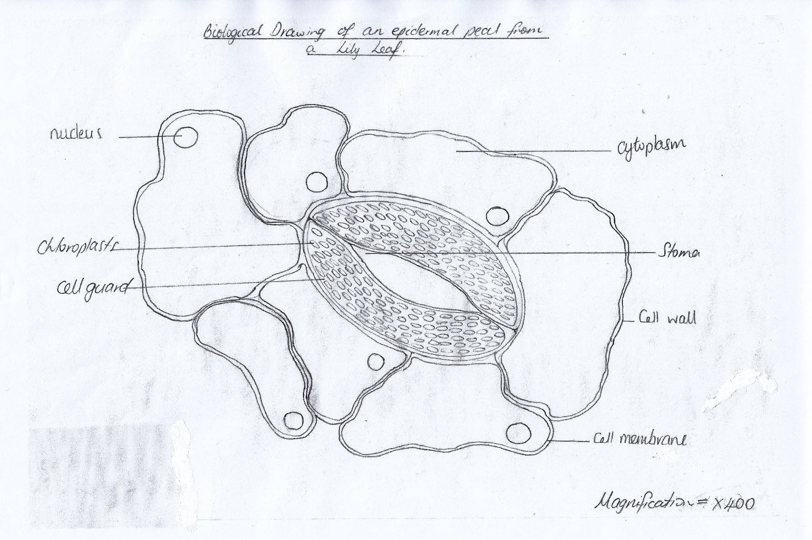
Biological drawing of a leaf tear from a Lily at Achievement

