

Internal Assessment Resource
Mathematics and Statistics Level 2
This resource supports assessment against:
Achievement Standard 91260 version 2
Apply network methods in solving problems
Resource title: Waikato Cycleway
2 credits
This resource:
- Clarifies the requirements of the standard
- Supports good assessment practice
- Should be subjected to the school’s usual assessment quality assurance process
- Should be modified to make the context relevant to students in their school environment and ensure that submitted evidence is authentic

Date version published by Ministry of Education | February 2015 Version 2  To support internal assessment from 2015
Quality assurance status | These materials have been quality assured by NZQA.  NZQA Approved number: A-A-02-2015-91260-02-5584
Authenticity of evidence | Teachers must manage authenticity for any assessment from a public source, because students may have access to the assessment schedule or student exemplar material.  Using this assessment resource without modification may mean that students’ work is not authentic. The teacher may need to change figures, measurements or data sources or set a different context or topic to be investigated or a different text to read or perform.

Internal Assessment Resource
Achievement Standard Mathematics and Statistics 91260: Apply network methods in solving problems
Resource reference: Mathematics and Statistics 2.5A v2
Resource title: Waikato Cycleway
Credits: 2
Teacher guidelines
The following guidelines are designed to ensure that teachers can carry out valid and consistent assessment using this internal assessment resource.
Teachers need to be very familiar with the outcome being assessed by Achievement Standard Mathematics and Statistics 91260. The achievement criteria and the explanatory notes contain information, definitions, and requirements that are crucial when interpreting the standard and assessing students against it.
Context/setting
This assessment activity requires students to use networks in solving problems. Students will use the properties of networks, for example traversability, shortest path, and minimum spanning trees.
The context for this resource is a set of cycle ways around the Waikato Region.
Conditions
This assessment activity may be conducted in one or more sessions. Confirm the timeframe with your students. Students need to work independently.
Students may use appropriate technology.
Resource requirements
Provide students with copies of Resource 1 and a large-scale map of the region.
Additional information
None.
Internal Assessment Resource
Achievement Standard Mathematics and Statistics 91260: Apply network methods in solving problems
Resource reference: Mathematics and Statistics 2.5A v2
Resource title: Waikato Cycleway
Credits: 2
Achievement | Achievement with Merit | Achievement with Excellence
Apply network methods in solving problems. | Apply network methods, using relational thinking, in solving problems. | Apply network methods, using extended abstract thinking, in solving problems.
Student instructions
Introduction
The Government is considering creating a cycle network around Waikato that will enable cyclists to travel on dedicated cycle paths connecting the following towns: Hamilton, Matamata, Pirongia, Te Awamutu, Cambridge, Tirau, Te Kuiti, Tokoroa, and Taupo.
Teacher note: This activity can be adapted by supplying students with an alternate non-trivial set of towns, construction costs, or scenic values in their local region.
They have asked local cycling groups what their priorities would be.
- The Taupo Club would like the cycle network to provide the shortest route between Hamilton and Taupo.
- The Hamilton Club would like a network of paths that connect all towns, with the resulting network costing as little as possible.
- The Tirau Club would like a network of paths that connects all towns, with the resulting network being the one with the greatest scenic value.
- The Tokoroa Club have no views but have asked, if all the possible paths were made, whether they would be able to cycle along all the paths to visit all the towns without repeating a path, starting and finishing at Tokoroa.
This assessment activity requires you to review the information provided in Resource 1, analyse the requirements of each cycling group, and design a network of cycleways that meets as many of the cycle groups’ priorities as possible. Present your network, justifying your decisions, as a recommendation to the Government.
Task
Working independently, use the route information, distances, costs, and scenic values in
Resource 1 to prepare a written cycleway route recommendation to the Government by:
- finding the networks that meet the requirements of the Hamilton, Taupo, and Tirau Clubs
- creating a network that satisfies the priorities of the three clubs, demonstrating how your network meets the requirements
- addressing the question from the Tokoroa Club.
The description of your networks, the quality of your justifications, and how well you link your findings to the context will determine the overall grade. Clearly communicate the different parts of your solution using appropriate mathematical statements.
Resources
Resource 1: Route information
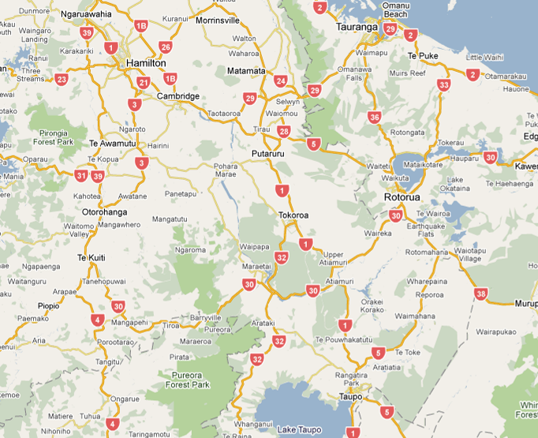
Waikato Region
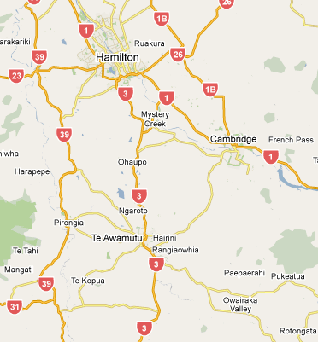
Showing Pirongia
Distances between towns in kilometres [km] for the proposed cycleways are given in the table below:
Hamilton
68 | Matamata
23 | 41 | Cambridge
………. | 21 | 32 | Tirau
32 | ………. | ………. | ...... | Pirongia
29 | ………. | 24 | 61 | 12 | Te Awamutu
………. | ………. | ………. | …... | ………. | 48 | Te Kuiti
………. | ………. | ………. | 32 | ………. | 70 | 114 | Tokoroa
………. | ………. | ………. | …… | ………. | ………. | 131 | 66 | Taupo

The cost of the cycleways will depend on terrain and existing infrastructure, such as current off-road routes, paved and un-paved paths, and scenic roads. The varying construction costs of the cycleways between towns, in thousands of dollars [$1000], are given in the table below:
Hamilton
1020 | Matamata
460 | 820 | Cambridge
………. | 630 | 1920 | Tirau
800 | ………. | ………. | ...... | Pirongia
725 | ………. | 480 | 1830 | 360 | Te Awamutu
………. | ………. | ………. | …... | ………. | 1440 | Te Kuiti
………. | ………. | ………. | 1120 | ………. | 1050 | 4560 | Tokoroa
………. | ………. | ………. | …… | ………. | ………. | 3930 | 990 | Taupo

The scenic value of the cycleways between the towns in the region has been assessed on a scale of 1 to 10 (10 highest). The scenic value scores are given in the table below:
Hamilton
6 | Matamata
3 | 9 | Cambridge
………. | 8 | 5 | Tirau
8 | ………. | ………. | ...... | Pirongia
10 | ………. | 6 | 5 | 4 | Te Awamutu
………. | ………. | ………. | …... | ………. | 10 | Te Kuiti
………. | ………. | ………. | 2 | ………. | 3 | 9 | Tokoroa
………. | ………. | ………. | …… | ………. | ………. | 7 | 4 | Taupo

Assessment schedule: Mathematics and Statistics 91260 Waikato Cycleway
Teacher note: Customise this schedule with examples of the types of responses that can be expected.
Evidence/Judgements for Achievement | Evidence/Judgements for Achievement with Merit | Evidence/Judgements for Achievement with Excellence
The student has applied network methods in solving problems. The student correctly selects and uses network methods. They have demonstrated knowledge of concepts and terms and communicated using appropriate representations.  For example:  - Shortest path  The student finds the correct shortest path and the minimum distance from Hamilton to Taupo.  - Minimum spanning tree  The student finds the minimum spanning tree for cost or the maximum spanning tree for scenic value.  - Traversability  The student explains that the network is not traversable. | The student has applied network methods, demonstrating relational thinking in solving problems.  The student has related their findings to the context or communicated their thinking using appropriate mathematical statements.  Students will demonstrate an understanding of concepts.  For example:  - Shortest path  The student finds the correct shortest path and the minimum distance from Hamilton to Taupo, justifying the solution by a clear and logical approach.  - Minimum spanning tree  The student finds the minimum spanning tree for cost or the maximum spanning tree for scenic value and justifies the solution by a clear and logical approach.  - Traversability  The student considers the number of connecting arcs for each town and accurately uses the traversability condition to explain that the network is not traversable from Tokoroa back to Tokoroa. | The student has applied networks, demonstrating extended abstract thinking in solving problems  The student has used correct mathematical statements or communicated mathematical insight.  The student needs to design a compromise network that meets as many of the groups’ priorities as possible.  For example:  The student develops and recommends, with justification, a compromise network for the government based on their shortest path and maximum/minimum spanning tree.  - Shortest path  The student finds the shortest path from Hamilton to Taupo and justifies the solution by clear and logical use of an appropriate algorithm e.g. Djikstra’s.  - Minimum spanning tree  The student finds the minimum or maximum spanning trees and justifies the solutions by clear and logical use of an appropriate algorithm, for example, Kruskal’s algorithm or by trial and error.
Final grades will be decided using professional judgement based on a holistic examination of the evidence provided against the criteria in the Achievement Standard.

