Internal Assessment Resource
Mathematics and Statistics Level 2
This resource supports assessment against:
Achievement Standard 91259 version 2
Apply trigonometric relationships in solving problems
Resource title: Miro’s measuring scoop
3 credits
This resource:
- Clarifies the requirements of the standard
- Supports good assessment practice
- Should be subjected to the school’s usual assessment quality assurance process
- Should be modified to make the context relevant to students in their school environment and ensure that submitted evidence is authentic

Date version published by Ministry of Education | February 2015 Version 2  To support internal assessment from 2015
Quality assurance status | These materials have been quality assured by NZQA.  NZQA Approved number A-A-02-2015-91259-02-5581
Authenticity of evidence | Teachers must manage authenticity for any assessment from a public source, because students may have access to the assessment schedule or student exemplar material.  Using this assessment resource without modification may mean that students’ work is not authentic. The teacher may need to change figures, measurements or data sources or set a different context or topic to be investigated or a different text to read or perform.

Internal Assessment Resource
Achievement Standard Mathematics and Statistics 91259: Apply trigonometric relationships in solving problems

Resource reference: Mathematics and Statistics 2.4B v2

Resource title: Miro’s measuring scoop

Credits: 3

Teacher guidelines
The following guidelines are designed to ensure that teachers can carry out valid and consistent assessment using this internal assessment resource.
Teachers need to be very familiar with the outcome being assessed by Achievement Standard Mathematics and Statistics 91259. The achievement criteria and the explanatory notes contain information, definitions, and requirements that are crucial when interpreting the standard and assessing students against it.

Context/setting
This activity requires students to calculate the capacity indicated by different lines on a measuring scoop and to investigate whether the scoop meets its design requirements.

Conditions
This activity may be conducted in one or more sessions. Confirm the timeframe with your students.
Students are to complete the task independently.
Students may use appropriate technology.

Resource requirements
Provide students with copies of Resource Sheet and the Level 2 Mathematics formulae sheet.

Additional information
None.
Internal Assessment Resource
Achievement Standard Mathematics and Statistics 91259: Apply trigonometric relationships in solving problems

Resource reference: Mathematics and Statistics 2.4B v2

Resource title: Miro’s measuring scoop

Credits: 3
Achievement | Achievement with Merit | Achievement with Excellence
Apply trigonometric relationships in solving problems. | Apply trigonometric relationships, using relational thinking, in solving problems. | Apply trigonometric relationships, using extended abstract thinking, in solving problems.

Student instructions

Introduction
This activity requires you to calculate the capacity indicated by lines on a measuring scoop and to check whether the scoop meets the design requirements.
You have <<insert time>> of class time in which to independently complete this assessment.
The quality of your reasoning and how well you link concepts and representations will determine your overall grade.
Task
Miro is designing the prototype for a measuring scoop and stand. The scoop is to have a capacity of one metric cup (250 ml).
Miro has asked you to assist him with some calculations.
The body of the scoop is a transparent half-cylinder. Horizontal lines on the ends of the scoop (see figure 1) and a rectangular heat and waterproof sticker placed around the curved part of the scoop (figure 2) will show ¼, ½, ¾, and 1 cup capacity.
When not in use, the scoop will sit in a hollowed-out recess in a wooden stand shaped as a triangular prism (figure 3). In Miro’s design, the cross-section of the recess forms an arc 6 cm long.

- Calculate the size of the angle at the end of the triangular region on the handle.
- Miro places the ½-cup line on the end of the scoop 2 cm from the base (measured vertically). Assuming this is the correct position, where should the ½-cup line (y) be on the sticker?

Design requirements
The 250 ml line must be between 5–10 mm from the top of the scoop.
The ¼-cup line on the end of the scoop is marked at 1.2 cm from the base. The capacity indicated by this line must be within 5 ml of ¼-cup (62.5 ml).
The recess in the wooden stand must be at least 1 cm deep.
The triangular region at the base of the handle must have room for a logo/label with an area of at least 16 cm².
- Verify whether the scoop meets its design requirements.
Clearly communicate your method using appropriate mathematical statements. Include relevant calculations and/or diagrams.
Resource Sheet

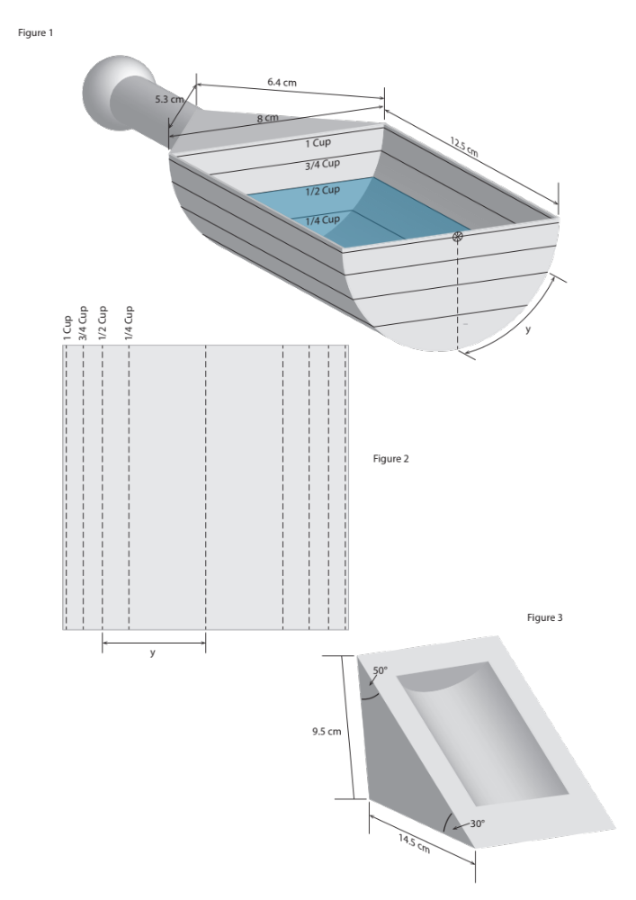

Assessment schedule: Mathematics and Statistics 91259 Miro’s measuring scoop
Teacher note: You will need to adapt this assessment schedule to include examples of the types of responses that can be expected.
Evidence/Judgements for Achievement | Evidence/Judgements for Achievement with Merit | Evidence/Judgements for Achievement with Excellence
The student has applied trigonometric relationships in solving problems.  The student correctly selects and uses trigonometric relationships. They have demonstrated knowledge of trigonometric concepts and terms and communicated using appropriate representations.  Examples of possible student responses:  - calculating the angle in the triangle on the handle  - finding the length of the arc created by the ½-cup line to locate where the line on the sticker should be  - finding the area of the triangular region at the base of the handle | The student has applied trigonometric relationships, demonstrating relational thinking in solving problems.  The student has related their findings to the context or communicated their thinking using appropriate mathematical statements.  Any appropriate and correct rounding is acceptable (including truncation) and does not need to be stated. Correct units are required.  The student connects the markings on the scoop with the identified capacities and explores how the scoop would need to meet the design requirements. | The student has applied trigonometric relationships, demonstrating extended abstract thinking in solving problems by, for example:  - devising a strategy to solve a problem  - identifying relevant concepts in context  - developing a chain of logical reasoning.  The student has used correct mathematical statements or communicated mathematical insight.  Any appropriate and correct rounding is acceptable (including truncation) and does not need to be stated. Correct units are required.  The student devises a strategy to connect the markings on the scoop for the ¼ and ½ cup capacity and verifies whether Miro’s design meets the design requirements.
Final grades will be decided using professional judgement based on a holistic examination of the evidence provided against the criteria in the Achievement Standard.

