Internal Assessment Resource
Chemistry Level 2

This resource supports assessment against Achievement Standard 91911
Standard title: Carry out an investigation into chemical species present in a sample using qualitative analysis
Credits: 3
Resource title: Sweet and Sour: Functional Group Identification in a Consumer Product
Resource reference: Chemistry 2.2A

This resource:
- Clarifies the requirements of the standard
- Supports good assessment practice
- Should be subjected to the school’s usual assessment quality assurance process
- Should be modified to make the context relevant to students in their school environment and ensure that submitted evidence is authentic

Date version published by Ministry of Education | December 2018 Version 1  To support internal assessment from 2019
Authenticity of evidence | Teachers must manage authenticity for any assessment from a public source, because students may have access to the assessment schedule or student exemplar material.  Using this assessment resource without modification may mean that students’ work is not authentic. The teacher may need to change figures, measurements or data sources or set a different context or topic to be investigated or a different text to read or perform.

Internal Assessment Resource
Achievement standard: Chemistry 91911
Standard title: Carry out an investigation into chemical species present in a sample using qualitative analysis
Credits: 3
Resource title: Sweet and Sour: Functional Group Identification in a Consumer Product
Resource reference: Chemistry 2.2A
Teacher guidelines
The following guidelines are supplied to enable teachers to carry out valid and consistent assessment using this internal assessment resource.
Teachers need to be very familiar with the outcome being assessed by the achievement standard. The achievement criteria and the explanatory notes contain information, definitions, and requirements that are crucial when interpreting the standard and assessing students against it.
Context/setting
This activity requires students to carry out a comprehensive investigation, using qualitative analysis, of samples containing organic compounds.
Teachers need to ensure students have access to all the information they need regarding organic functional groups and reactions, and the appropriate use of vocabulary, symbols and conventions, to enable them to carry out this investigation
Providing an organic identification procedure, including the reactions taking place and balanced equations for these reactions, guides students in identifying an organic functional group present in a molecule.
The context for this investigation is the use of organic compounds as the ingredients or components in a consumer product such as a food or drink. Students are required to identify two compounds in the consumer product using the behaviour of specific organic functional groups in pure samples of organic compounds derived from that food product. Identification of organic functional groups is limited to alkenes, alcohols, aldehydes, ketones, carboxylic acids, amines.
The activity requires students to present their analysis and their discussion of the significance of their findings as a written report. Other suitable presentation formats include, for example, a PowerPoint file or wall poster.
The teacher should include a clear statement providing the context for the investigation, so that students have a purpose for carrying out the qualitative analysis. In this activity students are provided with two pure samples of organic compounds that are ingredients of kombucha. The students carry out chemical tests (primary data) to identify the functional groups of the two ingredients and hence the unknown compound using a list of structural formulae (secondary data) of possible organic compounds.

Conditions
Students might carry out practical tasks individually or may collaborate to share practical tasks amongst a small group. If they work together the teacher would need to use the school’s authenticity procedures to ensure that each student has clear understanding of all criteria involved in the analysis process.
Teachers must ensure their schools risk assessment procedures and practices are followed and that they are adequate to manage safety aspects of the practical work and comply with the Hazardous Substances Regulations and the Health and Safety at Work Act. Consideration must be given to all chemicals and equipment used, taking into account all possible substances used and made during the assessment

Resource requirements
Chemical feature | Chemical test
Acid/base | red/blue litmus paper  universal indicator solution
Unsaturation C=C | Add 2-3 drops of bromine water to sample and mix
Primary alcohol | dilute sulfuric acid (1 mol L^{–1})  0.02 mol L^{–1} potassium permanganate  0.1 mol L^{–1} potassium dichromate
Carboxylic acid | red and blue litmus paper  dilute sodium carbonate solution (1 mol L^{–1})
Amine | red and blue litmus paper  0.1 mol L⁻¹ of copper sulfate solution (CuSO₄(aq))
Aldehyde and ketone | Fehlings A and B solutions AND/OR Benedict solution

Possibilities for samples of unknown compounds is not limited to but may include:
Sweet: glucose, fructose, sucrose, aspartame, xylitol, steviol, sucralose
Sour: lactic acid, maleic acid, ascorbic acid, citric acid, tartaric acid
Others: limonene, glycine, menthol

Once the teacher has decided on the food of drink to be analysed, they should identify the ingredients suitable for testing and construct a resource sheet accordingly, taking care to eliminate ambiguities.
Students may be provided with relevant resources containing information and news articles from the Internet, newspapers, TV, magazines, books, blogs, and advertisements.

Additional information
Ensure that students have access to adequate information about the chemistry of functional groups (alkenes, alcohols, carboxylic acids, amines) before beginning this assessment, including additional information about aldehyde and ketones. It is not expected that students will be able to explain the reactions for functional groups outside this list, even if they are part of the structure of the unknown compound – for example benzene rings.
The teacher could substitute the procedure given in the student resources for an alternative procedure that would enable students to identify the organic functional groups in different compounds. Teachers would also need to modify the resource sheets to match a different food or drink.
The teacher should carry out tests prior to the assessment to check that the procedure and samples provided to the student can be used to identify the compounds supplied. Internal Assessment Resource
Achievement standard: Chemistry 91911
Standard title: Carry out an investigation into chemical species present in a sample using qualitative analysis
Credits: 3
Resource title: Sweet and Sour: Functional Group Identification in a Consumer Product
Resource reference: Chemistry 2.2A
Student instructions

Introduction
In this assessment activity you will investigate some of the ingredients/components of the drink Kombucha. You will use provided qualitative procedures to identify unknown organic compounds by identifying one or more of the following functional groups present in each organic compound: alkene, alcohol, aldehyde, ketone, carboxylic acid, amine. You will then write a report to support the identification of the functional groups. The report should also discuss the significance of the organic compound present (in one of your identified samples) for people and/or the environment.
You will be assessed on how well you explain your identification procedure to identify the chemical species and link this to the purpose of the investigation.
The teacher should include a clear statement providing the context for the investigation, so that students have a purpose for carrying out the qualitative analysis. In this activity students are provided with two pure samples of organic compounds that are ingredients of kombucha. The students carry out chemical tests (primary data) to identify the functional groups of two ingredients and hence the unknown compound using a list of structural formulae (secondary data) of possible organic compounds. A discussion of the significance of one of the identified compounds with respect to its purpose and/or presence in kombucha (for example) is expected.
Your teacher will guide you about how much time you will have for this activity.
Teacher note: This is an individual task for the practical work but could be modified for students to work in groups of 2-3 (to suit your context and students) to carry out the practical analysis.
Task: Investigating functional groups in organic molecules
Part A: Identifying the compound
You will be provided with two unknown samples of ingredients found in kombucha. Use the procedures provided in Student Resource 1 to identify the functional group(s) present in each sample. Complete all the necessary procedures for your two samples to identify as many functional groups as you can by.
Refer to the list of structures of possible compounds in the chart in Student Resource 2 to identify each unknown sample.
Record the steps you used to identify the functional groups and any observations you made during the procedures.

Part B: Reporting on your investigation
Produce a comprehensive report for your investigation.
The report should include:
- the name or formula of the functional group(s) identified in each sample
- a description of the steps used to identify the functional group(s)
- a description of the observations you made during each step of the procedure
- equations, using structural formulae, for organic reactants and products for all the reactions
- justification of the identification of the organic group by linking the secondary data and chemical principles to the reactions
- discussion of the significance of the organic compound present (in one of your identified samples) for people and/or the environment.

Student Resource 1: (add or delete samples as availability allows)

Chemical reactions: alkanes, alkenes, amines, alcohols, aldehydes, ketone, carboxylic acids

Summary of Organic tests
Chemical feature | Chemical test
Use to test for any acid/base nature | Red/blue litmus paper
Use to determine approx. pH | Universal indicator
Unsaturation C=C | Add about 1 mL of bromine water to 2 mL of the sample in a test tube and shake. If there is no reaction, leave under a bright light for 10 minutes
Alcohol (1° or 2°) and aldehyde | Put 0.5 mL of acidified dichromate into a test tube (warm in a water bath). Then add 1mL of the sample and shake to mix. Keep warm
Carboxylic acid | Put 1 mL of sample into a boiling test tube and add 2 mL of dilute sodium carbonate solution
Amine | Put 1 mL of copper sulfate solution (CuSO₄) into a test tube. Add 2 drops of amine and shake to mix. Now add excess (10 drops should do it) amine and ammonia to the appropriate tts. Shake again. Now add excess (10 drops should do it) amine and shake again
Aldehyde | Fehlings: put 1 mL of Solution A into a test tube. Add Solution B until the blue precipitate just redissolves to form a deep blue solution. Add a small amount of sample and boil the mixture for a few minutes  or  Benedicts: put 1 mL of Benedicts solution in a test tube. Add a small amount of sample and boil the mixture for a few minutes.

Reactivity of selected Functional Groups – Observations/Results

Bromine water turns rapidly from orange to colourless in the presence of a carbon – carbon double or triple bond

Blue litmus turns red in the presence of an acid/ red litmus turns blue in the presence of a base

Fizzing will be observed when sodium carbonate is added to an acid

Acidified potassium dichromate solution turns from orange to green when warmed with a 1° or 2° alcohol or aldehyde

Fehlings (or Benedicts) solution changes from blue to yellow/brick red when heated with an aldehyde

Copper sulfate solution forms a deep blue solution with amines

Student Resource 2:

Structural formulae of organic molecules in the provided samples
Alkene | C=C | Aldehyde RCHO | or ketone R-CO-R’
Carboxylic acid | R-COOH | Amine | R-NH_{2 or} R-NH-R’
Alcohol (OH hydroxyl group) |  | R-OH (look for primary, secondary and tertiary arrangements)

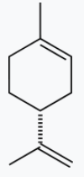 |  | 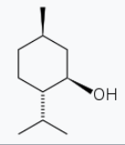 |  | 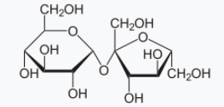
limonene |  | menthol |  | sucrose
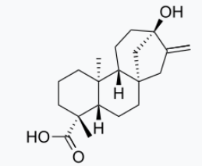 |  | 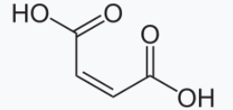 |  | 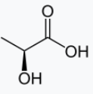
steviol |  | Maleic acid |  | Lactic acid
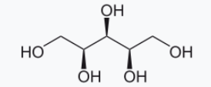 |  | 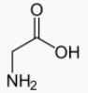 |  | 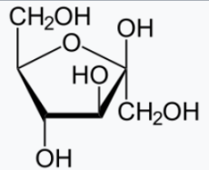
Xylitol |  | glycine |  | Fructose
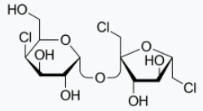 |  | 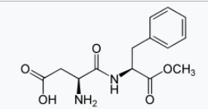 |  | 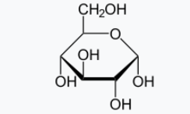
sucralose |  | Aspartame |  | Glucose

Assessment schedule: Chemistry 9xxxx – Sweet and Sour: Functional Group Identification in Consumer Products
Evidence/Judgements for Achievement | Evidence/Judgements for Achievement with Merit | Evidence/Judgements for Achievement with Excellence
These are responses to an activity whose purpose was to identify the organic compound(s) present in kombucha, to justify this identification on the basis of chemical reactions of their functional groups and to discuss the significance of the organic compound for people and/or the environment.
The student carries out an investigation into chemical species present in a sample using qualitative analysis.  The student has (for each sample):  - collected primary data using an identification procedure  - identified the chemical species present by matching primary data to the procedure  - linked the chemical species to the compound present in the sample  For example (note that students would write about two samples):  Results for Sample B: the sample turned blue litmus red, Universal indicator showed a pH of 3. Fizzing was observed with sodium carbonate solution. There was no reaction with Bromine water. Sample B reacted with acidified dichromate turning it from orange to green. There was no reaction with copper sulfate or Benedicts solution. Sample B is lactic acid.  Identification  Sample B: Contains a carboxylic acid (pH test and bicarbonate reaction) and alcohol functional groups (reaction with dichromate). There is no aldehyde as group indicated by the lack of reaction with Benedicts, and no C=C (alkene) group since no reaction with bromine water. No reaction with copper sulfate means no amine group.  Sample B is lactic acid  - described the significance of one the identified chemical species for people and/or the environment.  Lactic acid in food products usually serves as either a pH regulator or as a preservative. This is due to the carboxylic acid functional group which lowers the pH and inhibits bacterial growth which means we can keep food products longer without them going “off” due to bacteria acting on them. This is an advantage for us humans.  The examples above are indicative samples only. | The student carries out an in-depth investigation into chemical species present in a sample using qualitative analysis.  The student has (for each sample):  - explained the identification of chemical species present by linking the primary data to the procedure  - written relevant equations to explain all the changes occurring during the identification procedure  .  For example (note that students would write about two samples):  Results for Sample B: the sample turned blue litmus red, Universal indicator showed a pH of 3. Fizzing was observed with sodium carbonate solution. There was no reaction with Bromine water. Sample B reacted with acidified dichromate turning it from orange to green. There was no reaction with copper sulfate or Benedicts solution. Sample B is lactic acid.  Identification  Sample B: Contains a carboxylic acid (pH test) and alcohol functional groups (reaction with dichromate). There is no aldehyde as group indicated by the lack of reaction with Benedicts, and no C=C (alkene) group since no reaction with bromine water. No reaction with copper sulfate means no amine group.  Equations  Acid: RCOOH + H₂O → H₃O⁺ + RCOO⁻  RCOOH + CO₃²⁻ RCOO⁻ + H₂O + CO₂  Alcohol: ROH RCOOH  Chemistry Ideas for Sample B – lactic acid:  The formation of H₃O⁺ ions from the carboxylic acid dissociating in water causes the litmus to turn from blue to red. The organic product is the carboxylate ion of the acid. This can be classified as acid-base reaction. The reaction with sodium carbonate to produce carbon dioxide gas is typical of acids.  The alcohol group will react with an oxidant-like acidified dichromate to form a carboxylic acid – this is oxidation.  - explained the significance of the identified chemical species for people and/or the environment.  Knowing how its functional groups behave lets us understand why lactic acid is useful and significant to humans. Because lactic acid has a carboxylic acid functional group, foods containing lactic acid have a low enough pH to inhibit bacterial growth.  Humans probably discovered the properties of lactic acid because it forms naturally in many foods, especially dairy products. We can obtain lactic acid for the food industry either from natural sources, for example by fermenting milk using Lactobacillus bacteria, or by producing it synthetically by using bacteria to ferment carbohydrate. Humans use their knowledge of lactic acid’s properties to inoculate milk with bacteria that will produce lactic acid and effectively prolong the shelf life of many dairy products such as cheese, kefir, yoghurt and sourdough bread. Lactic acid is safe for human consumption so it an ideal preservative for foods like kombucha  .  As well as acting as a preservative, lactic acid has a sour flavour due to it being an acid. Sour beers get their flavour from lactic acid produced by bacteria.  http://www.lactic-acid.com/lactic_acid_in_food.html  https://en.wikipedia.org/wiki/Lactic_acid  The examples above are indicative samples only. | The student carries out a comprehensive investigation into chemical species present in a sample using qualitative analysis.  The student has (for each sample):  - justified the identification of chemical species present by linking secondary data and chemical principles to the reactions occurring during the analysis  For example (note that students would write about two samples):  Results for Sample B: the sample turned blue litmus red, Universal indicator showed a pH of 3. Fizzing was observed with sodium carbonate solution. There was no reaction with Bromine water. Sample B reacted with acidified dichromate turning it from orange to green. There was no reaction with copper sulfate or Benedicts solution. Sample B is lactic acid.  Identification  Sample B: Contains a carboxylic acid and alcohol functional groups. There are no alkene or aldehyde as groups indicated by the lack of reaction with Benedicts, and no C=C group. No reaction with bromine water. No reaction with copper sulfate means no amine group.  Equations  Acid: RCOOH + H₂O → H₃O⁺ + RCOO⁻  RCOOH + CO₃²⁻ RCOO- + H₂O + CO₂  Alcohol: ROH RCOOH  Chemistry Ideas for Sample B - lactic acid:  The formation of H₃O⁺ions from the carboxylic acid dissociating in water causes the litmus to turn from blue to red. Organic product is the carboxylate ion of the acid. This can be classified as acid-base reaction. The reaction with sodium carbonate to produce carbon dioxide gas is also an acid-base (proton transfer) reaction.  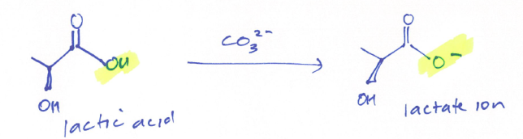  The alcohol group can be oxidised by a strong oxidant such as acidified potassium dichromate. In this case the secondary alcohol is oxidised to a ketone. In the oxidation reaction an H atom is lost. The change in the dichromate from orange to green is indicative of a chromium being reduced.  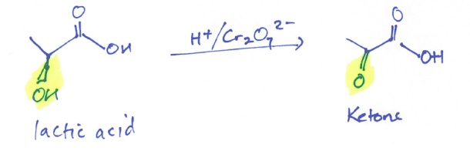  Sample B matches to the structure for lactic acid which has both a carboxylic acid group and an alcohol group.  - discussed the significance of the identified chemical species for people and/or the environment.  Source: Lactic acid is a compound that is formed naturally in many foods, especially dairy products. It can be derived from natural sources, for example fermented milk using Lactobacillus bacteria, or produced synthetically, by using bacteria to ferment carbohydrate (sugars, starch) or by chemical synthesis from ethanol.  Classification – lactic acid is an alpha-hydroxy acid (AHA) because it has an alcohol group next to the carboxylic acid group.  Uses: Lactic acid has been used for human consumption since pre-history in foods and drinks like cheeses, yoghurt, kefir, sourdough bread. The lactic acid has a sour flavour - because it is an acid – and also results in coagulation of proteins due to the acidic pH – this changes the texture. Sour beers get their flavour from lactic acid produced by bacteria. Lactic acid is often added to foods that are pickled in brine to prevent spoilage. In the case of kombucha, lactic acid is found as a by-product of the fermentation by the lactobacillus bacteria – rather than being an added ingredient.  Lactic acid is used as a food additive (E270) for regulating pH, preserving food, curing and also for flavouring. Lactic acid has low toxicity and, as there is no health and safety risk from its use, the food standards do not set a maximum limit in its use.  Because of the rise of popularity of cultured foods, lactic acid has a growing role in the niche food industry and craft beer industry. Foods like kimchi, sauerkraut and other pickled vegetables are considered to have a probiotic nature which means their acidic properties have a positive effect on the gut biome.  In industry alternative methods of production of lactic acid are being considered to utilise waste productions from other processes for example glycerol. Environmental aspects of the impact of lactic acid relate more to its production than to any adverse effects from its use.  Because lactic acid has a carboxylic acid functional group, foods containing lactic acid have a low enough pH to inhibit bacterial growth. When lactic acid is produced in milk from lactose, it reacts with protein in the milk and coagulates it to give solids like cheese or thick liquids like yoghurt. The sharp acidic flavour of lactic acid is prized by humans in products like sour dough bread and sour beers.  http://www.lactic-acid.com/lactic_acid_in_food.html  http://www.foodstandards.gov.au/code/applications/Documents/A1103-AppR.pdf  https://en.wikipedia.org/wiki/Lactic_acid  https://pubs.rsc.org/en/content/articlelanding/2015/ee/c4ee03352c#!divAbstract  The examples above are indicative samples only.
Final grades will be decided using professional judgement based on a holistic examination of the evidence provided against the criteria in the Achievement Standard.

