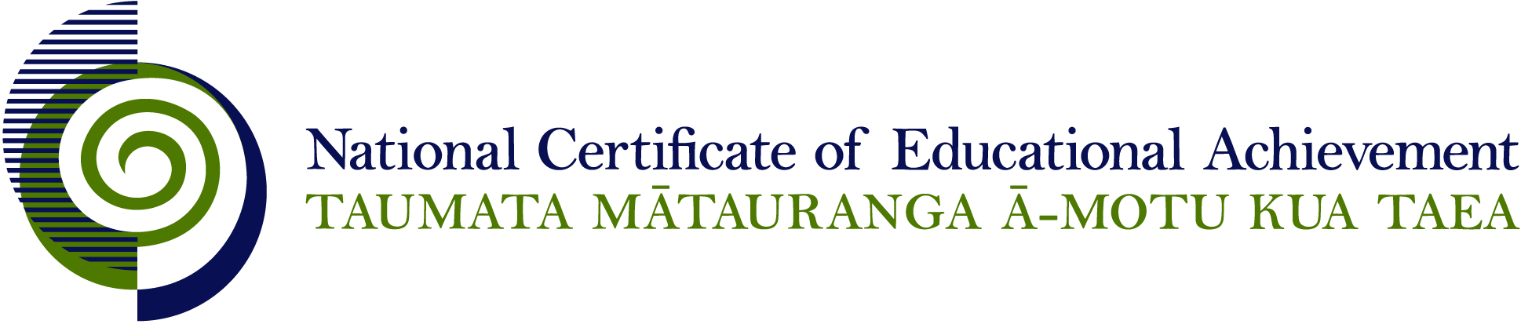

NCEA Level 1 Classical Studies

Conditions of Assessment

General Information

Subject Reference | Classical Studies
Domain | Classical Studies
Level | 1

This document provides guidelines for assessment against internally assessed standards. Guidance is provided on:
- appropriate ways of, and conditions for, gathering evidence
- ensuring that evidence is authentic
- any other relevant advice specific to an achievement standard.

NB: It is expected that teachers are familiar with additional generic guidance on assessment practice in schools published on the NZQA website. This should be read in conjunction with these Conditions of Assessment.

For All Standards

Internal assessment provides considerable flexibility in the collection of evidence. Evidence can be collected in different ways to suit a range of teaching and learning styles and a range of contexts of teaching and learning. Care needs to be taken to allow students opportunities to present their best evidence against the standard(s) that are free from unnecessary constraints.

It is recommended that the design of assessment reflects and reinforces the ways students have been learning. Collection of evidence for the internally assessed standards could include, but is not restricted to, an extended task, an investigation, digital evidence (such as recorded interviews, blogs, photographs or film) or a portfolio of evidence.

It is also recommended that the collection of evidence for internally assessed standards should not use the same method that is used for any external standards in a programme/course, particularly if that method is using a time bound written examination. This could unfairly disadvantage students who do not perform well under these conditions.

A separate assessment event is not needed for each standard. Often assessment can be integrated into one activity that collects evidence towards two or three different standards from a programme of learning. Evidence can also be collected over time from a range of linked activities (for example, in a portfolio).This approach can also ease the assessment workload for both students and teachers.

Effective assessment should suit the nature of the learning being assessed, provide opportunities to meet the diverse needs of all students and be valid and fair.

Where manageable, and after further learning has taken place, students may be offered a maximum of one further opportunity for assessment against an assessment standard within a year.

Authenticity of student evidence needs to be assured regardless of the method of collecting evidence. This needs to be in line with school policy. For example, for an investigation carried out over several sessions, this could include teacher observations or the use of milestones such as meetings with students, journal or photographic entries recording progress etc.

Specific Information for Individual Internal Achievement Standards

Achievement Standard Number | 91024 Classical Studies 1.4
Title | Demonstrate understanding of social relationships in the classical world
Number of Credits | 6
Version | 2

Students should be given the opportunity to demonstrate their understanding in a format that suits their individual learning style or the context of the assessment activity. Suggested formats include, but are not limited to: computer-assisted presentation, journal, essay, brochure, poster, photo-essay, debate, role-play, drama performance, video, model.

Students should have opportunities to work on this assessment both in and out of class time.

Where a group approach is used the teacher needs to ensure that there is evidence that each student has met all aspects of the standard.

Approximately a quarter of the learning time available during the year should be spent on the teaching and learning linked to this standard. This allows time for teachers to model the process by teaching an example before students undertake their own activity for assessment.

A range of primary and secondary source material should be available to students.

Achievement Standard Number | 91025 Classical Studies 1.5
Title | Demonstrate understanding of links between aspects of the classical world and another culture
Number of Credits | 6
Version | 2

Students should be given the opportunity to demonstrate their understanding in a format that suits their individual learning style or the context of the assessment activity. Where a group approach is used the teacher needs to ensure that there is evidence that each student has met all aspects of the standard.

Suggested formats include, but are not limited to: computer-assisted presentation, journal, essay, brochure, poster, photo-essay, debate, role-play, drama performance, video, model.

Approximately a quarter of the learning time available during the year should be spent on the teaching and learning linked to this standard. This allows time for teachers to model the process by teaching an example before students undertake their own activity for assessment.

Students should have opportunities to work on this assessment both in and out of class time.

A range of primary and secondary source material should be available to students. The students could be encouraged to draw on their local environment for evidence.

