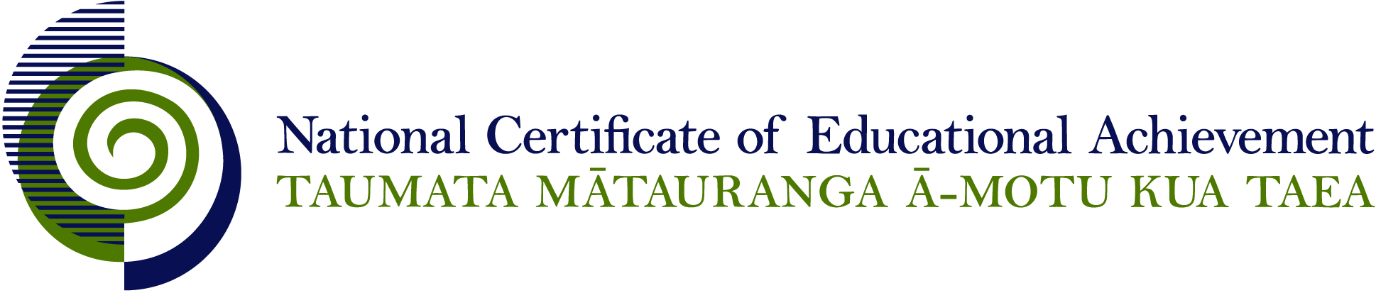

NCEA Level 2 History

Conditions of Assessment

General Information

Subject Reference | History
Domain | History
Level | 2

This document provides guidelines for assessment against internally assessed standards. Guidance is provided on:
- appropriate ways of, and conditions for, gathering evidence
- ensuring that evidence is authentic
- any other relevant advice specific to an achievement standard.

NB: It is expected that teachers are familiar with additional generic guidance on assessment practice in schools published on the NZQA website. This should be read in conjunction with these Conditions of Assessment.

For All Standards

Internal assessment provides considerable flexibility in the collection of evidence. Evidence can be collected in different ways to suit a range of teaching and learning styles and a range of contexts of teaching and learning. Care needs to be taken to allow students opportunities to present their best evidence against the standard(s) that are free from unnecessary constraints.

It is recommended that the design of assessment reflects and reinforces the ways students have been learning. Collection of evidence for the internally assessed standards could include, but is not restricted to, an extended task, an investigation, digital evidence (such as recorded interviews, blogs, photographs or film) or a portfolio of evidence.

It is also recommended that the collection of evidence for internally assessed standards should not use the same method that is used for any external standards in a programme/course, particularly if that method is using a time bound written examination. This could unfairly disadvantage students who do not perform well under these conditions.

A separate assessment event is not needed for each standard. Often assessment can be integrated into one activity that collects evidence towards two or three different standards from a programme of learning. Evidence can also be collected over time from a range of linked activities (for example, in a portfolio).This approach can also ease the assessment workload for both students and teachers.

Effective assessment should suit the nature of the learning being assessed, provide opportunities to meet the diverse needs of all students and be valid and fair.

Where manageable, and after further learning has taken place, students may be offered a maximum of one further opportunity for assessment against an assessment standard within a year.

Authenticity of student evidence needs to be assured regardless of the method of collecting evidence. This needs to be in line with school policy. For example, for an investigation carried out over several sessions, this could include teacher observations or the use of milestones such as meetings with students, journal or photographic entries recording progress etc.

Specific Information for Individual Internal Achievement Standards

Achievement Standard Number | 91229 History 2.1
Title | Carry out an inquiry of an historical event or place that is of significance to New Zealanders
Number of Credits | 4
Version | 2

The inquiry can focus on an event in a personal, local, national or international context.

The teacher may assist in the inquiry by:
  - aiding in the refinement of focusing questions
  - assisting in locating sources
  - conferring with individual students during the inquiry process.

Evidence for this achievement standard would be expected to be gathered from in and out of class activities to be completed by students over a period of time specified by the teacher. Where a group approach is used the teacher needs to ensure that there is evidence that each student has met all aspects of the standard.

This evidence may be generated from discussion, group work, research, decision making and/or reflection and will be presented in any media that clearly communicates the student’s understanding of the inquiry.

Students need to have access to their research materials in order to complete their evaluation of the inquiry process.

Achievement Standard Number | 91230 History 2.2
Title | Examine an historical event or place that is of significance to New Zealanders
Number of Credits | 5
Version | 2

An event can be examined in a personal, local, national or international context.

Evidence for this achievement standard would be expected to be gathered from in and out of class activities to be completed by students over a period of time specified by the teacher. Where a group approach is used the teacher needs to ensure that there is evidence that each student has met all aspects of the standard.

This evidence may be generated from discussion, group work, research, decision making and/or reflection and will be presented in any media that clearly communicates the student’s understanding of the historical event or place.

For example, possible formats for presentation of evidence could include:
- written – article, newspaper, letter, diary, journal, blog
- oral – recording , radio programme
- visual – timeline, poster, video, DVD, webpage, slide show, podcast or other digital formats
- or a portfolio format that includes a variety of media (for example, written notes, annotations, blog entries, video, graphics, photographs, podcasts, interactive mindmaps and other online presentations).

Although the evidence gathered as part of the inquiry for AS91229 can also be submitted for assessment against AS91230, this is not a requirement.

Achievement Standard Number | 91232 History 2.4
Title | Interpret different perspectives of people in an historical event that is of significance to New Zealanders
Number of Credits | 5
Version | 2

Students must use accurate historical information as the basis for the evidence communicated.

Evidence for this achievement standard would be expected to be gathered from in and out of class activities to be completed by students over a period of time specified by the teacher. Where a group approach is used the teacher needs to ensure that there is evidence that each student has met all aspects of the standard.

This evidence may be generated from discussion, group work, research, decision making and/or reflection and will be presented in any media that clearly communicates the student’s understanding of the historical event or place.

For example, possible formats for assessment could include:
- writing speeches
- answering interview questions
- writing diary entries
- constructing pamphlets
- role plays
- plays
- interviews
- essay

The format in which the evidence is submitted is not assessed.

Teachers can choose methods of assessment that do not require students to give a performance. This standard assesses students’ historical understanding of different perspectives, not the quality of a performance.

Students must use accurate historical information as the basis for the evidence communicated.

