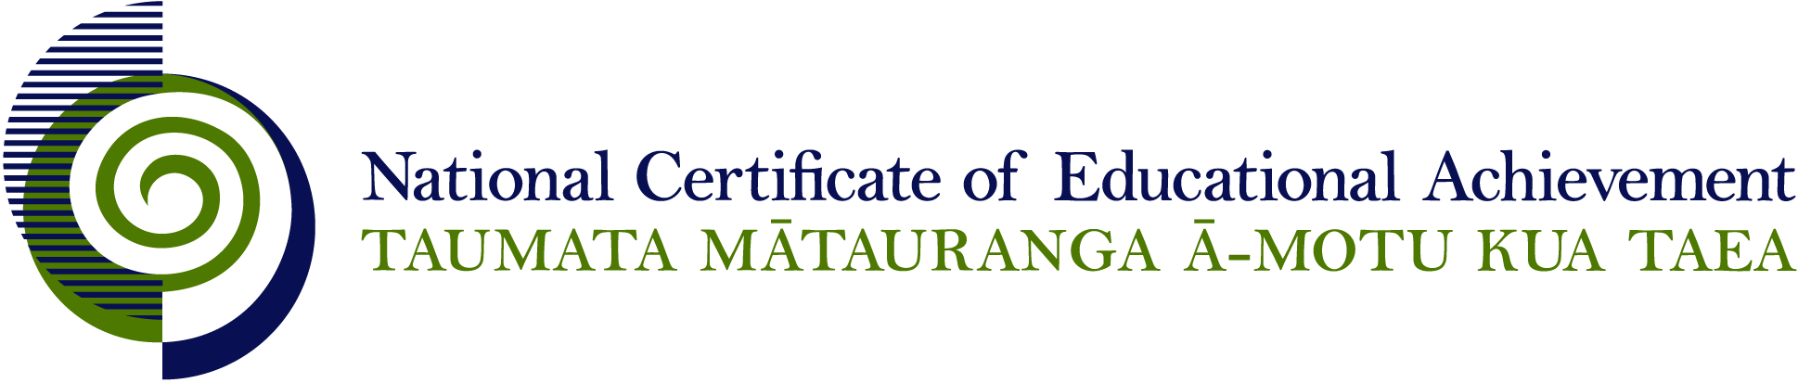

NCEA Level 3 Social Studies

Conditions of Assessment

General Information

Subject Reference | Social Science Studies
Domain | Social Studies
Level | 3

This document provides guidelines for assessment against internally assessed standards. Guidance is provided on:
- appropriate ways of, and conditions for, gathering evidence
- ensuring that evidence is authentic
- any other relevant advice specific to an achievement standard.

NB: It is expected that teachers are familiar with additional generic guidance on assessment practice in schools published on the NZQA website. This should be read in conjunction with these Conditions of Assessment.

For All Standards

Internal assessment provides considerable flexibility in the collection of evidence. Evidence can be collected in different ways to suit a range of teaching and learning styles and a range of contexts of teaching and learning. Care needs to be taken to allow students opportunities to present their best evidence against the standard(s) that are free from unnecessary constraints.

It is recommended that the design of assessment reflects and reinforces the ways students have been learning. Collection of evidence for the internally assessed standards could include, but is not restricted to, an extended task, an investigation, digital evidence (such as recorded interviews, blogs, photographs or film) or a portfolio of evidence.

It is also recommended that the collection of evidence for internally assessed standards should not use the same method that is used for any external standards in a programme/course, particularly if that method is using a time bound written examination. This could unfairly disadvantage students who do not perform well under these conditions.

A separate assessment event is not needed for each standard. Often assessment can be integrated into one activity that collects evidence towards two or three different standards from a programme of learning. Evidence can also be collected over time from a range of linked activities (for example, in a portfolio).This approach can also ease the assessment workload for both students and teachers.

Effective assessment should suit the nature of the learning being assessed, provide opportunities to meet the diverse needs of all students and be valid and fair.

Where manageable, and after further learning has taken place, students may be offered a maximum of one further opportunity for assessment against an assessment standard within a year.

Authenticity of student evidence needs to be assured regardless of the method of collecting evidence. This needs to be in line with school policy. For example, for an investigation carried out over several sessions, this could include teacher observations or the use of milestones such as meetings with students, journal or photographic entries recording progress etc.

Specific Information for Individual Internal Achievement Standards

Achievement Standard Number | 91597 Social Studies 3.2
Title | Conduct a critical social inquiry
Number of Credits | 6
Version | 1

The critical social inquiry is intended to be developed in consultation with the teacher and conducted by the student. The focus of the inquiry may be provided by the teacher or selected by the student and must relate to one of the Level 8 Social Studies Achievement Objectives.

Templates may be provided by teachers. Research questions should be written by the student and discussed with the teacher. The proposed process of inquiry will be discussed with the teacher to ensure that ethical implications are considered. The process of inquiry should be sensitive to safety, privacy, gender, cultural, and other individual needs.

Evidence for this achievement standard would be expected to be gathered from in and out of class activities to be completed by students over a period of time specified by the teacher. This evidence may be generated from discussion, group work, research, decision making and/or reflection and will be presented in any media that clearly communicates the student’s understanding of the investigation. Where a group approach is used the teacher needs to ensure that there is evidence that each student has met all aspects of the standard.

Achievement Standard Number | 91599 Social Studies 3.4
Title | Examine personal involvement in a social action(s) that aims to influence policy change(s)
Number of Credits | 6
Version | 1

Evidence for this achievement standard would be expected to be gathered from in and out of class activities to be completed by students over a period of time specified by the teacher. This evidence may be generated from discussion, group work, research, decision making and/or reflection and will be presented in any media that clearly communicates the student’s understanding of the investigation. Where a group approach is used the teacher needs to ensure that there is evidence that each student has met all aspects of the standard.

The personal involvement should be based on negotiated participation in an approved social action(s) by the assessing school.

Personal involvement means actively participating in a social action. It is recommended that evidence of participation is recorded. This record could be presented in a range of media (for example a written or visual log or in a portfolio format).

A portfolio could include a variety of media (for example, written notes, annotations, blog entries, video, graphics, photographs, podcasts, interactive mindmaps and other online presentations) in any format.

The record should contain specific examples of how the student has participated in the social action.

Organisations and groups involved could provide resource/material support.

Achievement Standard Number | 91600 Social Studies 3.5
Title | Examine a campaign of social action(s) to influence policy change(s)
Number of Credits | 4
Version | 1

The campaign being examined may be current or may be an historical campaign with ongoing consequences.

Evidence for this achievement standard would be expected to be gathered from in and out of class activities to be completed by students over a period of time specified by the teacher. This evidence may be generated from discussion, group work, research, decision making and/or reflection and will be presented in any media that clearly communicates the student’s understanding of the investigation. Where a group approach is used the teacher needs to ensure that there is evidence that each student has met all aspects of the standard.

