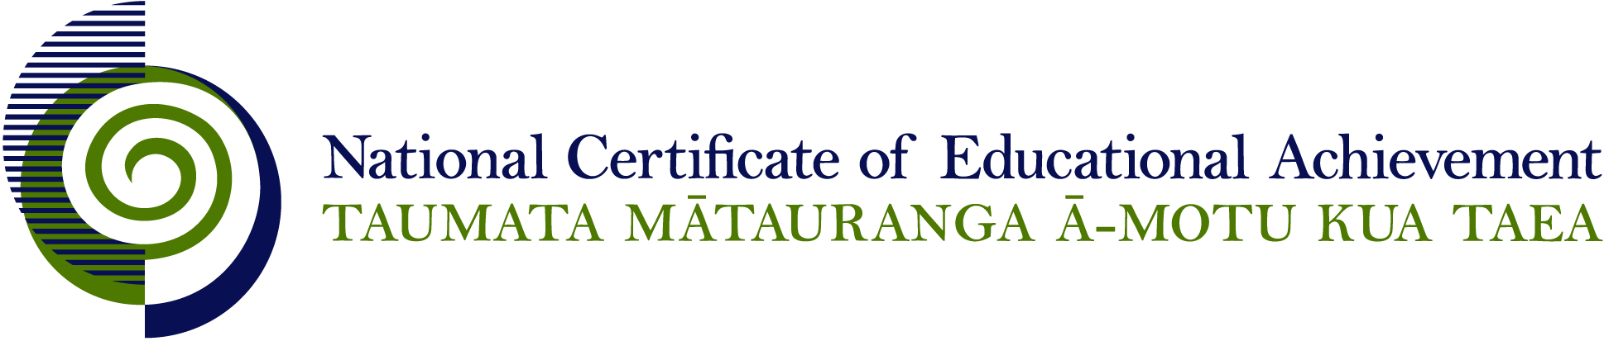

NCEA Level 1 Religious Studies

Conditions of Assessment

General Information

Subject Reference | Religious Studies
Domain | Understanding Religion
Level | 1

This document provides guidelines for assessment against internally assessed standards. Guidance is provided on:
- appropriate ways of, and conditions for, gathering evidence
- ensuring that evidence is authentic
- any other relevant advice specific to an achievement standard.

NB: It is expected that teachers are familiar with additional generic guidance on assessment practice in schools published on the NZQA website. This should be read in conjunction with these Conditions of Assessment.

For All Standards

Internal assessment provides considerable flexibility in the collection of evidence. Evidence can be collected in different ways to suit a range of teaching and learning styles and a range of contexts of teaching and learning. Care needs to be taken to allow students opportunities to present their best evidence against the standard(s) that are free from unnecessary constraints.

It is recommended that the design of assessment reflects and reinforces the ways students have been learning. Collection of evidence for the internally assessed standards could include, but is not restricted to, an extended task, an investigation, digital evidence (such as recorded interviews, blogs, photographs or film) or a portfolio of evidence.

It is also recommended that the collection of evidence for internally assessed standards should not use the same method that is used for any external standards in a programme/course, particularly if that method is using a time bound written examination. This could unfairly disadvantage students who do not perform well under these conditions.

A separate assessment event is not needed for each standard. Often assessment can be integrated into one activity that collects evidence towards two or three different standards from a programme of learning. Evidence can also be collected over time from a range of linked activities (for example, in a portfolio).This approach can also ease the assessment workload for both students and teachers.

Effective assessment should suit the nature of the learning being assessed, provide opportunities to meet the diverse needs of all students and be valid and fair.

Where manageable, and after further learning has taken place, students may be offered a maximum of one further opportunity for assessment against an assessment standard within a year.

Authenticity of student evidence needs to be assured regardless of the method of collecting evidence. This needs to be in line with school policy. For example, for an investigation carried out over several sessions, this could include teacher observations or the use of milestones such as meetings with students, journal or photographic entries recording progress etc.

Specific Information for All Internal Achievement Standards

Students should be given the opportunity to present evidence in a format that suits their individual learning style or the context of the assessment activity. Suggested formats include: computer-assisted presentation, timeline, journal, essay, brochure, poster, photo-essay, debate, role-play, drama performance, video, model, web 2.0 tools, and prepared speech.

Students may work on assessments individually or in groups. The contribution of each student needs to provide sufficient evidence for the assessment of that student and allow that student the opportunity to gain the standard with Achieved, Merit, or Excellence grades.

It is expected that the descriptions are largely sourced from material supplied by a supervisor or teacher through textbooks, lessons, scholarly works, or other teaching tools that form a delivery package.

Students should have opportunities to work on assessments both in and out of class time.

Specific Information for Individual Internal Achievement Standards

Achievement Standard Number | 90816 Religious Studies 1.1
Title | Describe the purpose of a sacred text within a religious tradition
Number of Credits | 6
Version | 2

Teachers or supervisors may assist students by stipulating the sacred text and the religious tradition to be used for the assessment activity, and by monitoring and guiding the early direction of the student’s work. They need to ensure that students identify the sacred text and religious tradition being used as the basis for their assessment activity.

Achievement Standard Number | 90817 Religious Studies 1.2
Title | Describe a significant development within a religious tradition
Number of Credits | 6
Version | 2

Teachers or supervisors may assist students by stipulating the development and the religious tradition to be used for the assessment activity, and by monitoring and guiding the early direction of the student’s work. They need to ensure that students identify the religious tradition and the development being addressed for their assessment activity.

Achievement Standard Number | 90818 Religious Studies 1.3
Title | Describe the application of the key ethical principle(s) of a religious tradition to an issue
Number of Credits | 6
Version | 2

Teachers or supervisors may assist students by stipulating the key ethical principle(s), the issue, and the religious tradition to be used for the assessment activity, and by monitoring and guiding the early direction of the student’s work. They need to ensure that students identify the religious tradition, the key ethical principle(s), and the issue being addressed for their assessment activity.

Achievement Standard Number | 90819 Religious Studies 1.4
Title | Describe key beliefs of a religious tradition
Number of Credits | 6
Version | 2

Teachers or supervisors may assist students by stipulating the key beliefs and the religious tradition to be used for the assessment activity, and by monitoring and guiding the early direction of the student’s work. They need to ensure that students identify the religious tradition being addressed for their assessment activity.

