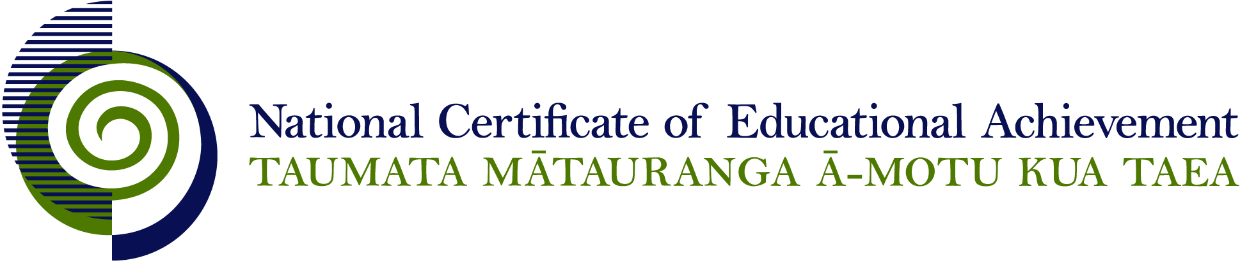

NCEA Level 3 Religious Studies

Conditions of Assessment

General Information

Subject Reference | Religious Studies
Domain | Understanding Religion
Level | 3

This document provides guidelines for assessment against internally assessed standards. Guidance is provided on:
- appropriate ways of, and conditions for, gathering evidence
- ensuring that evidence is authentic
- any other relevant advice specific to an achievement standard.

NB: It is expected that teachers are familiar with additional generic guidance on assessment practice in schools published on the NZQA website. This should be read in conjunction with these Conditions of Assessment.

For All Standards

Internal assessment provides considerable flexibility in the collection of evidence. Evidence can be collected in different ways to suit a range of teaching and learning styles and a range of contexts of teaching and learning. Care needs to be taken to allow students opportunities to present their best evidence against the standard(s) that are free from unnecessary constraints.

It is recommended that the design of assessment reflects and reinforces the ways students have been learning. Collection of evidence for the internally assessed standards could include, but is not restricted to, an extended task, an investigation, digital evidence (such as recorded interviews, blogs, photographs or film) or a portfolio of evidence.

It is also recommended that the collection of evidence for internally assessed standards should not use the same method that is used for any external standards in a programme/course, particularly if that method is using a time bound written examination. This could unfairly disadvantage students who do not perform well under these conditions.

A separate assessment event is not needed for each standard. Often assessment can be integrated into one activity that collects evidence towards two or three different standards from a programme of learning. Evidence can also be collected over time from a range of linked activities (for example, in a portfolio).This approach can also ease the assessment workload for both students and teachers.

Effective assessment should suit the nature of the learning being assessed, provide opportunities to meet the diverse needs of all students and be valid and fair.

Where manageable, and after further learning has taken place, students may be offered a maximum of one further opportunity for assessment against an assessment standard within a year.

Authenticity of student evidence needs to be assured regardless of the method of collecting evidence. This needs to be in line with school policy. For example, for an investigation carried out over several sessions, this could include teacher observations or the use of milestones such as meetings with students, journal or photographic entries recording progress etc.

Specific Information for All Internal Achievement Standards

Students should be given the opportunity to present evidence in a format that suits their individual learning style or the context of the assessment activity. Suggested formats include: computer-assisted presentation, timeline, journal, essay, brochure, poster, photo-essay, debate, role-play, drama performance, video, model, web 2.0 tools, and prepared speech.

Students may work on assessments individually or in groups. The contribution of each student needs to provide sufficient evidence for the assessment of that student and allow that student the opportunity to gain the standard with Achieved, Merit, or Excellence grades.

It is expected that the analysis is largely informed by material independently sourced by the student, with some guidance from a teacher or supervisor.

Students should have opportunities to work on assessments both in and out of class time.

Specific Information for Individual Internal Achievement Standards

Achievement Standard Number | 91725 Religious Studies 3.1
Title | Analyse the meanings in a sacred text within a religious tradition
Number of Credits | 6
Version | 1

Students should be guided towards the choice of interpretive methods, sacred text, and religious tradition to be used for the assessment activity through negotiation with the teacher or supervisor. Students may be guided to derive the relevant meanings from source material.

Achievement Standard Number | 90825 Religious Studies 3.2
Title | Analyse a religious tradition(s) in Aotearoa New Zealand
Number of Credits | 6
Version | 2

Students should be guided towards the choice of religious tradition(s) to be used for the assessment activity through negotiation with the teacher or supervisor.

Achievement Standard Number | 90826 Religious Studies 3.3
Title | Analyse the response of a religious tradition to a contemporary ethical issue
Number of Credits | 6
Version | 2

Students should be guided towards the choice of contemporary social issue and religious tradition to be used for the assessment activity through negotiation with the teacher or supervisor.

Achievement Standard Number | 90827 Religious Studies 3.4
Title | Analyse the key beliefs of a religious tradition and a secular world view in relation to ultimate questions.
Number of Credits | 6
Version | 2

Students should be guided towards the choice of secular world view, religious tradition, and ultimate questions to be used for the assessment activity through negotiation with the teacher or supervisor.

