NZQA
Approved

Achievement standard: 91026 Version 3
Standard title: Apply numeric reasoning in solving problems
Level: 1
Credits: 4
Resource title: It’s getting hot in here
Resource reference: Mathematics and Statistics VP-1.1 v2
Vocational pathway: Construction and Infrastructure

Date version published | February 2015 Version 2  To support internal assessment from 2015
Quality assurance status | These materials have been quality assured by NZQA.  NZQA Approved number A-A-02-2015-91026-02-7264
Authenticity of evidence | Assessors/educators must manage authenticity for any assessment from a public source, because learners may have access to the assessment schedule or exemplar material.  Using this assessment resource without modification may mean that learners’ work is not authentic. Assessors/ educators may need to change figures, measurements or data sources or set a different context or topic to be investigated or a different text to read or perform.

Vocational Pathway Assessment Resource
Achievement standard: 91026
Standard title: Apply numeric reasoning in solving problems
Level: 1
Credits: 4
Resource title: It’s getting hot in here
Resource reference: Mathematics and Statistics VP-1.1 v2
Vocational pathway: Construction and Infrastructure
Learner instructions

Introduction
This assessment activity requires you to advise a home owner about which option they should select for installing a solar unit to save on heating costs for their swimming pool.
You are going to be assessed on how you apply numeric reasoning, using extended abstract thinking, in your recommendation of a purchase option to the home owner.
The following instructions provide you with a way to structure your work so you can demonstrate what you have learnt and achieve success in this standard.
Assessor/educator note: It is expected that the assessor/educator will read the learner instructions and modify them if necessary to suit their learners.

Task
A home owner has decided to install a solar unit to heat their swimming pool. There are several purchase options available. The home owner has asked you to investigate the options and recommend which one they should select.

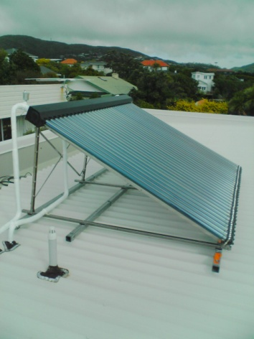
Option 1
This is a complete system installed by a registered installer from Heat It Up solar suppliers. A typical system costs about $5,025, including GST. Installation labour costs make up 27% of the cost of the system.
Several different payment options are available:
- a hire purchase deal for the complete cost (system plus installation), requiring a deposit of of the full amount, with the outstanding balance paid over two years and interest set at 4%
- a personal loan for up to $10,000 from the home owner’s bank
- a cash payment, requiring only the GST exclusive amount.

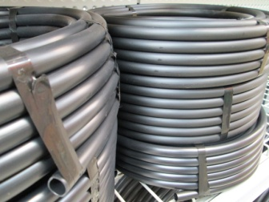
Option 2
A homemade system built and installed onsite by the home owner. Water to the swimming pool would be circulated (pumped) through a coil of black plastic pipe.
A typical system costs about $632, excluding GST, and includes the black pipe, pump and fittings.

Government subsidy
In 2013 the government introduced a new subsidy for people installing solar heating units. This subsidy gives purchasers off the full purchase and installation price if the units are installed by a registered provider.
In preparing your recommendation for the home owner you should:
- show the calculations, as appropriate, that you have used
- use mathematical statements
- explain what you are calculating at each stage.
The quality of your discussion and reasoning and how well you link this to the context will determine the overall grade.

Vocational Pathway Assessment Resource
Achievement standard: 91026
Standard title: Apply numeric reasoning in solving problems
Level: 1
Credits: 4
Resource title: It’s getting hot in here
Resource reference: Mathematics and Statistics VP-1.1 v2
Vocational pathway: Construction and Infrastructure
Assessor/Educator guidelines

Introduction
The following guidelines are supplied to enable assessors/educators to carry out valid and consistent assessment using this internal assessment resource.
As with all assessment resources, education providers will need to follow their own quality control processes. Assessors/educators must manage authenticity for any assessment from a public source, because learners may have access to the assessment schedule or exemplar material. Using this assessment resource without modification may mean that learners' work is not authentic. The assessor/educator may need to change figures, measurements or data sources or set a different context or topic. Assessors/educators need to consider the local context in which learning is taking place and its relevance for learners.
Assessors/educators need to be very familiar with the outcome being assessed by the achievement standard. The achievement criteria and the explanatory notes contain information, definitions, and requirements that are crucial when interpreting the standard and assessing learners against it.

Context/setting
This activity requires learners to perform operations with fractions, decimals, percentages and rates. They will need to apply numeric reasoning, using extended abstract thinking.
The context for this assessment is the installation of a solar water heating unit for a swimming pool. Learners are required to make a recommendation to a home owner of which purchase option they should use.

Conditions
Learners need to work independently to complete this activity.

Resource requirements
Learners should have access to appropriate technology.
Learners are expected to have the opportunity to find out appropriate information about bank loans.

Additional information
Ensure learners are familiar with any context specific vocabulary used in this resource.

Assessment schedule: Mathematics and Statistics 91026 – It’s getting hot in here
Evidence/Judgements for Achievement | Evidence/Judgements for Achievement with Merit | Evidence/Judgements for Achievement with Excellence
The learner applies numeric reasoning in solving problems by:  - selecting and correctly using at least three different numeric methods in solving problems  - demonstrating knowledge of number concepts and terms  - communicating solutions which would usually require only one or two steps  For example, the learner:  - uses percentages to calculate the labour costs for a qualified installer  - uses fractions to calculate the deposit for the hire purchase option  - uses percentages to calculate the GST exclusive cash price.  The examples above are indicative of the evidence that is required. | The learner applies numeric reasoning, using relational thinking, in solving problems by involving one or more of:  - selecting and carrying out a logical sequence of steps  - connecting different concepts and representations  - demonstrating understanding of concepts  - forming and using a model  and relating findings to the context, or communicating thinking using appropriate mathematical statements  For example, the learner:  - links the different constraints and information to find the cost for the different options.  The examples above are indicative of the evidence that is required. | The learner applies numeric reasoning, using extended abstract thinking, in solving problems by involving one or more of:  - devising a strategy to investigate or solve a problem  - identifying relevant concepts in context  - developing a chain of logical reasoning, or proof  - forming a generalisation  and using correct mathematical statements or communicating mathematical insight  For example, the learner:  - calculates the costs for all the options and makes a recommendation based on their assumptions and calculations  - discusses how their recommendation is affected by aspects such as choice of proprietary or DIY options, availability of funds, interest rate charges on bank loans and/or the government subsidy.  The examples above are indicative of the evidence that is required.
Final grades will be decided using professional judgement based on an examination of the evidence provided against the criteria in the Achievement Standard. Judgements should be holistic, rather than based on a checklist approach.

