NZQA
Approved

Achievement standard: 91034 Version 3
Standard title: Apply transformation geometry in solving problems
Level: 1
Credits: 2
Resource title: Cornice creation
Resource reference: Mathematics and Statistics VP-1.9 v2
Vocational pathway: Construction and Infrastructure

Date version published | February 2015 Version 2  To support internal assessment from 2015
Quality assurance status | These materials have been quality assured by NZQA.  NZQA Approved number A-A-02-2015-91034-02-7274
Authenticity of evidence | Assessors/educators must manage authenticity for any assessment from a public source, because learners may have access to the assessment schedule or exemplar material.  Using this assessment resource without modification may mean that learners’ work is not authentic. Assessors/ educators may need to change figures, measurements or data sources or set a different context or topic to be investigated or a different text to read or perform.

Vocational Pathway Assessment Resource
Achievement standard: 91034
Standard title: Apply transformation geometry in solving problems
Level: 1
Credits: 2
Resource title: Cornice creation
Resource reference: Mathematics and Statistics VP-1.9 v2
Vocational pathway: Construction and Infrastructure
Learner instructions

Introduction
This activity requires you to apply transformation geometry to a cornice design. (See Resource A.) You will design a pattern for a cornice, describe how your pattern will be used to make the cornice and explain how the cornice will be positioned in a room.
You are going to be assessed on how you use extended abstract thinking to apply transformation geometry in the design of your patterned cornice and the explanation of the layout of the cornice in the room. Use correct mathematical statements and clearly communicate your thinking about the transformations used in the design and use of the cornice.
The following instructions provide you with a way to structure your work so you can demonstrate what you have learnt and achieve success in this standard.
Assessor/educator note: It is expected that the assessor/educator will read the learner instructions and modify them if necessary to suit their learners.

Task
Sam is building a new room onto his house. He decides to have a patterned decorative cornice at the intersection of the walls and the ceiling of the room.
Design a pattern for the cornice using transformation geometry. Write instructions for your pattern and describe any symmetries in the pattern. Your instructions need to include descriptions of the transformations that have been used and enable your design to be reproduced accurately.
Cornices are usually manufactured in 3 metre or 3.6 metre lengths. Patterned moulds for making cornices can either have the pattern as a continuous form along the length or be spaced along the length.
You need to decide which will be more pleasing and determine the number of patterns and appropriate spacing along the length of either a 3 or 3.6 metre mould. (It is not uncommon for cornice moulds to have a small amount of un-patterned surface at either end of the mould that allows for cutting to size on site.)
A diagram of Sam’s new room is shown below. Explain the positioning of the lengths of cornice in the room paying particular attention to where the patterns will fall along the lengths of the walls and at the internal and external corners that will need to be formed where the different walls intersect.

Resource A
A cornice is an interior finishing component made from fibrous plaster by casting a mixture of gypsum plaster and fibreglass rovings in a mould. Cornices can be plain (where the decoration runs continuously along the length) or patterned (where additional raised or embedded patterns are repeated at regular intervals along the cornice length).

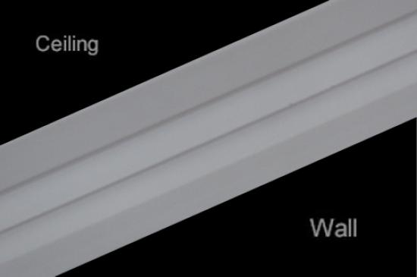  Plain cornice  Source: http://interiorsolutions.co.nz/ | 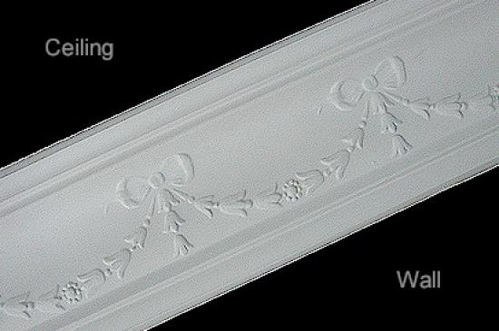  Decorative cornice
Cornices are usually manufactured in 3 metre or 3.6 metre lengths. Patterned moulds for making cornices can either have the pattern as a continuous form along the length or be spaced along the length.

Vocational Pathway Assessment Resource
Achievement standard: 91034
Standard title: Apply transformation geometry in solving problems
Level: 1
Credits: 2
Resource title: Cornice creation
Resource reference: Mathematics and Statistics VP-1.9 v2
Vocational pathway: Construction and Infrastructure
Assessor/Educator guidelines

Introduction
The following guidelines are supplied to enable assessors/educators to carry out valid and consistent assessment using this internal assessment resource.
As with all assessment resources, education providers will need to follow their own quality control processes. Assessors/educators must manage authenticity for any assessment from a public source, because learners may have access to the assessment schedule or exemplar material. Using this assessment resource without modification may mean that learners' work is not authentic. The assessor/educator may need to change figures, measurements or data sources or set a different context or topic. Assessors/educators need to consider the local context in which learning is taking place and its relevance for learners.
Assessors/educators need to be very familiar with the outcome being assessed by the achievement standard. The achievement criteria and the explanatory notes contain information, definitions, and requirements that are crucial when interpreting the standard and assessing learners against it.

Context/setting
This activity requires learners to apply transformation geometry, using extended abstract thinking, to design a length of patterned cornice and explain the layout of the cornice in a room.

Conditions
Learners will work independently on this activity.

Resource requirements
Learners need access to appropriate technology.

Additional information
Ensure learners are familiar with any context specific vocabulary used in this resource.
Some examples of decorative cornice patterns can be seen at: http://interiorsolutions.co.nz/

http://www.plastercraft2000.co.nz/

Assessment schedule: Mathematics and Statistics 91034 – Cornice creation
Evidence/Judgements for Achievement | Evidence/Judgements for Achievement with Merit | Evidence/Judgements for Achievement with Excellence
The learner applies transformation geometry in solving problems by:  - selecting and using a range of methods in solving problems  - demonstrating knowledge of geometrical concepts and terms  - communicating solutions using geometrical terms or representations  For example:  The learner uses at least three different methods, which are correctly identified in the design of the pattern for the cornice and/or the use of the pattern for the length of cornice.  The methods that could provide evidence are:  - reflection  - rotation  - translation  - enlargement  - symmetry.  The examples above are indicative of the evidence that is required. | The learner applies transformation geometry, using relational thinking, in solving problems by involving one or more of:  - selecting and carrying out a logical sequence of steps  - connecting different concepts and representations  - demonstrating understanding of concepts  - forming and using a model  and also relating findings to a context, or communicating thinking using appropriate mathematical statements  For example:  The learner describes the transformations used to design the pattern with the appropriate detail for the transformations to be positioned correctly and describes how their pattern will be used for the 3 m or 3.6 m length of cornice. Any symmetries in the pattern and/or length of cornice are also described. The learner considers the positioning of the lengths of cornice in the room.  The examples above are indicative of the evidence that is required. | The learner applies transformation geometry, using extended abstract thinking, in solving problems by involving one or more of:  - devising a strategy to investigate a situation  - identifying relevant concepts in context  - developing a chain of logical reasoning, or proof  - forming a generalisation  and also using correct mathematical statements, or communicating mathematical insight  For example:  The learner accurately describes the pattern that has been designed for the 3 m or 3.6 m length of cornice. The description includes the number of repetitions of the pattern and consideration of any gaps between the patterns. The positioning of the lengths of cornice in the room is explained, including aspects such as matching the patterns at the joins, the symmetry of the room, the best place to start installing the cornice (usually the wall where the visual impact of pattern symmetry and placement is the most important). The learner accurately describes the transformations used in the pattern design, the use of the pattern for the 3 m or 3.6 m length and the placement of the lengths of cornice in the room.  The examples above are indicative of the evidence that is required.
Final grades will be decided using professional judgement based on an examination of the evidence provided against the criteria in the Achievement Standard. Judgements should be holistic, rather than based on a checklist approach.

