NZQA
Approved

Achievement standard: 91077 Version 3
Standard title: Demonstrate understanding of basic concepts used in the design and construction of electronic environments
Level: 1
Credits: 3
Resource title: Cooling down
Resource reference: Digital Technologies VP-1.47 v2
Vocational pathway: Manufacturing and Technology

Date version published | February 2015 Version 2  To support internal assessment from 2015
Quality assurance status | These materials have been quality assured by NZQA.  NZQA Approved number A-A-02-2015-91077-02-7344
Authenticity of evidence | Assessors/educators must manage authenticity for any assessment from a public source, because learners may have access to the assessment schedule or exemplar material.  Using this assessment resource without modification may mean that learners’ work is not authentic. Assessors/ educators may need to change figures, measurements or data sources or set a different context or topic to be investigated or a different text to read or perform.

Vocational Pathway Assessment Resource
Achievement standard: 91077
Standard title: Demonstrate understanding of basic concepts used in the design and construction of electronic environments
Level: 1
Credits: 3
Resource title: Cooling down
Resource reference: Digital Technologies VP-1.47 v2
Vocational pathway: Manufacturing and Technology
Learner instructions

Introduction
This assessment activity requires you to demonstrate understanding of the basic electronic concepts used in the design and construction of a sensor-controlled cooling fan for a car.
You are going to be assessed on how comprehensively you demonstrate understanding of the basic concepts used in the design and construction of a sensor-controlled cooling fan for a car.
Assessor/educator note: It is expected that the assessor/educator will read the learner instructions and modify them if necessary to suit their learners.

Task
You are required to design and construct a sensor-controlled cooling fan for a car demonstrating your understanding of the basic electronic concepts used in its design and construction.
‘Electronic environment’ refers to functional combinations of hardware and embedded software.
‘Basic concepts’ includes understanding the function of the components you use and at least five of the following:
- a circuit as a complete path
- voltage as an energy path
- current as rate of flow of charge
- conduction (limited to the macroscopic behaviour of conductors, insulators, and semiconductors)
- circuit subsystems
- symbolic conventions and schematics
- hardware (for example components and combinations of components)
- embedded systems as software subject to hardware constraints.

Specifications
Specifications must be agreed with the assessor/educator prior to the implementation of the interfacing procedures.
The car cooling system will include:
- a system that indicates when the engine temperature reaches approximately 90 degrees and requires the cooling fan to be switched on
- a remote indicator, using a LED, that shows when the fan is operating
- a short warning buzzer that buzzes for 1 second to warn the driver
- a circuit that provides a switch so the driver can manually operate the cooling fan.
The system will be a microcontroller-based circuit, using the following components:
- microcontroller (for example PIC, PICAXE, AVR, Basic Stamp)
- LED and a buzzer as indicators
- switch for manual override control
- thermistor in a voltage divider sub-circuit
- motor with a fan driven by a suitable transistor amplifier sub-circuit.
A suitable platform for this work would be an electronic breadboard and you may also need fixed or variable resistors, diodes and capacitors.

Steps for construction
Use these six steps to design and construct your fan cooling system for a car, and support your work with documented evidence:
- Use a breadboard to connect 3 LEDs to a microcontroller with three different resistor values. Program the microcontroller to control the LEDs, and describe and explain the effects of different resistor values. Determine a correct value of resistance for your circuit and explain your choice in terms of current and voltage requirements for an LED. Show your calculations for the currents and voltages in each LED sub-circuit.
- Connect a transistor amplifier circuit to your microcontroller and attach a small motor to this. Explain why a transistor is required and how it affects the current and voltage in the relay sub-circuit.
- Connect a switch to your microcontroller and write a simple program that changes the state of the motor every time the switch is pressed. Describe the purpose of the resistor in the circuit and explain its effect on the microcontroller input.
- Connect a thermistor in a voltage divider to your microcontroller and use this to show the effect of heat on your motor:
  - in the normal room environment
  - when the temperature is 90-100 degrees Celsius.
- Calibrate the thermistor at specific temperature levels and explain how this is done.
- Modify the program so that either the thermistor or the switch controls the motor LED and buzzer.
Use the circuit below, if required.

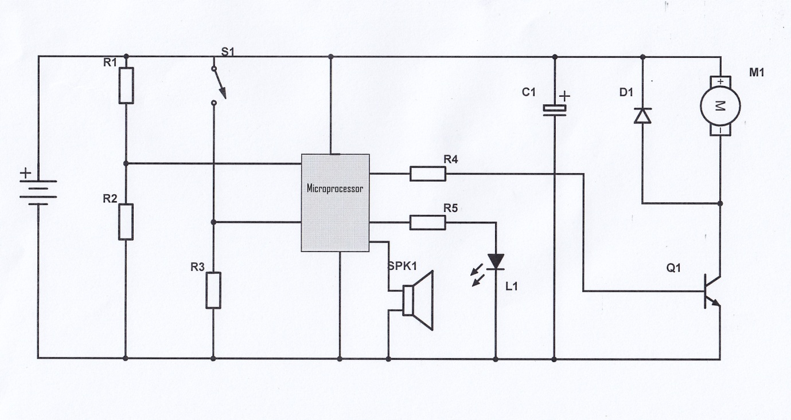Completing the task
As you perform the task, make notes and gather evidence for inclusion in a portfolio. For example:
- describe what happens to the operating function of your temperature-controlled detection system when you use different values of electronic components
- describe what happens to the light-controlled detection system when you apply consistent and correct use of at least five basic concepts, for example voltage, current, open and closed circuits, correct use of component symbols, software to control basic microcontroller circuits
- explain your choice of basic components to build your circuit, for example resistor to limit current and/or transistor to amplify current
- explain any calculations and/or research, for example using manufacturer data sheets, that you used to determine the best components for your circuit
- describe how your circuit behaves in terms of the basic concepts, for example a voltage divider
- discuss the operation, function, and calculation of the electronic components you used in your circuit, for example:
  - resistor values in a LED current limit sub-circuit controlled by a microcontroller
  - voltage divider sub-circuit resistor values as inputs to a microcontroller
  - diode between a circuit and a power source
  - selecting a suitable transistor based upon its characteristics as an amplifier between a microcontroller and a motor.

Presentation
Present your understandings as a portfolio, which must include:
- circuit diagrams
- layouts
- programs for each of the six steps in the task.
You may also want to include:
- annotated diagrams and photographs
- journal entries that describe your trialling and testing of circuits
- your responses to assessor/educator questions
- interview notes from a scheduled assessor/educator consultation
- test results.
This is an individual activity.

Resources

Useful websites:
http://www.arduino.cc/en/
www.electronics-tutorials.com/basics/basic-electronics.htm
http://williamson-labs.com/
www.technologylearner.com
www.picaxe.com

Vocational Pathway Assessment Resource
Achievement standard: 91077
Standard title: Demonstrate understanding of basic concepts used in the design and construction of electronic environments
Level: 1
Credits: 3
Resource title: Cooling down
Resource reference: Digital Technologies VP-1.47 v2
Vocational pathway: Manufacturing and Technology
Assessor/Educator guidelines

Introduction
The following guidelines are supplied to enable assessors/educators to carry out valid and consistent assessment using this internal assessment resource.
As with all assessment resources, education providers will need to follow their own quality control processes. Assessors/educators must manage authenticity for any assessment from a public source, because learners may have access to the assessment schedule or exemplar material. Using this assessment resource without modification may mean that learners' work is not authentic. The assessor/educator may need to change figures, measurements or data sources or set a different context or topic. Assessors/educators need to consider the local context in which learning is taking place and its relevance for learners.
Assessors/educators need to be very familiar with the outcome being assessed by the achievement standard. The achievement criteria and the explanatory notes contain information, definitions, and requirements that are crucial when interpreting the standard and assessing learners against it.

Context/setting
This activity requires learners to demonstrate comprehensive understanding of basic concepts used in the design and construction of electronic environments, using the design and construction of a sensor-controlled cooling fan for a car.
The specifications need to be agreed prior to the implementation of interfacing procedures. They may be provided or developed in negotiation with the learner.

Conditions
In this activity, learners will work individually.

Resource requirements
Electronic catalogues and supplies are available at:
www.Surplustronics.co.nz
www.Activecomponents.com
Learners will also require:
- internet access
- materials to build their detection system
- a digital camera
- an electronic breadboard
- electronic circuit simulation software, for example:
www.falstad.com/circuit/
www.yenka.com
- software for schematic capture, for example:
www.cadsoft.de
The following resources may also be useful:
An Introduction to Practical Electronics, Microcontrollers and Software Design by Bill Collis (available at www.techideas.co.nz).
PICAXE Microcontroller Projects for the Evil Genius by Ron Hackett (available at www.amazon.com).

Additional information
Other microprocessors such as Arduino could be used.

Assessment schedule: Digital Technologies 91077 – Cooling down
Evidence/Judgements for Achievement | Evidence/Judgements for Achievement with Merit | Evidence/Judgements for Achievement with Excellence
The learner demonstrates understanding of basic concepts used in the design and construction of a sensor-controlled cooling fan for a car by:  - describing concepts of electronics in practical contexts  Basic concepts will include understanding of the function of electronic components as well as at least five of the following:  - a circuit as a complete path  - voltage as an energy level  - current as rate of flow of charge  - conduction (limited to the macroscopic behaviour of conductors, insulators, and semiconductors)  - circuit subsystems  - symbolic conventions and schematics  - hardware (for example components and combinations of components)  - embedded systems as software subject to hardware constraints  For example:  The learner draws a completed circuit schematic with all the correct symbols and conventions.  The learner describes how a voltage divider works.  In electronics, we talk about a circuit as a complete path. This means that electrons flow from a battery through the components and back to the battery again. Sometimes there are breaks and shorts in the path due to incorrect wiring. See my circuit diagram and photograph with notes showing a completed circuit without short circuits or disconnections.  - describing the operational function of electronic components in a sensor-controlled cooling fan for a car (e.g. in a transistor switch system)  Electronic components include:  - a microcontroller (one example)  - a cell  - a switch (for example SPST, SPDT, reed, relay)  - a resistor (for example fixed, variable, light dependent [LDR], thermistor)  - light-emitting diode (LED)  - motor  - voltage divider and transistor switch subsystems  For example:  A resistor is required to be put in series with an LED because … Current and voltage … might …  The voltage divider is used as a … into the microprocessor so that …  The above expected learner responses are indicative only and relate to just part of what is required. | The learner demonstrates in-depth understanding of basic concepts used in the design and construction of a sensor-controlled cooling fan for a car by:  - describing concepts of electronics in practical contexts  Basic concepts will include understanding of the function of electronic components as well as at least five of the following:  - a circuit as a complete path  - voltage as an energy level  - current as rate of flow of charge  - conduction (limited to the macroscopic behaviour of conductors, insulators, and semiconductors)  - circuit subsystems  - symbolic conventions and schematics  - hardware (for example components and combinations of components)  - embedded systems as software subject to hardware constraints  For example:  The learner draws a completed circuit schematic with all the correct symbols and conventions and annotates it with the values to be used in the final circuit.  In electronics, we talk about a circuit as a complete path. This means that electrons … through the components and back to the … Sometimes there are breaks and shorts in the path due to incorrect wiring explaining the behaviour of electronic circuits.  - explaining the behaviour of electronic circuits  For example:  I chose this resistor because a lower value would have … effect and a higher value would have … effect (explained in terms of current and voltage). The purpose of the transistor is to … between the motor and the microcontroller because… When I made my circuit, I made sure the LED and resistor were in series, not in parallel, OR  When I made the circuit, I realised the LED and resistor were in parallel, and I changed them to series because the current …  - explaining the operational function of electronic components in a sensor-controlled cooling fan for a car  Electronic components include:  - a microcontroller (one example)  - a cell  - a switch (for example SPST, SPDT, reed, relay)  - a resistor (for example fixed, variable, light dependent [LDR], thermistor)  - light-emitting diode (LED)  - motor  - voltage divider and transistor switch subsystems  For example:  The learner explains the purpose of the transistor in the motor sub circuit and could explain what effect changing the value may have on the circuit.  A resistor is required to be put in series with an LED because … Current and voltage … might … The learner spent some time determining the correct value of the resistor.  The voltage divider is used as a … microprocessor so that … Changing the value of the resistor will …  During testing the learner decided to replace the fixed resistor in the voltage divider with a variable one because …  The above expected learner responses are indicative only and relate to just part of what is required. | The learner demonstrates comprehensive understanding of basic concepts used in the design and construction of a sensor-controlled cooling fan for a car by:  - describing concepts of electronics in practical contexts  Basic concepts will include understanding of the function of electronic components as well as at least five of the following:  - a circuit as a complete path  - voltage as an energy level  - current as rate of flow of charge  - conduction (limited to the macroscopic behaviour of conductors, insulators, and semiconductors)  - circuit subsystems  - symbolic conventions and schematics  - hardware (for example components and combinations of components)  - embedded systems as software subject to hardware constraints  For example:  The learner draws a completed circuit schematic with all the correct symbols and conventions and annotates it with the values to be used in the final circuit.  In electronics, we talk about a circuit as a complete path. This means that electrons … through the components and back to the …. Sometimes there are breaks and shorts in the path due to incorrect wiring.  - explaining the behaviour of electronic systems (e.g. the effects of voltage levels on the operation of a transistor switch sub-system)  For example:  I calculated the resistor value for my LED on my microcontroller to be… using Ohm’s law in this way (see my calculation and explanation). I wanted the LED to be bright enough for the light to be seen at a distance on a bright day. I chose the capacity of the cells for my project to be … based upon my calculations of the current demands of my circuit with … LEDs, motor…  Here are my calculations…  - discussing the operational function of electronic components in a sensor-controlled cooling fan for a car (e.g. the effect of swapping the fixed resistor and the LDR in a voltage divider circuit)  Electronic components include:  - a microcontroller (one example)  - a cell  - a switch (for example SPST, SPDT, reed, relay)  - a resistor (for example fixed, variable, light dependent [LDR], thermistor)  - light-emitting diode (LED)  - motor  - voltage divider and transistor switch subsystems  For example:  I tested my motor and found that it could not be run directly by my microcontroller. So I used a transistor in the circuit between the microcontroller and the relay because the microcontroller is limited to providing X current and my motor requires Y current. The transistor for my motor amplifies the current as a microcontroller cannot drive a motor directly.  The microcontroller has … which can be used along with some code to control the function of the circuit. It does this by … I found some errors in the code on testing which I fixed by …  I researched three transistors… Their specifications are… I chose... as the specification for my relay is… and then I knew that my chosen transistor would not overheat/explode/cease to function. The effect of swapping the transistor in the circuit is …  The above expected learner responses are indicative only and relate to just part of what is required.
Final grades will be decided using professional judgement based on an examination of the evidence provided against the criteria in the Achievement Standard. Judgements should be holistic, rather than based on a checklist approach.

