NZQA
Approved

Achievement standard: 91033 Version 3
Standard title: Apply knowledge of geometric representations in solving problems
Level: 1
Credits: 3
Resource title: A mighty wind
Resource reference: Mathematics and Statistics VP-1.8 v2
Vocational pathway: Manufacturing and Technology

Date version published | February 2015 Version 2  To support internal assessment from 2015
Quality assurance status | These materials have been quality assured by NZQA.  NZQA Approved number A-A-02-2015-91033-02-7273
Authenticity of evidence | Assessors/educators must manage authenticity for any assessment from a public source, because learners may have access to the assessment schedule or exemplar material.  Using this assessment resource without modification may mean that learners’ work is not authentic. Assessors/ educators may need to change figures, measurements or data sources or set a different context or topic to be investigated or a different text to read or perform.

Vocational Pathway Assessment Resource
Achievement standard: 91033
Standard title: Apply knowledge of geometric representations in solving problems
Level: 1
Credits: 3
Resource title: A mighty wind
Resource reference: Mathematics and Statistics VP-1.8 v2
Vocational pathway: Manufacturing and Technology
Learner instructions

Introduction
This assessment activity requires you to apply your knowledge of geometric representations to solve problems relating to the design of a weather vane and a gift box for it.
You are going to be assessed on how you apply knowledge of geometric representations, using extended abstract thinking, when creating the design of a wind vane and the box to supply it. You are required to communicate your solutions clearly and accurately.
The following instructions provide you with a way to structure your work so you can demonstrate what you have learnt and achieve success in this standard.
Assessor/educator note: It is expected that the assessor/educator will read the learner instructions and modify them if necessary to suit their learners.

Task
The A Mighty Wind weather vane company makes and sells weather vanes – available in a variety of differently shaped box sets that can be sent as gifts. As a designer for the company you have been asked to design a weather vane and gift box. You also need to provide a report to support your designs.
Design a simple weather vane and develop a scale drawing of both the weather vane and a plan of the net for the gift box that it will be delivered in. You could consider incorporating a viewing window and/or a company logo in your gift box design.
Resource A has background information about weather vanes to help you.
When designing your weather vane and gift box, you must use at least three of: constructions, loci, scale diagrams, nets or two-dimensional co-ordinate systems.
Write a report to support your design for the weather vane and gift box. Your report should include relevant information about your design decisions and appropriate mathematical statements and correct geometrical terms.
You will be assessed on your understanding and application of geometrical representations. It is important that you clearly communicate your thinking and use correct mathematical statements.

Resource A

Weather vanes
Weather vanes are a way of finding out which way the wind is blowing. Generally they have a simple design, but to function they need to be perfectly balanced on their rotating axis and an unequal area on each side that the wind can blow against.
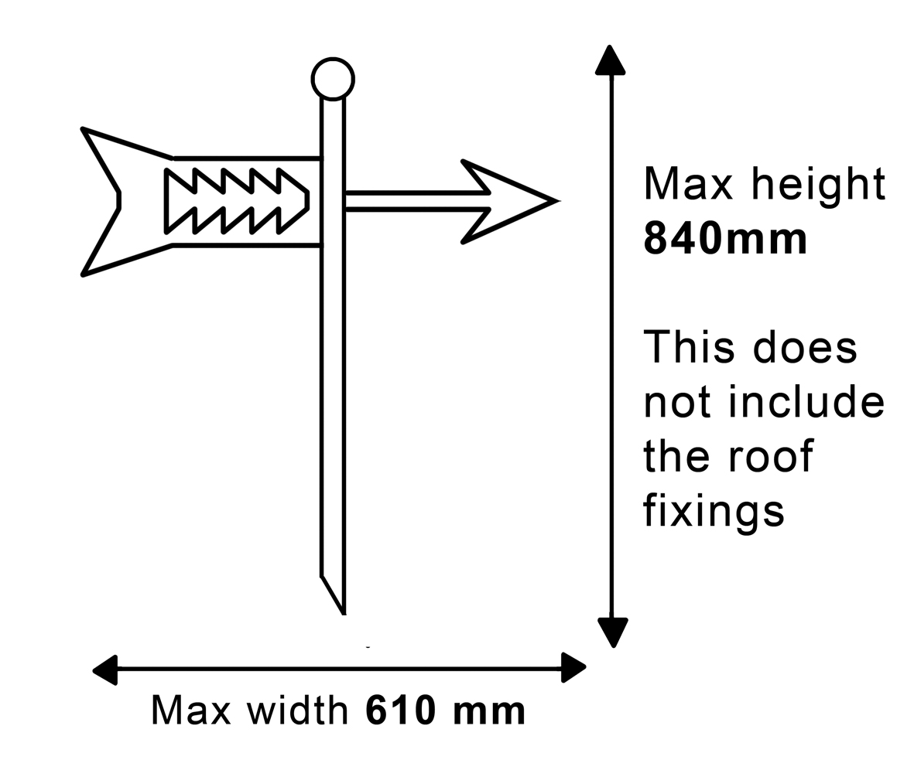
They are usually located on the highest point of a structure – away from other tall buildings or structures that may affect wind direction. As the vane spins, to reduce the force of the wind on its surface the end with the least surface area turns into the wind, and indicates the wind direction.

The A Mighty Wind company makes some banner weather vanes to the dimensions shown in the diagram.

The banner is removed from the pole for packaging.
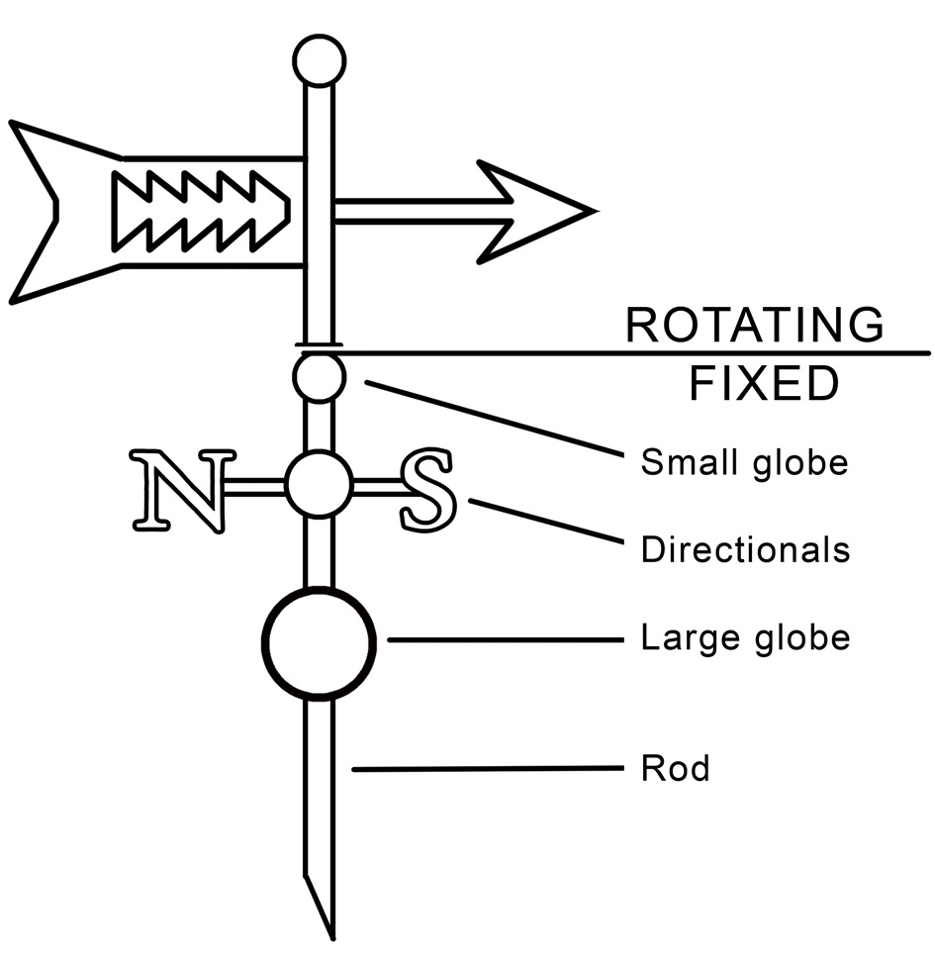

Weather vanes have various components as shown in this diagram.

Some have a simple design, while others are more complex. The arrow is an essential component, which can be decorated. Directionals are not always added.
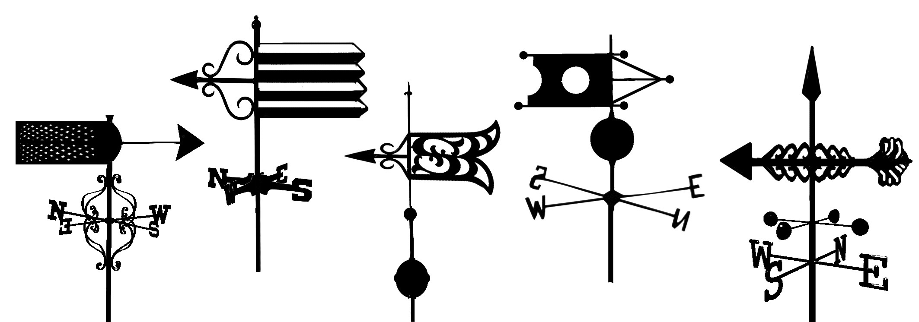

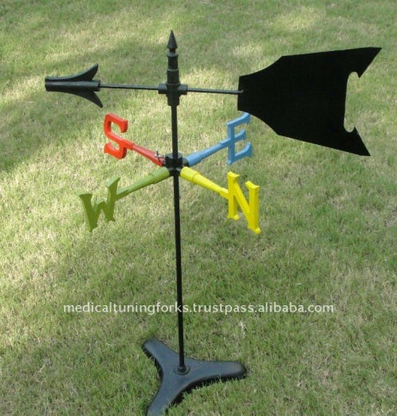
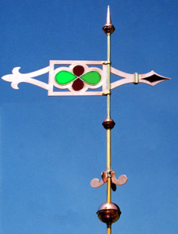
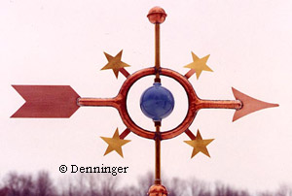
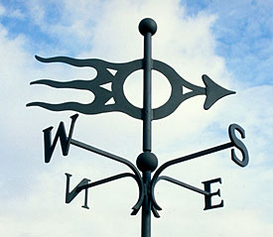

Vocational Pathway Assessment Resource
Achievement standard: 91033
Standard title: Apply knowledge of geometric representations in solving problems
Level: 1
Credits: 3
Resource title: A mighty wind
Resource reference: Mathematics and Statistics VP-1.8 v2
Vocational pathway: Manufacturing and Technology
Assessor/Educator guidelines

Introduction
The following guidelines are supplied to enable assessors/educators to carry out valid and consistent assessment using this internal assessment resource.
As with all assessment resources, education providers will need to follow their own quality control processes. Assessors/educators must manage authenticity for any assessment from a public source, because learners may have access to the assessment schedule or exemplar material. Using this assessment resource without modification may mean that learners' work is not authentic. The assessor/educator may need to change figures, measurements or data sources or set a different context or topic. Assessors/educators need to consider the local context in which learning is taking place and its relevance for learners.
Assessors/educators need to be very familiar with the outcome being assessed by the achievement standard. The achievement criteria and the explanatory notes contain information, definitions, and requirements that are crucial when interpreting the standard and assessing learners against it.

Context/setting
This activity requires learners to apply knowledge of geometric representations, using extended abstract thinking, when designing and drawing a scale diagram of their design for a weather vane and a net for the gift box it is to be packaged in, and write a report to support their design.

Conditions
Learners need to work independently to complete this activity.

Resource requirements
Learners are expected to have access to appropriate technology.
Although a resource sheet is provided, assessor/educators should also encourage learners to do their own research about the weather vane designs and gift boxes before they begin this activity.

Additional information
Assessors/educators need to ensure that learners are familiar with any context specific vocabulary used in this resource.

Assessment schedule: Mathematics and Statistics 91033 – A mighty wind
Evidence/Judgements for Achievement | Evidence/Judgements for Achievement with Merit | Evidence/Judgements for Achievement with Excellence
The learner applies knowledge of geometric representations in solving problems by:  - selecting and using a range of methods in solving problems  - demonstrating knowledge of geometrical concepts and terms  - communicating solutions using geometrical terms or representations.  The learner uses and correctly identifies at least three different methods in the weather vane and gift box design  For example:  The learner could provide evidence of correctly identifying and using:  - scale diagram  - loci  - constructions with appropriate construction marks visible  - two-dimensional co-ordinate systems.  The examples above are indicative of the evidence that is required. | The learner applies knowledge of geometric representations, using relational thinking, in solving problems by involving one or more of:  - selecting and carrying out a logical sequence of steps  - connecting different concepts and representations  - demonstrating understanding of concepts  - forming and using a model  and also relating findings to a context, or communicating thinking using appropriate mathematical statements  For example:  The learner has made an accurate drawing of the weather vane and a suitable gift box. A majority of elements in the diagram are to scale, complete, correct, and have matching descriptions.  Appropriate mathematical statements are used and dimensions are consistent with those given.  The examples above are indicative of the evidence that is required. | The learner applies knowledge of geometric representations, using extended abstract thinking, in solving problems by involving one or more of:  - devising a strategy to solve a problem  - identifying relevant concepts in context  - developing a chain of logical reasoning, or proof  - forming a generalisation  and also using correct mathematical statements, or communicating mathematical insight  For example:  The learner has considered other designs for the weather vane and justified the choice of the gift box. The impact on the overall design of the other design options has been discussed in the report.  The scale diagram and net are correct and match the decisions discussed in the justification.  The examples above are indicative of the evidence that is required.
Final grades will be decided using professional judgement based on an examination of the evidence provided against the criteria in the Achievement Standard. Judgements should be holistic, rather than based on a checklist approach.

