NZQA
Approved

Achievement standard: 91033 Version 3
Standard title: Apply knowledge of geometric representations in solving problems
Level: 1
Credits: 3
Resource title: Dig a little deeper
Resource reference: Mathematics and Statistics VP-1.8 v2
Vocational pathway: Primary Industries

Date version published | February 2015 Version 2  To support internal assessment from 2015
Quality assurance status | These materials have been quality assured by NZQA.  NZQA Approved number A-A-02-2015-91033-02-7272
Authenticity of evidence | Assessors/educators must manage authenticity for any assessment from a public source, because learners may have access to the assessment schedule or exemplar material.  Using this assessment resource without modification may mean that learners’ work is not authentic. Assessors/ educators may need to change figures, measurements or data sources or set a different context or topic to be investigated or a different text to read or perform.

Vocational Pathway Assessment Resource
Achievement standard: 91033
Standard title: Apply knowledge of geometric representations in solving problems
Level: 1
Credits: 3
Resource title: Dig a little deeper
Resource reference: Mathematics and Statistics VP-1.8 v2
Vocational pathway: Primary Industries
Learner instructions

Introduction
This assessment activity requires you to apply knowledge of geometric representations to solve problems relating to garden designs for a school.
You are going to be assessed on how you apply knowledge of geometric representations, using extended abstract thinking, to devise a strategy and develop a chain of logical reasoning in creating garden designs. You are required to communicate your solutions clearly and accurately.
The following instructions provide you with a way to structure your work so you can demonstrate what you have learnt and achieve success in this standard.
Assessor/educator note: It is expected that the assessor/educator will read the learner instructions and modify them if necessary to suit their learners.

Task
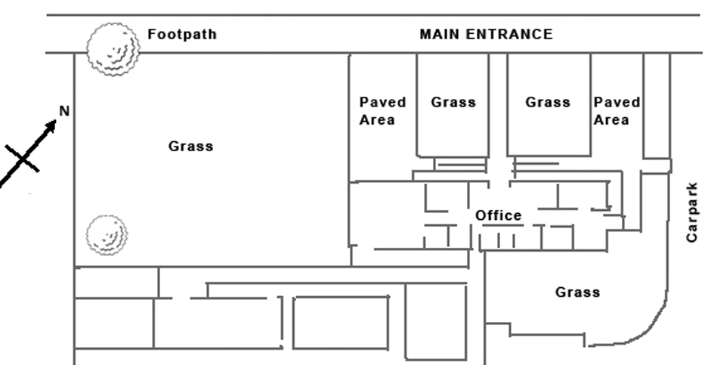
New Hope school has had some of its buildings refurbished including the administration block. This involved putting in an entry porch, as shown below in diagram 1.

Diagram 1

The Board of Trustees and parents group have been fundraising and would now like to do some planting in the grassed areas at the front of the school. They have asked you to create a scale drawing of the two gardens, showing the planned position of the plants that you have chosen and giving clear instructions on the planting. You also need to provide a report to support your garden design.
When designing gardens it is usual to develop a concept plan with draft ideas. Then follow this with a detailed scale drawing and planting guide that includes sufficient detail for the gardener to plant the selected plants as required.
The Board of Trustees have only two requirements for the types of planting:
- They want at least one tree in the area to the left side of the office block.
- The other planting needs to be reasonably hardy and easy to care for.
These areas to be planted are shown below in diagram 2.
When creating your garden design, you must use at least three of: constructions, loci, bearings, scale diagrams, or two-dimensional co-ordinate systems.
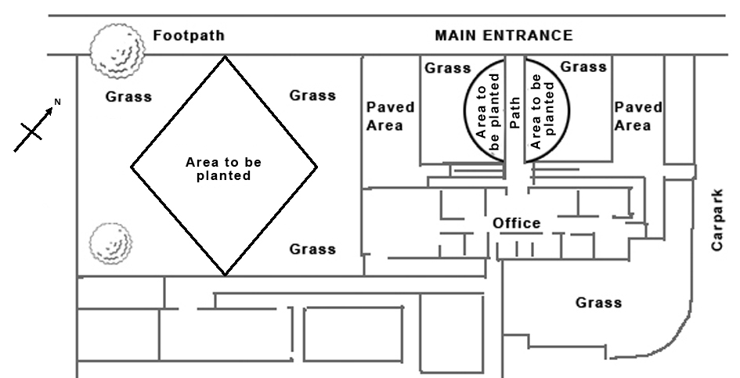

Diagram 2

Make a scale plan for the garden that:
- shows the location of the plants
- provides location details to enable the garden areas to be excavated
- provides enough information so the gardener can lay out the garden accurately from your plan.
Write a report to support your garden design. Justify your choice of plants and how they have been combined in your design. Discuss other alternatives to the design or choices of plants.
Your report should include appropriate mathematical statements and correct geometrical terms.
Resource A provides an enlarged outline, with the dimensions, of the gardens to be planted.
Resource B is provided to help you in your selection of plants for your design.
You will be assessed on your understanding and application of geometrical representations. It is important that you clearly communicate your thinking and use correct mathematical statements.

Resource A
Enlarged outlines of the gardens to be planted.
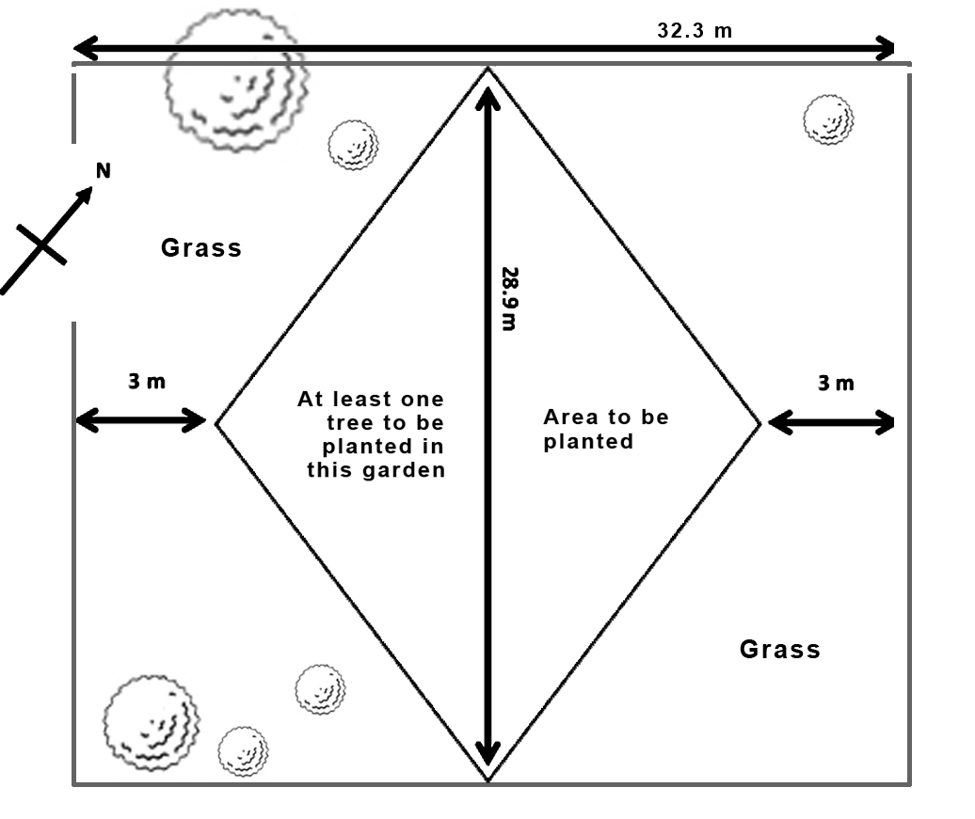

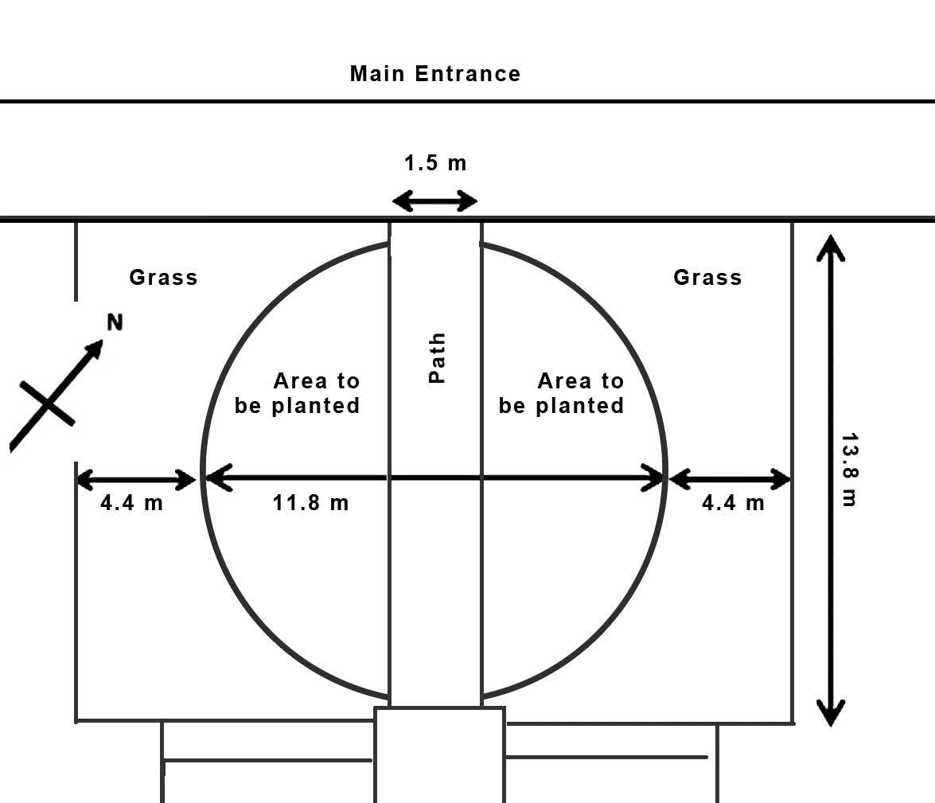

Resource B:
Planting guide
Function | Botanical name | Common name | Height x width | Description
Groundcover | Ajuga reptans | Bugle weed | 0.1 x 0.5 m | Herbaceous spreader with purplish green leaves, blue flowers. Likes damp soil in sun/semi-shade.
Groundcover | Coprosma acerosa ‘Hawera’ | Sand dune coprosma | 1.2 x 0.2 m | Fine, dense mid-green foliage. Hardy and dependable. Prefers sunny site in average soil. Stands some foot traffic.
Groundcover | Microsorum pustulatum | Creeping rhizome fern | 1.0 x 0.3 m | Shiny green fern foliage will slowly creep to cover ground. Prefers well-drained soils in shade or semi-shade.
Small shrub | Hebe odora | Boxwood hebe | 1 x 1 m | Dense, bright green foliage, small white flowers October to March. Frost-hardy. Prefers full sun, in any soil not waterlogged.
Small shrub | Sarcococca ruscifloia | Fragrant sweet box | 1 x 1 m | Hardy, dependable shrub with fragrant flowers in winter, followed by red berries in spring, turning black in summer. Prefers fertile soil not soggy or dry. Tolerates deep shade.
Small shrub | Azalea indica ‘Apple Blossom’ | Evergreen azalea | 1 x 1 m | Fresh green foliage in spring/summer, turning bronze tones in winter. White/pink flowers in spring. Prefers a light, well-drained lime-free soil in semi-shade.
Small shrub | Leptospermum scoparium ‘Winter Cheer’ | Winter Cheer flowering manuka | 1.5 x 1.5 m | Hardy shrub with reddish foliage and bright red flowers in winter/early spring. Best in a sunny position. Tolerates damp to dry soil and exposure to wind.
Small shrub | Astelia chathamica ‘Silver Spear’ | Silver spear | 1.2 x 1.2 m | A bold, flax-like plant with silver/green foliage in shade, turning bright silver in full sun. Prefers semi-shade, but tolerates sun or shade, in average to dry soil.
Large shrub/ small tree | Sophora microphylla var.fulvida | Small-leaved kowhai | 4 x 2.5 m | Small evergreen tree with light, open foliage, famous for its yellow flower display in spring. Attracts tuis and wood pigeons. Tolerates wide range of site conditions, except very wet soils or heavy shade.
Large shrub/ small tree | Azara microphylla | Vanilla tree | 6 x 2 m | Small evergreen tree with fine, dark green foliage, and small yellow vanilla-scented flowers in spring. It prefers well-drained soil in sun or semi-shade.
Large shrub/ small tree | Lagerstroemia indica x L. fauriei ‘Tonto’ | Crepe myrtle ‘Tonto’ | 3 x 3 m | Multi-stemmed deciduous shrub/small tree with attractive bark; foliage dark green in summer, turning reddish maroon in autumn. Pink flowers in late summer. Prefers a hot site in full sun, in average soils.
Definitions: Small Shrubs 1 to 1.5 m high, Large Shrub (small tree) 3 to 6 m high.
Vocational Pathway Assessment Resource
Achievement standard: 91033
Standard title: Apply knowledge of geometric representations in solving problems
Level: 1
Credits: 3
Resource title: Dig a little deeper
Resource reference: Mathematics and Statistics VP-1.8 v2
Vocational pathway: Primary Industries
Assessor/Educator guidelines

Introduction
The following guidelines are supplied to enable assessors/educators to carry out valid and consistent assessment using this internal assessment resource.
As with all assessment resources, education providers will need to follow their own quality control processes. Assessors/educators must manage authenticity for any assessment from a public source, because learners may have access to the assessment schedule or exemplar material. Using this assessment resource without modification may mean that learners' work is not authentic. The assessor/educator may need to change figures, measurements or data sources or set a different context or topic. Assessors/educators need to consider the local context in which learning is taking place and its relevance for learners.
Assessors/educators need to be very familiar with the outcome being assessed by the achievement standard. The achievement criteria and the explanatory notes contain information, definitions, and requirements that are crucial when interpreting the standard and assessing learners against it.

Context/setting
This activity requires learners to draw a scale diagram representing a possible planting plan for new school gardens by applying knowledge of geometric representations, using extended abstract thinking. A report is to be written to justify the selection and placement of the plants.

Conditions
Learners need to work independently to complete this activity.

Resource requirements
Learners are expected to have access to appropriate technology.

Additional information
Assessors/educators need to ensure that the learners are familiar with any context specific vocabulary used in this resource.

Assessment schedule: Mathematics and Statistics 91033 – Dig a little deeper
Evidence/Judgements for Achievement | Evidence/Judgements for Achievement with Merit | Evidence/Judgements for Achievement with Excellence
The learner applies knowledge of geometric representations in solving problems by:  - selecting and using a range of methods in solving problems  - demonstrating knowledge of geometrical concepts and terms  - communicating solutions using geometrical terms or representations  The learner uses and correctly identifies at least three different methods in their garden design  For example:  The learner could provide evidence of correctly identifying and using:  - scale diagram  - loci  - constructions with appropriate construction marks visible  - two-dimensional co-ordinate systems.  The examples above are indicative of the evidence that is required. | The learner applies knowledge of geometric representations, using relational thinking, in solving problems by involving one or more of:  - selecting and carrying out a logical sequence of steps  - connecting different concepts and representations  - demonstrating understanding of concepts  - forming and using a model  and also relating findings to a context, or communicating thinking using appropriate mathematical statements  For example:  The learner has made an accurate drawing of the two new gardens that meet the design brief from the Board of Trustees. They have given sufficient information to enable the planting to be done by a gardener.  A majority of elements in the diagram are to scale, complete, correct, and match descriptions.  The learner has used appropriate mathematical statements and instructions involving dimensions are consistent with the garden design.  The examples above are indicative of the evidence that is required. | The learner applies knowledge of geometric representations, using extended abstract thinking, in solving problems by involving one or more of:  - devising a strategy to solve a problem  - identifying relevant concepts in context  - forming a generalisation  - developing a chain of logical reasoning, or proof  and also using correct mathematical statements, or communicating mathematical insight  For example:  The learner has made an accurate drawing of the two new gardens that meet the design brief, has identified and discussed aspects, such as the plants’ suitability for the shade cast by buildings and considering how this is affected by different times during the day (and year). The report justified their planting decisions and the implications of these on the design. The learner has considered other options and how these would impact on the overall design and fit the Board of Trustees’ brief.  The scale diagram and instructions are correct and match recommendations.  The examples above are indicative of the evidence that is required.
Final grades will be decided using professional judgement based on an examination of the evidence provided against the criteria in the Achievement Standard. Judgements should be holistic, rather than based on a checklist approach.

