NZQA
Approved

Achievement standard: 91085 Version 3
Standard title: Whakarongo kia mōhio ki te reo o tōna ao
Level: 1
Credits: 6
Resource title: Tū tonu
Resource reference: Te Reo Māori VP-1.1 v3
Vocational Pathway: Primary Industries

Date version published | January 2017 Version 3  To support internal assessment from 2017
Quality assurance status | These materials have been quality assured by NZQA.  NZQA Approved number A-A-01-2017-91085-03-7392
Authenticity of evidence | Assessors/educators must manage authenticity for any assessment from a public source, because learners may have access to the assessment schedule or exemplar material.  Using this assessment resource without modification may mean that learners’ work is not authentic. Assessors/ educators may need to change figures, measurements or data sources or set a different context or topic to be investigated or a different text to read or perform.

Vocational Pathway Assessment Resource
Achievement standard: 91085
Standard title: Whakarongo kia mōhio ki te reo o tōna ao
Level: 1
Credits: 6
Resource title: Tū tonu
Resource reference: Te Reo Māori VP-1.1 v3
Vocational Pathway: Primary Industries
Learner instructions

Introduction
This assessment activity requires you to complete at least two listening tasks based on experiences in rural Māori settings to demonstrate your understanding of spoken te reo Māori.
You are going to be assessed on how you demonstrate comprehensive understanding of what you hear. You will do this by:
- selecting and expanding on relevant ideas, information, and opinions from the listening texts, with supporting detail or evidence
- showing understanding of possible implied meanings or conclusions
- providing a fully explained response.
The following instructions provide you with a way to structure your work so you can demonstrate what you have learnt and achieve success in this standard.
Assessor/educator note: It is expected that the assessor/educator will read the learner instructions and modify them if necessary to suit their learners.

Task
Complete at least two listening tasks to demonstrate comprehensive understanding of spoken te reo Māori related to the experiences of working in rural Māori settings.
For each task, you will answer in English. Your assessor/educator will consider your responses as a whole to determine the overall quality of your work.

Part 1: Te Kāpata Kai
Listen to the assessor/educator’s instructions:
Map
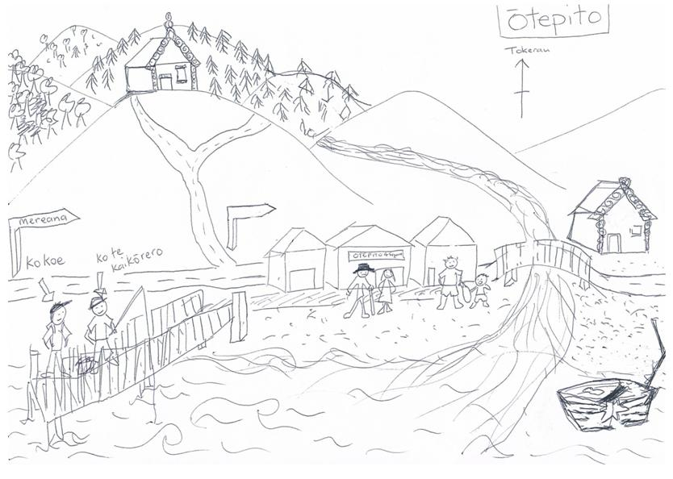

Answer the following questions about the passage in English:
- What is the ‘kāpata kai’ of Ōtepito?
- What are the people of Tāwhiri marae good at?
- When and where (specifically) should you gather pipi?
- What might happen if you don’t ask before gathering pipi?
- When should you catch kanae?
- What dangers are mentioned that might be faced when hunting?
- According to the local person, what should you do if you are hungry right now, and Why? (Be as specific and detailed as possible.)

Part 2: Tāmā Tū, Tama Ora
Listen to the assessor/educator’s instructions and make detailed notes about Wiremu and Mikaere’s days. Include any and all information given about:
- where they went
- what they liked and why (if mentioned)
- what they didn’t like and why (if mentioned)
- what they said about dangers
- what they said about safety
- what they are doing the next day.

Vocational Pathway Assessment Resource
Achievement standard: 91085
Standard title: Whakarongo kia mōhio ki te reo o tōna ao
Level: 1
Credits: 6
Resource title: Tū tonu
Resource reference: Te Reo Māori VP-1.1 v3
Vocational Pathway: Primary Industries
Assessor/Educator guidelines

Introduction
The following guidelines are supplied to enable assessors/educators to carry out valid and consistent assessment using this internal assessment resource.
As with all assessment resources, education providers will need to follow their own quality control processes. Assessors/educators must manage authenticity for any assessment from a public source, because learners may have access to the assessment schedule or exemplar material. Using this assessment resource without modification may mean that learners' work is not authentic. The assessor/educator may need to change figures, measurements or data sources or set a different context or topic. Assessors/educators need to consider the local context in which learning is taking place and its relevance for learners.
Assessors/educators need to be very familiar with the outcome being assessed by the achievement standard. The achievement criteria and the explanatory notes contain information, definitions, and requirements that are crucial when interpreting the standard and assessing learners against it.

Context/setting
This activity requires learners to complete at least two listening tasks over the course of the year to demonstrate comprehensive understanding of spoken te reo Māori from primary industries contexts.

Conditions
This is an individual activity.
Responses need to be in English.

Resource requirements

Part 1: Te Kāpata Kai

Context/setting
This activity requires learners to listen to a passage in which a local person describes the best places to gather kai in the region, mark the locations and features on a map, and answer questions related to the passage. It is preferable that the passage is pre-recorded.
Read the following to the learners:
In front of you is a map of a fictional area. You will hear a description of the local area, people and kai. There are three tasks:
- draw the kai that is described in the correct places on your map
- write in the names of people and buildings that are given in the correct place on your map
- answer the seven questions on your response sheet in English.
You will hear the passage three times. The first time, you will hear it without pausing. The second time, there will be a one minute pause between 5 sections. Finally, you will hear the passage again without pauses. You will then have two minutes to check what you have done and add or change details.
Note: If you prefer you may write the name of the kai next to your drawing. You will not be assessed on the quality of your drawing.
Script:
Tēnā koe. Āe, he maha ngā kai reka ki Ōtepito. Ki ngā tūpuna, ko Ōtepito, arā, ngā puke, ngā maunga, te awa me te moana nei, te kāpata kai o te iwi. E rua ngā marae o tēnei rohe: ko tērā ki te tihi o te maunga, ko Ohorerenui marae tōna ingoa, ā, ko tērā atu ki te taha moana, ko Tāwhiri.
He tohunga te haukāinga o Tāwhiri marae ki te hī ika me te kohi mātaitai. Ko te wāhi pai rawa mō te kohi pipi ko te oneone kei mua tonu i te marae, ki tua atu i te poti pakaru i te wā kua timu te tai. Engari, me pātai atu koe ki te kaumātua rā, e tū ana kei waho i te toa i mua i tō mahi kohikohi, kia kaua ia e whai atu i a koe me tana tokotoko. Ko Matua Hāmi taua kaumātua.
Nā, e rua ngā momo ika pai hei hīnga ki konei, ki te wāpu nei, arā, ko te tāmure me te kahawai. Engari, mō te ika kanae, haere kē ki te ngutuawa e rere hāngai ana ki te marae o Tāwhiri i te wā kua tata pari te tai.
Ehara te mea ko te wai anake te kāpata kai o tēnei rohe, kei ngā puke me ngā maunga hoki ngā kai huhua, pērā i ngā poaka puihi me ngā tia. E noho ana ngā poaka ki te ngahere ki te taha hauāuru o Ohorerenui, kei roto hoki i te wao paina i te puke kei muri i a Ōtepito. E kitea ana ngā tia ki te puke tawhiti anake. Kia tūpato i te wā e whakangau poaka ana, he nunui ētahi, he riri hoki aua poaka, ā, ki te haere koe ki te wao paina i tēnei wā he āhua mōrearea nā te topetopenga o ngā rākau.
Tērā pea e whakaaro ana koe he uaua rawa te tiki kai mā te puku hiakai i tēnei wāhi, engari, kaua e āwangawanga, ki te hiakai koe ināia tonu nei, me haere ki te wharekai o Hōhepa Tau, ki te kokonga o te ara o Tūī me Mereana. Te mutunga mai o ngā maramara rīwai wera me te ika tāmure i te kiri parāoa ki reira. Engari, ko te mea pai rawa atu, nō konei ngā kai whakauru katoa. Kātahi anō te toa ka hūaki mō te rā, ki te mea atu koe ki a Hōhepa, nāku, nā Pita koe i tono atu ki tōna toa, iti iho te utu, nui ake te rahi āu kai hoki! Kia pai tō rā!

Part 2: Tama Tū, Tama Ora

Context/setting
This activity requires learners to listen to a conversation between two people who are returning by bus from a work experience day. It is recommended that you pre-record the dialogue of two people with distinct voices, and then play it for your learners to listen to.
The learners need to record as much of the information from the conversation as possible (two copies per learner - one to be marked final).
Read the following to the learners:
I’m going to play you a recording in which Wiremu and Mikaere meet and talk about their work experience days at different places.
- You are to listen and record the information required in the questions provided. You will respond in English.
- I’ll play the recording three times.
- For the second reading there will be a 30 second pause between sections.
- After playing the third reading, you will have five minutes to finish completing the responses.
- If you wish you can re-write your notes. Make sure you write final copy at the top of the sheet you want to be assessed.
Script:
Wiremu: Kia ora e hoa, ko Wiremu tōku ingoa. I mahi koe i hea i tēnei rā?
Mikaere: Kia ora, ko Mikaere ahau. I haere au ki tētahi pāmu hīpi. I haere koe ki hea?
Wiremu: I haere au ki te wao paina hei tope rākau. I pēhea tō rā?
Mikaere: He rawe. He nui ngā mahi rerekē. He whakaneke kararehe, he whāngai kararehe, he hanga taiapa, he whakatika pūrere pāmu, te aha, te aha.
Wiremu: Āe rā! He nui te mahi ki tētahi pāmu!
Mikaere: Āe. He pai ki a au te mahi haere ki wīwī, haere ki wāwā, kāore au e pai ki te noho ki rō whare i ngā wā katoa. I pai ki a koe te mahi tope rākau?
Wiremu: Āe. I te tīmatanga he āhua hōhā nō te mea he tino tawhiti te roa ki te wao paina, ā, kāore te taraiwa me ngā kaimahi i kōrero mai ki a au.
Mikaere: Nē rā? Pakaru mai te haunga!
Wiremu: Ha, ha. Engari, i te taenga atu, tērā ētahi atu kaimahi, ā, i kite au i tōku kaihana, a Henare. Kāore au i te paku mōhio i te mahi ia ki reira! Ka nui te koa. Nāna ahau i arataki mō te rā.
Mikaere: Ka pai. I pēhea te mahi?
Wiremu: Ko te mea whakamīharo rawa ko ngā mīhini. Rite tonu ngā rākau tino teitei ki ngā peka iti i te waha o ēra mihini kaitā. Koinā te take e pīrangi ana au kia mahi hei kaitope rākau, kia whakahaere i ngā mihini nunui!
Mikaere: Ki a au nei, he āhua mōrearea rawa te mahi tope rākau.
Wiremu: Āe, tika tāu. I mate tētahi o ngā kaimahi i tēra tau. I hē te hinga o te rākau, ā, ka taka ki runga i a ia.
Mikaere: Taukuri e! Engari kei te hiahia tonu koe ki te mahi i taua momo mahi?
Wiremu: Āe, ko te tikanga, me whai ngā ture haumaru nē. Whakamaua tō pōtae mārō me ngā kākahu haumaru. Kia koi tō hinengaro, mōhio ki te wāhi me te mahi, me kōrero hoki ki ō hoa mahi i ngā wā katoa. He mea mōrearea ki te pāmu?
Mikaere: Āe, i ētahi wā ka tahuri ngā paika wīrawhā me ngā tarakihana. He mōrearea ngā paitini, he mōrearea hoki ētahi o ngā kararehe nunui, pērā i ngā pūru. Engari, ka tautoko au ki tō kōrero, ki te mōhio koe ki te mahi me ngā tikanga haumaru, he pai tonu. Kei te pīrangi koe ki te hoki ki te wao āpōpō?
Wiremu: Engari tonu! Kua mea mai tōku kaihana ka whakaaetia au ki te whakahaere i te mīhini tope rākau i te ata. Ka aha koe?
Mikaere: Ki tōku mōhio, ka rere au mā runga waka toparere kia kite i tētahi roto i ngā maunga teitei kia kite ai te kaipāmu mehemea he hōhonu tonu te wai, nō te mea, kua ititi rawa te hekenga ua i te raumati.
Wiremu: Ka rawe! Kia pai tō rā, engari, ka kite anō tāua i a tāua i te ata nē? Kei te haere anō koe mā runga pahi?
Mikaere: Āe, hei konei rā

Additional information
This assessment resource contains assessor transcripts of the listening tasks, unless modified learners work may not be authentic.
Learner response sheets for the listening tasks in this resource will require formatting for learner use.
Each task will require the development of evidence statements.
Formative feedback may be provided after each individual task. Final grades will be decided using professional judgement based on an examination of the evidence provided by the three listening tasks against the criteria in the Achievement Standard.

Assessment schedule: Te Reo Māori 91085 – Tū tonu
Evidence/Judgements for Achievement | Evidence/Judgements for Achievement with Merit | Evidence/Judgements for Achievement with Excellence
Whakarongo kia mōhio ki te reo o tōna ao.  The learner demonstrates their knowledge of spoken te reo Māori by:  - providing two pieces of evidence of their listening skills in te reo Māori  - showing a basic understanding/being able to make meaning of the text  - understanding the gist of the text without being able to develop explanatory responses/answers or giving fine details  - giving some valid information/details  For example, for Tama Tū, Tama Ora:  Mikaere thought the day on a sheep farm was great. They did lots of things, feeding the sheep, and building fences. He doesn’t like being inside.  The above expected learner responses are indicative only and relate to just part of what is required. Each task will require the development of evidence statements for each level of achievement. | Whakarongo kia mārama ki te reo o tōna ao.  The learner demonstrates their understanding of spoken te reo Māori by:  - providing two pieces of evidence of their listening skills in te reo Māori  - selecting relevant information, ideas and opinions from the text and communicating them unambiguously  - developing an explanatory response/answer without indicating a grasp of fine detail and/or nuance  - giving a range of valid information/details  For example, for Tama Tū, Tama Ora:  Mikaere thought the day was great. They did lots of different things on the sheep farm such as moving the animals, feeding them, building fences. He likes to do different things.  The above expected learner responses are indicative only and relate to just part of what is required. Each task will require the development of evidence statements for each level of achievement. | Whakarongo kia mātau ki te reo o tōna ao.  The learner demonstrates their comprehensive understanding of spoken te reo Māori by:  - providing pieces of evidence of their listening skills in te reo Māori  - selecting and expanding on relevant information, ideas and opinions from the text, with supporting evidence or detail  - showing comprehensive understanding of possible implied meanings or conclusions within the text  - giving a fully explained and detailed response/answer  For example, for Tama Tū, Tama Ora:  Mikaere thought the day was great. There were lots of different things to do such as moving the animals, feeding them, building fencing, repairing farm machinery etc. etc. He likes doing jobs that require moving about a lot as he doesn’t like spending all day inside.  The above expected learner responses are indicative only and relate to just part of what is required. Each task will require the development of evidence statements for each level of achievement.
Final grades will be decided using professional judgement based on an examination of the evidence provided against the criteria in the Achievement Standard. Judgements should be holistic, rather than based on a checklist approach.

