**NZQA**

**Approved**

Achievement standard: 91030 Version 3

Standard title: Apply measurement in solving problems

Level: 1

Credits: 3

Resource title: Hair today and gone tomorrow

Resource reference: Mathematics and Statistics VP-1.5 v2

Vocational pathway: Services Industries

|  |  |
| --- | --- |
| Date version published | February 2015 Version 2  To support internal assessment from 2015 |
| Quality assurance status | These materials have been quality assured by NZQA.  NZQA Approved number A-A-02-2015-91030-02-7269 |
| Authenticity of evidence | Assessors/educators must manage authenticity for any assessment from a public source, because learners may have access to the assessment schedule or exemplar material.  Using this assessment resource without modification may mean that learners’ work is not authentic. Assessors/ educators may need to change figures, measurements or data sources or set a different context or topic to be investigated or a different text to read or perform. |

Vocational Pathway Assessment Resource

Achievement standard: 91030

Standard title: Apply measurement in solving problems

Level: 1

Credits: 3

Resource title: Hair today and gone tomorrow

Resource reference: Mathematics and Statistics VP-1.5 v2

Vocational pathway: Services Industries

Learner instructions

# Introduction

This assessment activity requires you to apply measurement in solving problems while improving the presentation of hotel bathroom products.

You are going to be assessed on how you apply measurement, using extended abstract thinking, to improve the presentation of hotel bathroom products. You are required to communicate your solutions clearly and accurately.

The following instructions provide you with a way to structure your work so you can demonstrate what you have learnt and achieve success in this standard.

Assessor/educator note: It is expected that the assessor/educator will read the learner instructions and modify them if necessary to suit their learners.

# Task

The Myatt Hotel is going to improve the presentation of their guest bathroom products. Each room currently has three bottles; one each of shampoo, conditioner and body wash.

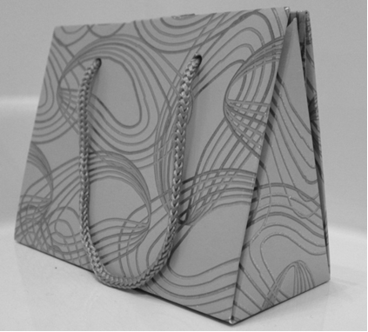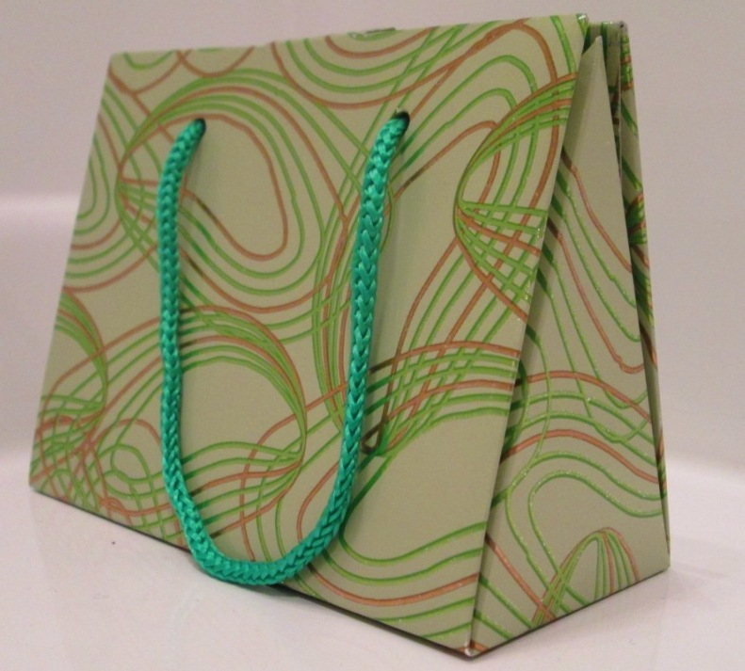The new bathroom products will be packaged in a presentation bag similar to the one in the photograph.

The bottles need to fit in the presentation bag with a minimum of wasted space and meet the following criteria:

* the bag’s rectangular base must not take up more than 55 cm2 on the bathroom vanity, but there are no restrictions on the bag’s height
* there will still be three bottles in the presentation bag
* the new bottles for the bathroom products each need to contain 50 mL of product.

The hotel has narrowed their choice of design for the new bottles to the three shown below:

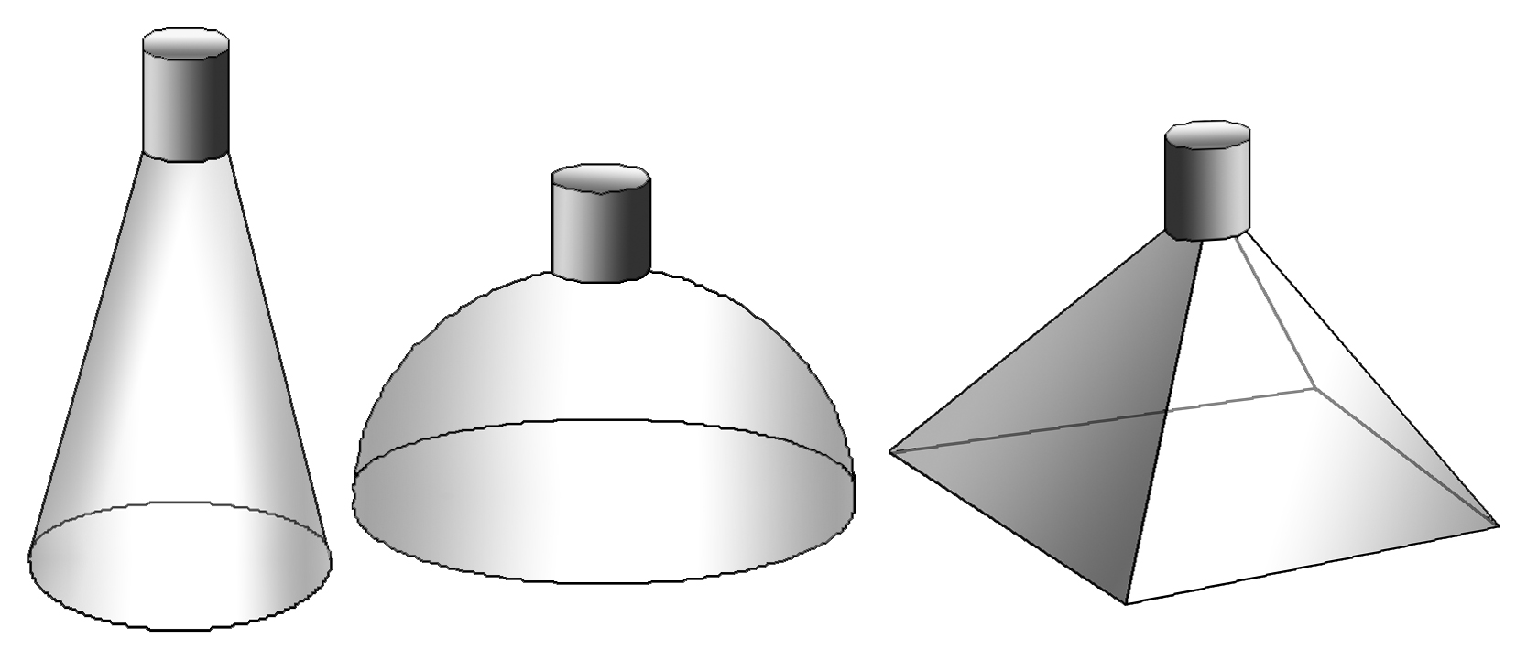

Your task is to compare the three designs and make a recommendation to the hotel about which one they should choose.

You need to consider the possible dimensions for both the new bottles and the new presentation bag.

Show all calculations that you have used and clearly communicate your method using appropriate mathematical statements. Identify any assumptions you need to make and discuss how they might affect your calculations and your final recommendation to the hotel.

## Formulae sheet

Area of circle = 

Circumference of circle = 

Area of trapezium = 

Area of parallelogram = 

Area of triangle = 

Volume of prism = base area × *h*

Volume of pyramid =  × base area × *h*

Volume of cylinder = 

Volume of cone = 

Volume of sphere =

Vocational Pathway Assessment Resource

Achievement standard: 91030

Standard title: Apply measurement in solving problems

Level: 1

Credits: 3

Resource title: Hair today and gone tomorrow

Resource reference: Mathematics and Statistics VP-1.5 v2

Vocational pathway: Services Industries

Assessor/Educator guidelines

# Introduction

The following guidelines are supplied to enable assessors/educators to carry out valid and consistent assessment using this internal assessment resource.

As with all assessment resources, education providers will need to follow their own quality control processes. Assessors/educators must manage authenticity for any assessment from a public source, because learners may have access to the assessment schedule or exemplar material. Using this assessment resource without modification may mean that learners' work is not authentic. The assessor/educator may need to change figures, measurements or data sources or set a different context or topic. Assessors/educators need to consider the local context in which learning is taking place and its relevance for learners.

Assessors/educators need to be very familiar with the outcome being assessed by the achievement standard. The achievement criteria and the explanatory notes contain information, definitions, and requirements that are crucial when interpreting the standard and assessing learners against it.

# Context/setting

This activity requires learners to apply measurement, using extended abstract thinking, to improve the presentation of three hotel bathroom products. Calculations include finding the volume of the bottles, using area techniques to find the dimensions of the bottles, establishing that three bottles will fit in the given base area of the bag and the conversion of units for volume.

# Conditions

Learners need to work independently and may use any appropriate technology.

# Resource requirements

Provide learners with a sheet of formulae.

# Additional information

Taking measurements is not a requirement of the standard. It is acceptable for learners to complete this activity using provided measurements.

Assessors/educators need to ensure learners are familiar with any context specific vocabulary used in this task.

## Other possible contexts for this vocational pathway

The presentation of kitchen products.

# Assessment schedule: Mathematics and Statistics 91030 – Hair today and gone tomorrow

|  |  |  |
| --- | --- | --- |
| Evidence/Judgements for Achievement | Evidence/Judgements for Achievement with Merit | Evidence/Judgements for Achievement with Excellence |
| The learner applies measurement in solving problems by:   * selecting and using a range of methods in solving problems * demonstrating knowledge of measurement concepts and terms * communicating solutions which would usually require only one or two steps   The learner selects and correctly uses at least three different methods when investigating which shape or shapes could be used for the presentation of the bathroom products  For example the learner has:   * determined the dimensions of a bottle and shown that it has the expected capacity of 50 mL * used area techniques to establish that three bottles will fit in a bag with a base area that is less than 55 cm2 * correctly used units in the measurements and calculations at a level of precision appropriate to the task.   The learner has clearly identified what is being calculated.  *The examples above are indicative of the evidence that is required.* | The learner applies measurement, using relational thinking, in solving problems by involving one or more of:   * selecting and carrying out a logical sequence of steps * connecting different concepts and representations * demonstrating understanding of concepts * forming and using a model   and also relating findings to a context, or communicating thinking using appropriate mathematical statements  For example:  The learner has investigated different shapes for the bottles and they have used area techniques to establish that three bottles will fit in a bag with a base area that is less than 55 cm2. They have determined the dimensions of the bottles for the given volume and linked these to the height of the bag.  Working is shown and correct units used.  *The examples above are indicative of the evidence that is required.* | The learner applies measurement, using extended abstract thinking, in solving problems by involving one or more of:   * devising a strategy to investigate or solve a problem * identifying relevant concepts in context * developing a chain of logical reasoning, or proof * forming a generalisation   and also using correct mathematical statements, or communicating mathematical insight  For example:  The learner has made appropriate volume calculations for all three bottles, determining the dimensions of the bottles and proving that they have a capacity of 50 mL. They have proved that the three containers will fit neatly with respect to the base of the bag (with a minimum of space wasted). The learner has also clearly established an appropriate height for the bag so that the bottles fit neatly into it (e.g. realising that the sides of the bag will slope up). The learner has made at least one relevant assumption and has linked this to the accuracy of the calculations and final recommendation.  The strategy used is clear, working and units are shown and reasoning is clearly communicated.  *The examples above are indicative of the evidence that is required.* |

Final grades will be decided using professional judgement based on an examination of the evidence provided against the criteria in the Achievement Standard. Judgements should be holistic, rather than based on a checklist approach.