NZQA
Approved

Achievement standard: 91034 Version 3
Standard title: Apply transformation geometry in solving problems
Level: 1
Credits: 2
Resource title: Poppy’s boxes
Resource reference: Mathematics and Statistics VP-1.9 v2
Vocational pathway: Services Industries

Date version published | February 2015 Version 2  To support internal assessment from 2015
Quality assurance status | These materials have been quality assured by NZQA.  NZQA Approved number A-A-02-2015-91034-02-7276
Authenticity of evidence | Assessors/educators must manage authenticity for any assessment from a public source, because learners may have access to the assessment schedule or exemplar material.  Using this assessment resource without modification may mean that learners’ work is not authentic. Assessors/ educators may need to change figures, measurements or data sources or set a different context or topic to be investigated or a different text to read or perform.

Vocational Pathway Assessment Resource
Achievement standard: 91034
Standard title: Apply transformation geometry in solving problems
Level: 1
Credits: 2
Resource title: Poppy’s boxes
Resource reference: Mathematics and Statistics VP-1.9 v2
Vocational pathway: Services Industries
Learner instructions

Introduction
This assessment activity requires you to apply transformation geometry to design the labelling for a box.
You are going to be assessed on how you use extended abstract thinking to apply transformation geometry in the design and placement of labelling on the faces of a box. Use correct mathematical statements and clearly communicate your thinking about the transformations used in the design of the labelling for the box.
The following instructions provide you with a way to structure your work to demonstrate what you have learnt and to allow you to achieve success in this standard.
Assessor/educator note: It is expected that the assessor/educator will read the learner instructions and modify them if necessary to suit their learners.

Task
Poppy uses boxes to store some of the things she makes and sells. She needs the labelling on the boxes to be positioned in such a way that her logo and the product name will always be the right way up, no matter how she places the box in her display.
In this activity you will design the labelling for a box and describe the placement of the labelling on the different faces of the box. The labelling needs to include a logo and product name.
In her displays, Poppy wants to be able to stand the box up, lie it down and also place it so only the end is visible. Different views of the box with the labelling the right way up are shown in Resource A.
Poppy has decided to use cuboid-shaped boxes for her products. The net of one of her boxes is provided in Resource B.
It is not essential that all faces of the box have both the logo and product name, for example Poppy could decide to just have the product name on a face. Poppy might also want to use one of the larger faces of the box for detailed information about the contents so this face will not include the logo or product name.
Working independently you should:
- design a logo for Poppy using transformation geometry. Write instructions to create the logo and describe any symmetries and invariance in the logo. Your instructions need to include descriptions of the transformations that have been used and enable your design to be reproduced accurately
- draw the logo and show the product name on the net in the Resource sheet. You need to indicate what is on all faces of the net so that when the net is folded to make the box the labelling will be the right way up
- fully describe the placement of the logo and product name on the faces of the net. Include descriptions of the transformations that have been used and explain how to change from one view of the box to another.

Resources

Resource A
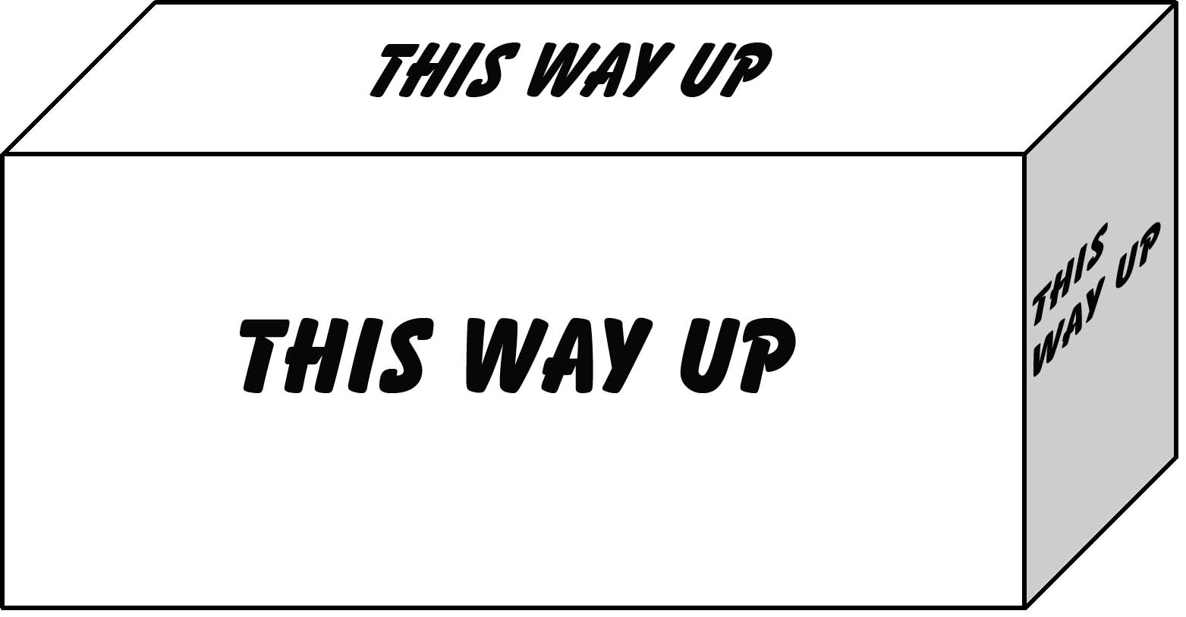

Resource B

Vocational Pathway Assessment Resource
Achievement standard: 91034
Standard title: Apply transformation geometry in solving problems
Level: 1
Credits: 2
Resource title: Poppy’s boxes
Resource reference: Mathematics and Statistics VP-1.9 v2
Vocational pathway: Services Industries
Assessor/Educator guidelines

Introduction
The following guidelines are supplied to enable assessors/educators to carry out valid and consistent assessment using this internal assessment resource.
As with all assessment resources, education providers will need to follow their own quality control processes. Assessors/educators must manage authenticity for any assessment from a public source, because learners may have access to the assessment schedule or exemplar material. Using this assessment resource without modification may mean that learners' work is not authentic. The assessor/educator may need to change figures, measurements or data sources or set a different context or topic. Assessors/educators need to consider the local context in which learning is taking place and its relevance for learners.
Assessors/educators need to be very familiar with the outcome being assessed by the achievement standard. The achievement criteria and the explanatory notes contain information, definitions, and requirements that are crucial when interpreting the standard and assessing learners against it.

Context/setting
This activity requires learners to apply transformation geometry, using extended abstract thinking, to design the labelling on a box.

Conditions
Learners will work independently on the activity.
Learners are expected to have access to appropriate technology.

Resource requirements
Provide learners with a copy of Resource A and Resource B.
Learners need access to appropriate technology.

Additional information
Ensure learners are familiar with any context specific vocabulary used in this resource.

Assessment schedule: Mathematics and Statistics 91034 – Poppy’s boxes
Evidence/Judgements for Achievement | Evidence/Judgements for Achievement with Merit | Evidence/Judgements for Achievement with Excellence
The learner applies transformation geometry in solving problems by:  - selecting and using a range of methods in solving problems  - demonstrating knowledge of geometrical concepts and terms  - communicating solutions using geometrical terms or representations  For example:  The learner uses at least three different methods, which are correctly identified in the logo for the box and/or the placement of the logo and product name on the faces of the cuboid.  The methods that could provide evidence are:  - reflection  - rotation  - translation  - enlargement  - symmetry.  The examples above are indicative of the evidence that is required. | The learner applies transformation geometry, using relational thinking, in solving problems by involving one or more of:  - selecting and carrying out a logical sequence of steps  - connecting different concepts and representations  - demonstrating understanding of concepts  - forming and using a model  and also relating findings to a context, or communicating thinking using appropriate mathematical statements  For example:  The learner describes the transformations used to create the logo with the appropriate detail for the transformations to be positioned correctly and has described any symmetries in the completed design. The learner has considered the positioning of the logo and labelling on the faces of the box.  The examples above are indicative of the evidence that is required. | The learner applies transformation geometry, using extended abstract thinking, in solving problems by involving one or more of:  - devising a strategy to investigate a situation  - identifying relevant concepts in context  - developing a chain of logical reasoning, or proof  - forming a generalisation  and also using correct mathematical statements, or communicating mathematical insight  For example:  The learner correctly positions the logo and/or product name on the faces of the net so they are the right way up for the different possible orientations of the box in the display. The learner accurately describes the transformations used to create the logo design and positions the logo and product name on the faces of the net. The folded net is appropriate for the purpose.  The learner may choose to have a face or faces with specific product detail, directions, ingredients, etc., rather than just the logo and/or product name. The face or faces they choose for this need to be the ‘underside’ or the ‘backside’ in the display.  The examples above are indicative of the evidence that is required.
Final grades will be decided using professional judgement based on an examination of the evidence provided against the criteria in the Achievement Standard. Judgements need to be holistic, rather than based on a checklist approach.

