NZQA
Approved

Achievement standard: 91101 Version 2
Standard title: Produce a selection of crafted and controlled writing
Level: 2
Credits: 6
Resource title: Promotions and objections
Resource reference: English VP-2.4 v2
Vocational pathway: Services Industries

Date version published | February 2015 Version 2  To support internal assessment from 2015
Quality assurance status | These materials have been quality assured by NZQA.  NZQA Approved number A-A-02-2015-91101-02-8157
Authenticity of evidence | Assessors/educators must manage authenticity for any assessment from a public source, because learners may have access to the assessment schedule or exemplar material.  Using this assessment resource without modification may mean that learners’ work is not authentic. Assessors/ educators may need to change figures, measurements or data sources or set a different context or topic to be investigated or a different text to read or perform.

Vocational Pathway Assessment Resource
Achievement standard: 91101
Standard title: Produce a selection of crafted and controlled writing
Level: 2
Credits: 6
Resource title: Promotions and objections
Resource reference: English VP-2.4 v2
Vocational pathway: Services Industries
Learner instructions

Introduction
This assessment activity requires you to produce two pieces of crafted and controlled writing that develop, sustain and structure ideas related to the tourism industry. In these pieces you will use language features appropriate to audience and purpose to create effects.
You are going to be assessed on how effectively you develop, sustain and structure ideas related to tourism industries in both pieces of writing, using language features appropriate to audience and purpose to command attention.
The following instructions provide you with a way to structure your work so you can demonstrate what you have learnt and achieve success in this standard.
Assessor/educator note: It is expected that the assessor/educator will read the learner instructions and modify them if necessary to suit their learners.

Task
Promoting the product is a big part of the tourism industry. A lot of time and money is spent on this aspect of the industry. For your first piece of writing, promote a tourism operation of your choice. This is for a local tourism webpage. Ensure your style of writing is carefully crafted to capture the target audience and convince them to buy or invest.
Another significant part of the tourism industry is dealing with resource consents. Sometimes a tourism operator needs to get permission for a new operation, or sometimes they need to object to a new development that threatens their livelihood. For your second piece of writing, write a submission to the council objecting to, or supporting, a planned development.
Part 1: Promotional text for a tourism operation
Produce your promotional writing for a tourism website by doing the following:
- Identify a tourism operation that interests you. It could include adventure activities such as bungee jumping, jet boating, scuba diving or hospitality activities such as promoting a new hotel, resort, or thermal pools, spa treatment, etc.
- gather information about this tourism operation. This could include the business’ own promotional materials, interviews with the operator, employees, or customers, and books, magazines, and internet information about the business in general
- clearly identify:
  - the nature of the product or service (basic facts, contact details, pricing, etc.)
  - who the target audience is
  - why this operation is unique and special (this is the most important part).
- make a mind-map of all the main ideas (see Resource A for an example)
  - arrange your ideas in different orders, and think about which information should come first
  - look for interesting or unexpected ways to support your ideas
  - think of a strong ‘hook’ to begin with, and an unexpected ‘sting’ to finish with
  - try to include some interesting language features such as rhyming or alliteration. Use adjectives to enhance the effectiveness of the message, for example don’t just say ‘sunshine’ but ‘golden sunshine that warms your heart’. Your message needs to be very clear. It may be useful to start and finish with the core message
  - link all your evidence to the central idea.
- organise and structure your ideas and gathered evidence. Choose a particular approach, and then build a sustained and convincing argument to promote your chosen tourism operation
  - explain the main features and benefits of the operation, then develop, sustain and structure your ideas to convince people to experience it
  - support your reasoning with evidence. The most compelling arguments are supported by a range of different perspectives. For example it is not enough just to say that ‘Skiing is fun’. You need to build on this point, such as ‘Skiing is a great activity because you meet new people and get away from the stresses and strains of everyday life’. Then you could connect this to evidence, such as ‘Last year there were 2 weddings resulting from four of our clients meeting on our ski runs’.
- use your planning to construct your first draft, and swap it with another learner. Comment about each other’s work including:
  - what do you like most?
  - how could they improve the message?
  - what else could they include?
- review and revise your draft
- produce your first piece of writing:
  - use at least 500 words
  - check that your piece of writing develops, sustains, and structures ideas appropriately for the text type, makes connections between ideas, and uses language features that are appropriate to the audience and purpose to command attention
  - make sure your spelling, grammar and punctuation are all correct.

Part 2: Submission to the council objecting to or supporting a planned development
Produce your submission by doing the following:
- identify a project that an entrepreneur is planning, and how it will seriously affect or enhance your business. Talk to your assessor/educator, family and friends to identify a suitable project for this purpose. For example it could be:
  - a dam that will ruin the river your jet-boat business relies on, or provides a reservoir for recreational boating
  - privatising, for example owners wanting to prevent your access or to charge you for access to coast, lakes or rivers, or opening up access to new areas
  - farms or factories spoiling water quality for trout fishing or kayaking, or a reserve area that will enhance marine life.
- gather a variety of evidence about your chosen project
  - identify the nature of the development, and how it will adversely affect or enhance your business (you need evidence and examples)
  - find evidence of similar projects in other regions – what effect did these projects have in the long term?
  - sources of information may include the promotional materials, scientific reports, and interviews with the operator, employees, or customers, and books, magazines, and internet information about the business in general.
- plan your submission report to the council objecting to or supporting the proposed development, and include:
  - why it should be stopped or supported
  - counter arguments, alternative solutions or suggest modifications.
- make a mind-map of all the main ideas
  - think about which information should come first
  - look for convincing ways to support your ideas.
- establish your standing and credentials, including what qualifications, business experience, and commitment to the region you can give to add weight to your argument. For this part, imagine that you are a tourism operator:
  - find clear and compelling reasons to object or support the proposed development. For example a strong argument will be that the development will be bad for the whole region, not just for your business
  - a convincing argument will go beyond ‘It will damage my business’. You might explain how the damage will occur and why your business is more important for the region than the proposed development. If on the other hand you support the new development, clearly explain in terms of your business, how it will improve it. Try to put a number on the amount of extra money it will bring in to your business
  - talk about the wider consequences of how other businesses and the region will benefit too, saying how and how much.
- use your planning to construct your first draft and swap it with another learner. Comment about each other’s work, including:
  - what do you like most?
  - how could they improve the message?
  - what else could they include?
- review and revise your draft
- produce your second piece of writing:
  - use at least 500 words
  - check that your piece of writing develops, sustains, and structures effective ideas appropriately for the text type, makes connections between ideas, and uses language features that are appropriate to the audience and purpose to command attention
  - make sure your spelling, grammar and punctuation are all correct.

Resource A
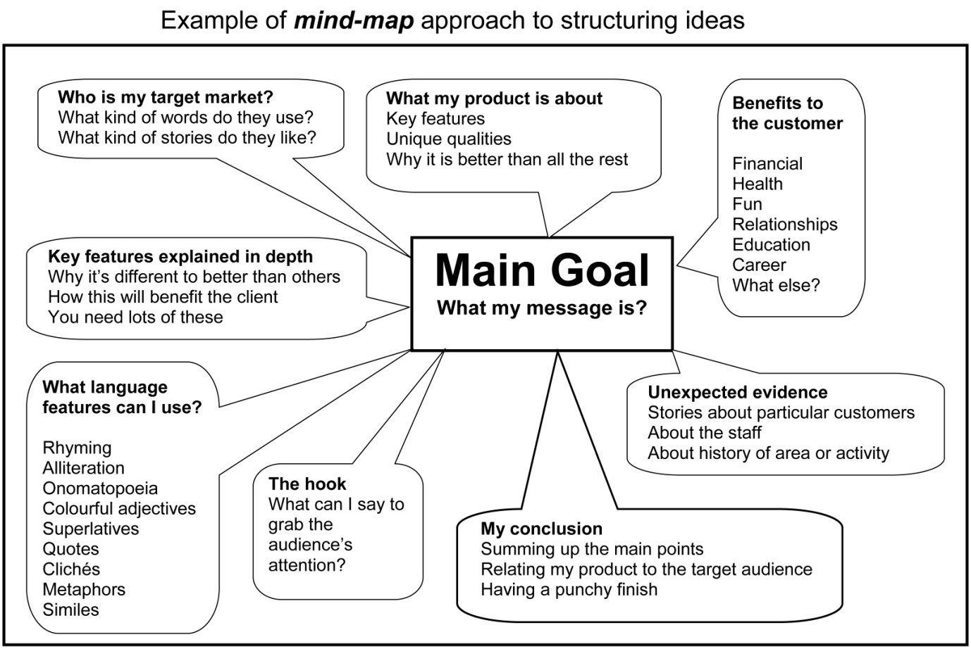

Vocational Pathway Assessment Resource
Achievement standard: 91101
Standard title: Produce a selection of crafted and controlled writing
Level: 2
Credits: 6
Resource title: Promotions and objections
Resource reference: English VP-2.4 v2
Vocational pathway: Services Industries
Assessor/Educator guidelines

Introduction
The following guidelines are supplied to enable assessors/educators to carry out valid and consistent assessment using this internal assessment resource.
As with all assessment resources, education providers will need to follow their own quality control processes. Assessors/educators must manage authenticity for any assessment from a public source, because learners may have access to the assessment schedule or exemplar material. Using this assessment resource without modification may mean that learners' work is not authentic. The assessor/educator may need to change figures, measurements or data sources or set a different context or topic. Assessors/educators need to consider the local context in which learning is taking place and its relevance for learners.
Assessors/educators need to be very familiar with the outcome being assessed by the achievement standard. The achievement criteria and the explanatory notes contain information, definitions, and requirements that are crucial when interpreting the standard and assessing learners against it.

Context/setting
This assessment activity requires learners to produce two pieces of crafted and controlled writing related to a tourism operation of their choice. Learners will develop, sustain and structure effective ideas in writing for a web page and submission report. Both pieces will use language features, appropriate to this audience and purpose, to command attention.

Conditions
Learners should have the opportunity to receive feedback, edit, revise, and polish their work before submitting their final work.
Writing should not be treated as one or two short assessment events. Instead, programme design should ensure that a learner’s writing is developed over the year, and then their best is submitted for summative assessment.
The assessor/educator can validly make suggestions about areas where further development is needed, guide learners through the writing process, and might demonstrate how the techniques used in samples and exemplars can be applied to the learner’s own writing.

Resource requirements
Learners may need access to:
- regional tourism organisation, identifiable on http://www.newzealand.com/travel/trade/marketing-toolbox/industry-directory/rto-index/rto-index_home.cfm
- local tourism industry operations
- appropriate books and magazines
- the internet.

Additional information
Useful websites relating to the tourism industry include:
http://www.newzealand.com/travel/media/press-releases/list-of-press-releases.cfm
http://www.tourismnewzealand.com/news-and-features/
http://www.aa.co.nz/about/newsroom/media-releases/tourism/
http://www.tianz.org.nz/main/tia-news-releases/
http://www.howtolaw.co.nz/oppose-the-granting-of-a-resource-consent-xidp392133.html

Assessment schedule: English 91101 – Promotions and objections
Evidence/Judgements for Achievement | Evidence/Judgements for Achievement with Merit | Evidence/Judgements for Achievement with Excellence
The learner produces two pieces of crafted and controlled writing which develop, sustain, and structure ideas, using language features appropriate to audience and purpose to create effects by:  - building on ideas adding comments, explanations, details or examples appropriate to the selected text type and audience  - making connections between ideas throughout the writing  - deliberately using language features appropriate to the selected text type and purpose to create meaning and effects  - using text conventions accurately so that the writing contains only minor errors  For example, in the promotional writing the learner:  - uses language structures and vocabulary appropriate for an identified target audience. It’s the awe at being 8 metres above the ground, while knowing you’re secure thanks to the double carabineer system, that makes ‘Tarzan’s Toyland’ a must.  - outlines and builds on ideas about the benefits of the product service which may include financial, status, entertainment, education or health. A day at ‘Tarzan’s Toyland’ is affordable for the whole family. With short courses starting at $15 per adult it’s cheaper (and healthier) than going to the movies…  The above expected learner responses’ are indicative only and relate to just part of what is required. | The learner produces two pieces of crafted and controlled writing which develop, sustain, and structure ideas convincingly, using language features appropriate to audience and purpose to create convincing effects by:  - building on ideas, adding comments, explanations, details, or examples appropriate to the selected text type and audience  - making connections between ideas throughout the writing  - developing ideas and structure that are reasoned, clear, and relevant to the purpose of the text  - deliberately using language features appropriate to the selected text type and purpose to create meaning, effects, and audience interest  - using text conventions accurately so that the writing contains only minor errors  For example, in the promotional writing the learner:  - uses a variety of language structures and effective vocabulary to enhance the promotional message related to target audience. Awesome! At ‘Tarzan’s Toyland’ you’ll find yourself high up in the forest canopy, amazed at the birdseye view. You’ll be secure thanks to the double carabineer system that holds you tight, no matter whether you’re 8 centimetres or 8 metres above the forest floor.  - makes direct and convincing links between the specific features of the product and/or service and interests of the target audience. ‘Tarzan’s Toyland’: fun, excitement and challenges for everyone, no matter what age or fitness level. It’s a whole family experience, with prices starting at just $15. Less than a couple of hours at the movies and far more fun.  The above expected learner responses are indicative only and relate to just part of what is required. | The learner produces two pieces of crafted and controlled writing which develop, sustain, and structure ideas effectively, using language features appropriate to audience and purpose to command attention by:  - building on ideas, adding comments, explanations, details, or examples appropriate to the selected text type and audience  - making connections between ideas throughout the writing  - using ideas and structure to create texts that are compelling, persuasive, innovative, and/or striking  - deliberately and consistently using inventive or articulate language features, vocabulary selection, distinctive personal voice, dimensions or viewpoints to create meaning, effects, and audience engagement  - using text conventions accurately so that the writing contains only minor errors  For example, the learner uses:  - innovative structures and a targeted evocative vocabulary to enhance engagement and desire to participate in the product or service; language structures and vocabulary always matched to target audience. Climbing trees was a part of most kiwi’s childhood. But we grew up and the world changed around us. At ‘Tarzan’s Toyland’ you can relive that excitement and happiness of yesteryear…  - wide evidence and well-structured arguments to generate a compelling case for the product/service; the promotional message is innovative and persuasive. ‘Tarzan’s Toyland’ is a place the whole family can get their thrills. For less than the price of a movie pass your kids will be swinging from the trees, rather than just watching them.  The above expected learner responses are indicative only and relate to just part of what is required.
Final grades will be decided using professional judgement based on an examination of the evidence provided against the criteria in the Achievement Standard. Judgements should be holistic, rather than based on a checklist approach.

