Internal Assessment Resource
Economics Level 2

This resource supports assessment against:
Achievement Standard 91227 version 2
Analyse how government policies and contemporary economic issues interact
Resource title: When Jupiter Aligns with Mars
6 credits
This resource:
- Clarifies the requirements of the standard
- Supports good assessment practice
- Should be subjected to the school’s usual assessment quality assurance process
- Should be modified to make the context relevant to students in their school environment and ensure that submitted evidence is authentic

Date version published by Ministry of Education | February 2015 Version 2  To support internal assessment from 2015
Quality assurance status | These materials have been quality assured by NZQA.  NZQA Approved number: A-A-02-2015-91227-02-5486
Authenticity of evidence | Teachers must manage authenticity for any assessment from a public source, because students may have access to the assessment schedule or student exemplar material.  Using this assessment resource without modification may mean that students’ work is not authentic. The teacher may need to change figures, measurements or data sources or set a different context or topic to be investigated or a different text to read or perform.

Internal Assessment Resource
Achievement Standard Economics 91227: Analyse how government policies and contemporary economic issues interact
Resource reference: Economics 2.6A v2
Resource title: When Jupiter Aligns with Mars
Credits: 6
Teacher guidelines
The following guidelines are designed to ensure that teachers can carry out a valid and consistent assessment using this internal assessment resource.
Teachers need to be very familiar with the outcome being assessed by Achievement Standard Economics 91227. The achievement criteria and the explanatory notes contain information, definitions, and requirements that are crucial when interpreting the standard and assessing students against it.
Context/setting
This activity requires students to carry out an economic analysis that presents government policies aimed at lifting the economy out of recession without jeopardising the policy objective of price stability.
It is expected that students will be familiar with economic policies relating to inflation, economic growth, and international trade before using this assessment resource.
Conditions
Teachers will need to determine how long students need to complete each task and what processes they will follow. These will need to be clearly outlined in the student instructions following.
Resource requirements
The students will need to gather secondary material such as photocopies or printouts. They could use text books, material from magazines or newspapers, news stories or reports from the Internet.
Some useful websites are:
- www.rbnz.govt.nz
- www.mfat.govt.nz
- www.med.govt.nz
- www.dol.govt.nz
- http://www.nzherald.co.nz
- www.3news.co.nz/
- www.tvnz.co.nz
- www.interest.co.nz.
Additional information
None.

Internal Assessment Resource
Achievement Standard Economics 91227: Analyse how government policies and contemporary economic issues interact
Resource reference: Economics 2.6A v2
Resource title: When Jupiter Aligns with Mars
Credits: 6
Achievement | Achievement with Merit | Achievement with Excellence
Analyse how government policies and contemporary economic issues interact. | Analyse in depth how government policies and contemporary economic issues interact. | Analyse comprehensively how government policies and contemporary economic issues interact.
Student instructions
Introduction
Policies aimed at maintaining price stability often conflict with policies that are aimed at achieving higher levels of growth and trade. However, during a recession, these policy objectives become aligned as the government and Reserve Bank work together to achieve economic recovery.
This assessment activity requires you to carry out an economic analysis of government policies that could lift the economy out of recession without jeopardising the policy objective of price stability.
You will present the economic analysis in a mode of your choice. Check with your teacher to see if they believe the mode you have chosen is viable.
You will be assessed on the quality of your explanations, and on your justification for the combination of government policies that would achieve price stability and minimise any negative flow-on effects on economic growth and trade.
This is an individual task and you have [insert time] weeks of in and out-of-class time to complete this activity.
Task
Research and analyse government policies.
Include the following elements in your analysis.
- An introduction that describes the objectives of government policy in relation to price stability. This should include key facts that explain how the Reserve Bank operates monetary policy in order to achieve price stability.
- An explanation of why price stability is a desirable objective, including explanations of:
- negative impacts of price inflation on households;
- negative impacts of price Inflation on producers;
- why the government has price stability as an objective, and how it can conflict with employment levels.
- An explanation of the direct impact of current expansionary monetary policy (due to the recession) on price stability, showing the changes this would cause on the AS/AD model and the Foreign Exchange Market model. Then integrate the changes shown on the AS/AD model into explanations of the flow-on effects to economic growth and integrate the changes shown on the FOREX market model into explanations of the flow-on effects to trade.
- An explanation of the direct impact of an alternative government policy(s) (apart from monetary policy) on price stability. You will need to show the changes this would cause using an appropriate economic model and link this into your explanations.
- An explanation of the negative flow-on effects that a tight monetary policy would have on economic growth and trade. Show the changes this would cause on appropriate economic models and link these changes into your explanations.
- Provide two further policies that the government could introduce to minimise the negative flow-on effects that tight monetary policy has on economic growth and trade.

When you have completed your report, hand it in to your teacher.

Assessment schedule: Economics 91227 When Jupiter Aligns with Mars
Evidence/Judgements for Achievement | Evidence/Judgements for Achievement with Merit | Evidence/Judgements for Achievement with Excellence
The student has described current monetary policy and its objectives in terms of the Reserve Bank and operation of the policy.  The student has explained a negative impact of price inflation on both households and producers and linked this to price stability to explain why it is a desirable objective.  The student has identified the use of the OCR to influence interest rates, and explained one mechanism for this to impact on the economy, using the AD/AS model or FOREX market model to support this.  The student has explained the direct impact of the alternative government policy(s) on price stability and used an economic model to support their explanation.  The student has explained the flow-on effects of monetary policy on exports and imports or explained the effect on one of them, and/or they have explained the flow-on effect on the balance of trade. This is supported by their FOREX market model.  The student has explained the flow-on effect of monetary policy on economic growth, and has used the AD/AS model to support their explanation.  For example:  The Reserve Bank Act requires the Reserve Bank to maintain price stability as defined in the PTA at 1-3 over the medium term. They achieve this by influencing interest rates through adjusting the level of the OCR.  - Households that are on a fixed income find that their purchasing power declines as prices rise, making them worse off.  - Producers face more costs resulting from more frequent updating of price lists on websites and catalogues etc. as price levels rise  By keeping the OCR at a low level, interest rates will fall. This will discourage saving and result in increased consumption. Aggregate Demand will increase. This will increase the price level so it does not fall below the 1% threshold. Or lower interest rates will cause the exchange rate to fall. This makes exports more competitive, increasing exports so AD increases. This will increase the price level so it does not fall below the 1% threshold.  See Appendix A for examples of economic models.  Fiscal policy: By adjusting the level of taxes or government spending, the government can influence price levels.  By decreasing the level of tax, disposable incomes of households will increase, resulting in an increased level of consumption. Aggregate Demand will increase. This will increase the price level so it does not fall below the 1% threshold.  See Appendix A for examples of economic models.  Lower interest rates result in a lower exchange rate which will result in exports being more competitive so they will increase. Imports will be less competitive so they will decrease. The balance of trade should improve.  See Appendix A for an example of the FOREX model.  By increasing the OCR, interest rates will rise. This will encourage saving and resulting in a decreased consumption. Aggregate Demand will decrease. Or higher interest rates cause the exchange rate to rise. This makes exports less competitive, decreasing exports so AD decreases. This results in a decrease in Real GDP, decreasing growth. | The student has explained in detail the negative impacts of price inflation on both households and producers and linked this to price stability to explain why it is a desirable objective.  The student has explained in detail how the OCR impacts on interest rates, at least two impacts on AD, one impact on AS, and has used the AD/AS model and the FOREX model to support their explanations.  The student has explained in detail the direct impact of the alternative government policy(s) on price stability and used an economic model to support their explanation.  The student has explained the flow-on effect of the monetary policy on exports and imports. They have explained the flow-on effect on the balance of trade. This is supported by the change shown in their FOREX market model.  The student has explained in detail the flow-on effect of monetary policy on economic growth, and has used the AD/AS model to support their explanation.  For example:  Households that are on a fixed income find that their purchasing power declines as prices rise, making them worse off.  Producers find planning more difficult as prices and costs rise at different rates reducing business confidence.  The government considers price stability desirable due to the negative effects it has on households and companies.  The OCR is the overnight settlement account rate charged by the Reserve Bank to the major trading banks. If this is kept low, the cost for the trading bank credit is low, which allows the trading banks to lower the rates they charge in the public markets. Low interest rates impact on AD because they discourage saving, resulting in increased consumption. The cost of borrowing will also be lower which will encourage increased investment. Lower interest rates cause the exchange rate to fall because there is a decreased level of overseas investment in NZ. This makes exports more competitive. All of this results in an increase in AD. The lower exchange rate makes imported inputs more expensive, increasing costs of production. This will decrease AS. The result of increasing AD and decreasing AS is that the price level will increase so it does not fall below the 1% threshold.  See Appendix A for examples of economic models.  Fiscal policies: By adjusting the level of taxes or government spending, the government can influence price levels.  By decreasing the level of tax, disposable incomes of households will increase resulting in an increased level of consumption. Alternatively, the government could increase spending on infrastructure, resulting in increased revenue for companies contracting to complete this work. Aggregate Demand will increase. This will increase the price level so it does not fall below the 1% threshold.  See Appendix A for examples of economic models.  A news story to support this could be:  Government delivers April 1 tax cuts, SME changes  Sunday, 29 March 2009, 2:11 pm  Press Release: New Zealand Government  The personal tax cuts, which take effect from Wednesday, will boost the income of a worker on the average wage of $48,500 by $18 a week. A range of initiatives making it simpler and less expensive for small and medium sized businesses to pay tax also take effect from this date.  "These changes form a central part of the Government's Jobs and Growth plan and will provide a shot in the arm for our economy at a vital time," Mr English said.  About 1.5 million workers will receive a personal tax cut, injecting an extra $1 billion into the economy in the coming year. The business initiatives are worth $484 million over four years.  "The tax cuts we have delivered will stimulate the economy in the short term by putting cash in people’s pockets, and in the longer term by encouraging people to invest in their own skills to earn and keep more money. They are an important step towards the government's medium-term goal of delivering a tax system that rewards effort and provides better incentives to get ahead."  Source: http://www.scoop.co.nz/stories/PA0903/S00422.htm  Lower interest rates result in less foreign investment in NZ. This decreases the demand for the NZ$ (shift to the left, in FOREX model) resulting in a lower exchange rate. This means exporters gain more NZ$, but imports become more expensive so less are demanded and so this improves our balance of trade.  By increasing the OCR, interest rates will rise. Higher interest rates impact on AD because it encourages saving, resulting in decreased consumption. The cost of borrowing will also be higher which will discourage increased investment. Higher interest rates cause the exchange rate to rise because there will be an increased level of overseas investment in NZ. This makes exports less competitive, which decreases exports. All of this results in a decrease in AD. The higher exchange rate makes imported inputs less expensive decreasing costs of production. This will increase AS. The result of decreasing AD, although partially offset by increasing AS, is a decrease in Real GDP, decreasing growth.  See Appendix B for examples of economic models. | The student has comprehensively explained the negative impacts of price inflation on both households and producers and linked this to price stability to explain why it is a desirable objective.  The student has comprehensively explained how the OCR impacts on interest rates, at least two impacts on AD, one impact on AS, and has shown the changes on the AS/AD model and the FOREX model, and integrated these changes into their explanations.  The student has comprehensively explained the impact of the lower interest rates on the FOREX Market. This is consistent with the changes shown on the FOREX market model created and they make specific reference to these changes in their explanations (integration). They also explain the impact of the lower exchange rate on exports, imports, and the balance of trade.  The student has comprehensively explained flow-on effects of price stability on trade and economic growth, integrating changes shown on FOREX market and AS/AD models into their explanations.  The student has comprehensively explained the direct impact of the alternative government policy(s) on price stability and has shown the changes on an appropriate economic model and integrated these changes into the explanations.  The student provides two further policies and justifies them by explaining how they would minimise the negative flow-on effects of tight monetary policy on economic growth and trade.  High rates of inflation erode the purchasing power of savings, because the value of what they can buy will be less.  Households that are on a fixed income find that their purchasing power declines as prices rise, making them worse off.  Producers face more costs resulting from more frequent updating of price lists on websites and catalogues etc. as price levels rise.  Producers find planning more difficult as prices and costs rise at different rates reducing business confidence.  The government considers price stability desirable due to the negative effects it has on households and companies.  An explanation for the alternative policy(s) could be (Fiscal policies):  By decreasing the level of tax, disposable incomes of households will increase, resulting in an increased level of consumption. Alternatively, the government could increase its spending on infrastructure, resulting in increased revenue for companies contracting to complete this work. Aggregate Demand will increase to AD1(shift right). This will increase the price level to PL1 so it does not fall below the 1% threshold.  See Appendix A for examples of economic models.  Lower interest rates cause the exchange rate to fall to Er1 because there will be a decreased level of overseas investment in NZ, decreasing the demand for the NZ$ to Dnz$1 (shift left). This makes exports more competitive. Exporters will receive more NZ$ when they exchange their export receipts, increasing their revenue. This will result in an increase in exports. The imports will now cost more in NZ$, and this will decrease the demand for imported goods, decreasing the level of imports. Exports increasing and imports falling will cause the balance of trade to improve.  Contractionary monetary policy can adversely affect economic growth because as the OCR goes up household consumption decreases and the cost of borrowing increases so households and firms find the cost of loans increase. Saving becomes more attractive which withdraws income from the economy, and demand for final goods and services decreases so decreasing the demand for labour so adversely affecting employment levels. However, the government believes that in the longer term, price stability will create more job security as businesses can plan for future price increases and exporters can become more price competitive against other trading partners.  An answer that integrates the changes shown on economic models could be:  Th OCR is the overnight settlement account rate charged by the Reserve Bank to the major trading banks. If this is kept low, the cost for the trading bank credit is low, which allows the trading banks to lower the rates they charge in the public markets. Low interest rates impact on AD because they discourage saving, resulting in more consumption spending. This results in an increase in AD to AD1 (shift right). The cost of borrowing will also be lower which will encourage increased investment. Lower interest rates cause the exchange rate to fall to Er1 because there will be a decreased level of overseas investment in NZ, decreasing the demand for the NZ$ to Dnz$1 (shift left). This makes exports more competitive. The lower exchange rate makes imported inputs more expensive increasing costs of production.  Petrolwatch – January 2009  New year fuel prices off to a bad start  “Kiwi motorists where hit by rising imported petrol prices and a falling exchange rate.”  Source: AA (The New Zealand Automobile Association Inc.) website.  This will decrease AS1 to AS (shift left). The result of increasing AD and decreasing AS is that the price level will increase to PL1 so it does not fall below the 1% threshold.  See Appendix A for examples of economic models.  By increasing the OCR, interest rates will rise. Higher interest rates impact on AD because it encourages saving, resulting in decreased consumption spending. The cost of borrowing will also be higher which will discourage increased investment. Higher interest rates cause the exchange rate to rise because there will be an increased level of overseas investment in NZ. This increases the demand for NZ$ to Dnz$1 (shift right), so the exchange rate increases to Er1. This makes exports less competitive, which decreases exports. All of this results in a decrease in AD to AD1 (shift left). This is offset because the higher exchange rate makes imported inputs less expensive decreasing costs of production. This will increase AS shifting it to AS1 (shift right). The result of decreasing AD, although partially offset by increasing AS, is a decrease in Real GDP, decreasing growth.  See Appendix B for examples of economic models.  To counter the contractionary effects of raising the OCR, the government could reduce indirect taxes. If this reduced firms costs, this would result in an increase (shift right) in the AS curve which would help reverse the contraction in growth while further supporting the objective of price stability by gaining real GDP without a substantial rise in price level. Specific policies could be introduced to support exporters, such as subsidies or export credits to overcome the impact of the higher exchange rate.
Final grades will be decided using professional judgement based on a holistic examination of the evidence provided against the criteria in the Achievement Standard.
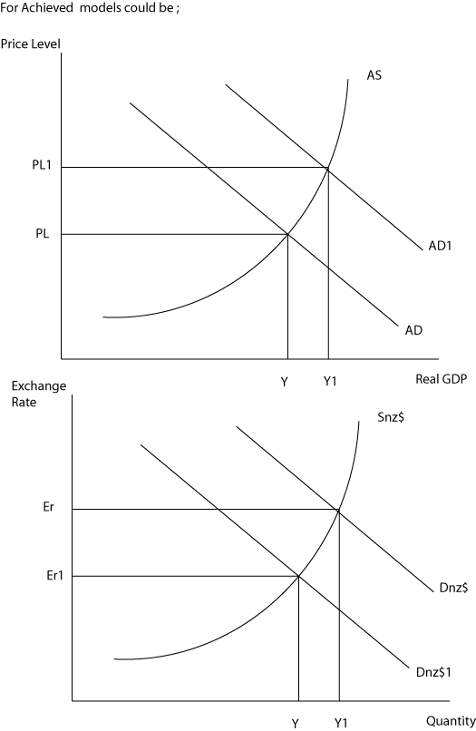
Appendix A: For expansionary policy
Y1 Y
For Merit/Excellence models could be;
AD
Y
Y1
Y2
Real GDP
Price Level
AS
AD1
PL1
AS1
PL2
AS/AD Analysis
YF
PL

Appendix B: Models for contractionary policy
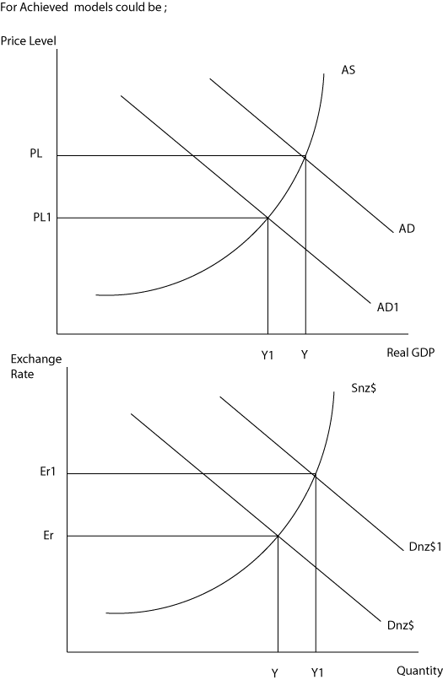
For Merit/Excellence models could be;
PL2
PL1
Y1 Y Y2
PL
AD
AS
AD1
Real GDP
Price
Level
AS1
YF
AS/AD Model

