

Internal Assessment Resource

Te Reo Māori Level 1

This resource supports assessment against Achievement Standard 91085 version 3

**Standard title:** Whakarongo kia mōhio ki te reo o tōna ao

**Credits:** 6

Resource title: Taringa whakarongo

**Resource reference:** Te Reo Māori 1.1A v4

|  |
| --- |
| This resource:   * Clarifies the requirements of the standard * Supports good assessment practice * Should be subjected to the school’s usual assessment quality assurance process * Should be modified to make the context relevant to students in their school environment and ensure that submitted evidence is authentic |

|  |  |
| --- | --- |
| Date version published by Ministry of Education | January 2017 Version 4  To support internal assessment from 2017 |
| Quality assurance status | These materials have been quality assured by NZQA.  NZQA Approved number A-A-01-2017-91085-04-4707 |
| Authenticity of evidence | Teachers must manage authenticity for any assessment from a public source, because students may have access to the assessment schedule or student exemplar material.  Using this assessment resource without modification may mean that students’ work is not authentic. The teacher may need to change figures, measurements or data sources or set a different context or topic to be investigated or a different text to read or perform. |

**Internal Assessment Resource**

Achievement standard: 91085

**Standard title:** Whakarongo kia mōhio ki te reo o tōna ao

**Credits:** 6

Resource title: Taringa whakarongo

**Resource reference:** Te Reo Māori 1.1A v4

Teacher guidelines

The following guidelines are supplied to enable teachers to carry out valid and consistent assessment using this internal assessment resource.

Teachers need to be very familiar with the outcome being assessed by Achievement Standard Te Reo Māori 91085. The achievement criteria and the explanatory notes contain information, definitions and requirements that are crucial when interpreting the standard and assessing students against it.

Context/setting

This assessment activity consists of two parts and requires students to provide evidence that they can understand spoken Māori in familiar contexts.

Students will be assessed on how well they can comprehend spoken Māori. The intention is that students will be assessed on spoken language that they have encountered as part of the teaching and learning programme. Students need to be given written notification about the way that assessment will be carried out.

You will need to select or create spoken texts in te reo Māori that ensure that achievement at each level of the standard is possible. The activities provided are only examples to show how listening evidence can be collected. To ensure the authenticity of student responses, the activities cannot be used without significant re-contextualisation, as the scripts and indicative responses are available on-line. Each task will require the development of evidence statements for recontextualised tasks.

You must make a single holistic judgement across the two pieces of evidence (do not give the students two separate grades). **Note**: the assessment schedule has judgement statements as a guide to help make an overall judgement for parts 1 and 2.

Conditions

Students will have been exposed to a range of vocabulary and language structures specific to the chosen themes and will have had exposure to the types of tasks they will have to complete as part of their assessment. This is an individual, in-class assessment activity.

Resource requirements

Teacher resource sheets are included with this assessment resource.

A student response sheet is provided for Part 1.

The attached map is required by students for Part 2.

Additional information

Follow your school’s internal guidelines for storing student work for moderation purposes.

Grammar progression tables for each curriculum level of Te Reo Māori are available on TKI at: <http://tereomaori.tki.org.nz/Teacher-tools/Te-Whakaipurangi-Rauemi/Grammar-Progression-Table>.

Teacher resource 1: Pukamata (Facebook)

This activity requires students to listen to a passage and provide certain information on the attached response sheet. Students write in English to show their understanding of the passage.

Read the following to the students

I am about to read you a passage called“Pukamata”. A teenager called Pare is writing a message on Facebook about her activities. She refers to past, present and future events.

As I read, listen carefully for meaning. You need to:

* identify the various different events; decide whether they are past, present or future; and list them in the correct column on the response sheet
* say how Pare feels about these different events, supporting your responses with specific information from the passage.

You will hear the passage four times.

* First, I will read it right through slowly but without breaks.
* Then I will read it one paragraph at a time, pause for a minute, and then repeat the paragraph. I will wait for a minute before moving on to the next paragraph.
* Lastly, I will read the passage right through again. You will then have two minutes to make any final additions or changes to your responses.

**Pukamata**

Kua tae ki te kāinga. E hika mā! Auē he roa rawa tēnei Rāmere. Kua pau taku hau! Kua kai hapa kē te whānau. Kei te kai maramara rīwai kē ahau. Kātahi anō ka mutu i ahau aku ake karere rorohiko te titiro. He nui rawa ngā karere e tatari ana ki tōku pouaka īmera.

E hiahia ana koutou kia mōhio kei te aha ahau i tēnei wiki? Inanahi i te haurua mai i te ono karaka i te ata, ka tae atu mātou ki te kura hei whakaharatau i te pā whutupaoro. Ā tērā marama ka tū te whakataetae ā-motu ki Tokoroa mō ngā kura tuarua. Ko te tino wawata, ka wikitōria mātou, ā, ka eke mātou ki te tūranga toa.

I muri mai i te pā whutupaoro, ka haere māua ko Ani ki te akomanga mō te Pūtaiao. I reira kua whakahokia te whakamātautau e te kaiako. E wiriwiri ana tōku tinana i te wā e hoatu haere ana a Whaea Mere i ngā pepa ki a mātou. I pānui i tōku ake pepa. Auē! Kua whiwhi kairangi ahau, ka mau te wehi! I te akomanga Ingarihi, ka whakarite mātou ki te haere ki te kiriata i te tāone ā tērā Rāpare. I pānui mātou i tētahi pukapuka, ā, ka haere ki te kite i te kiriata o tāua pukapuka. Engari ki a au nei he koretake te pukapuka. He koretake pea hoki te kiriata.

Taihoa, kei te tangi taku waea pūkoro. Ka rawe, kua tae mai tētahi karere nō tōku whaiāipo. Anei ana kōrero: “E te tau kei te pīrangi koe ki te haere mai ki te huritau o tōku whanaunga a Tupu āpōpō? Kua tekau mā whitu ōna tau.” Tino tere tōku whakaae. Engari, ka puta mai te whakaaro, me pēhea ōku kākahu papai me te tākoha mō taua pāti? Āpōpō i te ata, me haere ahau ki te papahoko ki te hoko i tētahi kaka hōu me tētahi kōpae pūoro hei tākoha.**Teacher resource 2: Te mahere tāone**

This activity requires students to listen to a passage that describes a route, and to mark the route and features on a map.

Give students the attached map resource before you begin reading.

Read the following to the students

On the sheet in front of you is a map of a fictional town. I’m going to describe a route from the school to the beach. As I read, plot the route on your map and label the streets and buildings that you hear identified. Note: you do not need to write the names of streets and buildings already identified on your answer sheet. I will read the description three times. The first time, I will read the passage through without pausing. The second time, I will pause briefly after every one or two sentences. Finally, I will read the passage again without pausing. You will then have two minutes to check what you have done and add or change details.

Kātahi ka mutu te kura. Kei te rori o Wairere koe e tū ana i mua tonu i te Kura o Aniwaniwa. Kei tērā taha o te rori tētahi wharekai e hāngai ana ki te kura. Ko te ingoa o taua wharekai ko Kai Reka. Kei muri rawa i tērā wharekai ko te hohipera, e rua kē ngā whare o te hohipera.

Kua reri koe ki te haere, ka haere whakatemauī koe, ā, tae atu ki te piriti e tata ana ki te awa o Wairere. Whakawhitia te piriti ki te taha hauāuru. Haere tōtika ki te ara rīpeka.

Kei te kokonga o taua ara rīpeka, i tō taha matau tērā tētahi pēke. Me huri whakatematau i taua rīpeka ki runga tonu i te rori o Tainui. Kātahi ka hipa atu koe ki te whare karakia kei tō taha mauī. Ko te ingoa o taua whare karakia ko Hato Tīpene. Tērā tētahi urupā hoki e tata ana ki taua whare karakia.

Kei tō taha matau tētahi whare nui ko te whare pukapuka tēnā. Haere torotika ka hipa atu koe ki te tiriti o Waka, ka pāhi hoki koe i tētahi whare iti i tō taha matau, ko tēnei tētahi toa hoko pūoro. E hāngai ana taua toa hoko pūoro ki te whare hākinakina i tō taha mauī. Ko te ingoa o taua whare hākinakina ko Te Whare Whakakorikori Tinana.

Haere tonu tae noa ki te pito o te rori, kātahi ka huri whakatematau ki te huarahi o Tītoki. Ka kite koe i te tauranga wakarererangi kei te taha mauī. Haere tōtika ki te huringa tuatahi, huri whakatematau ki te rori o Pito. Ka kitea te papa tākaro mō ngā tamariki nohinohi i tērā taha o te rori. Whakawhiti i te rori ki te papa tākaro. Haere ki te oneone o Waikarekare. Atu i te oneone ka kitea ngā pae maunga o Karamea i tō taha mauī. Kei roto hoki i te wai tētahi poti pakupaku. Me tau koe ki te oneone o Waikarekare ki te tatari ki ō hoa.

**Internal Assessment Resource**

**Standard title:** Whakarongo kia mōhio ki te reo o tōna ao

**Credits:** 6

Resource title: Taringa whakarongo

**Resource reference:** Te Reo Māori 1.1A v4

Student instructions

Introduction

Over the course of the year your teacher will assess your understanding of spoken Māori. This assessment task is in two parts. Each part will involve listening to either a passage read by the teacher or a recording.

You will be assessed on the quality of your understanding.

Your teacher will collect and retain your work. The two parts will not be individually graded; rather, you will be given an overall grade based on the evidence across the three parts.

This is an individual, in-class assessment task.

Your teacher will provide details of when the two parts of this assessment will take place.

In each case, you are aiming to show that you have understood what you have listened to.

Task

Part 1: Pukamata

Follow your teacher’s instructions.

Write your responses on the formatted sheet.

Give the response sheet to your teacher when you have finished.

Part 2: Te mahere tāone

Follow your teacher’s instructions.

Use the town map provided.

Give your annotated map to your teacher when you have finished.

Student response sheet for Part 1: Pukamata

|  |  |
| --- | --- |
| * **Put each event Pare mentions into the correct column.** * **Explain how Pare feels about the event. Support your response with evidence/information from the text.** | |
| **Events** | **How was Pare feeling?** |
| **Past events** |  |
| **Present events** |  |
| **Future events** |  |

Student resource for Part 2: Te mahere tāone

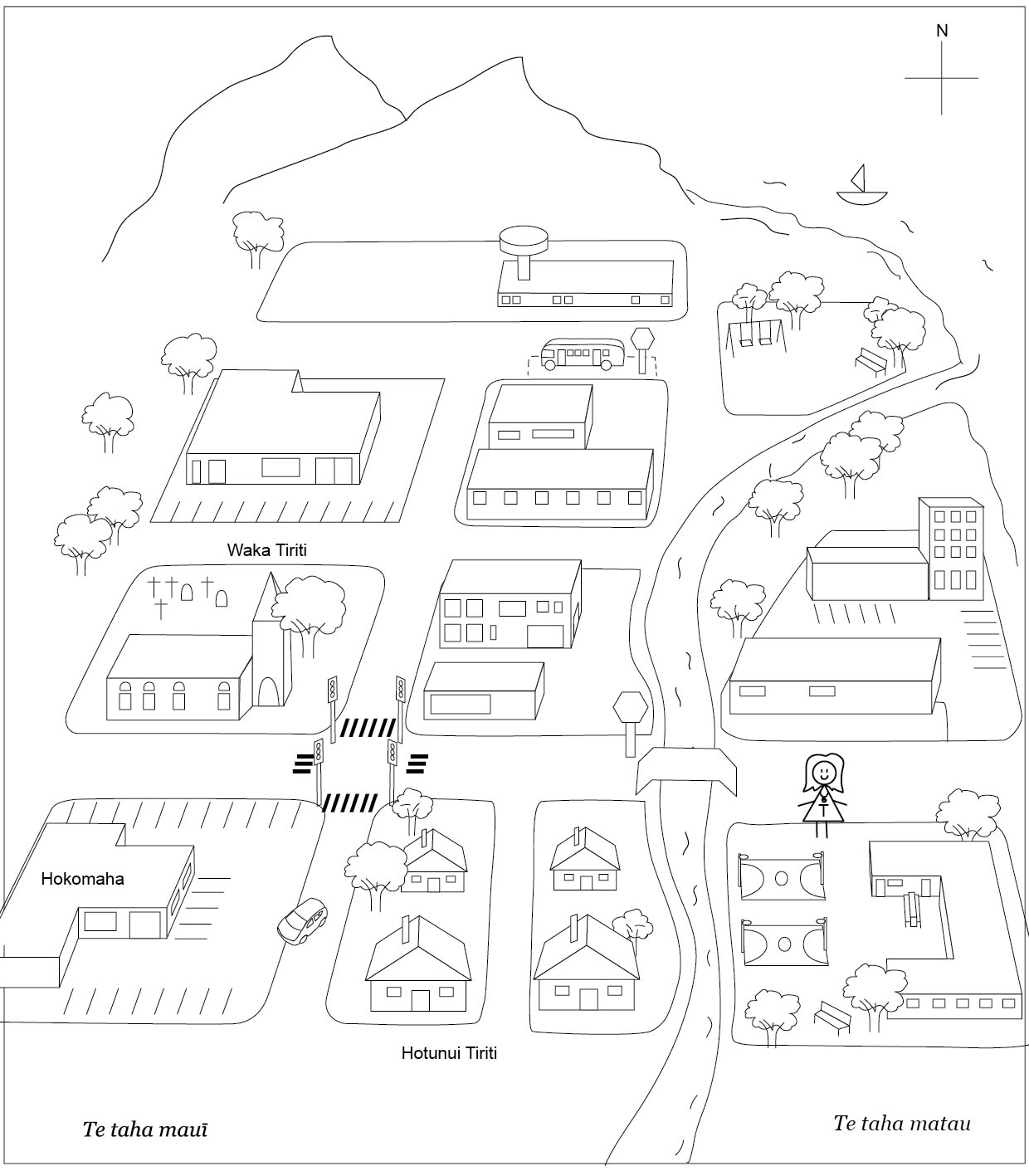

|  |  |  |  |
| --- | --- | --- | --- |
| Assessment Schedule Part 1: Pukamata | | | |
| Evidence (expected responses) | | | |
| **Achievement**   * Whakarongo kia mōhio ki te reo o tōna ao * The student demonstrates a basic understanding of the text, but responses lack detail. * The student provides at least 12 correct responses. | **Achievement with Merit**   * Whakarongo kia mārama ki te reo o tōna ao * The student demonstrates clear understanding of the text and some detailed information is given. * The student provides 16 correct responses with 4 at Merit level or above. | | **Achievement with Excellence**   * Whakarongo kia mātau ki te reo o tōna ao * The student demonstrates a comprehensive understanding of the text. Detailed information is given and responses may be supported by evidence from the text. * The student provides 18 correct responses with a minimum of 2 at Excellence level. |
| Note for parts of this assessment schedule, responses for Achievement are in plain text; information for Merit is underlined; and information for Excellence is bolded. | | | |
| Past events | | * **How is Pare feeling?** | |
| * She has just returned home | | * She said she was tired after a long day | |
| * Her family have already finished supper | | * She is hungry so she is eating potato chips | |
| * She has just finished checking her messages | |  | |
| * Yesterday at 6:30 am she went to school to train for touch | |  | |
| * Last year the football team lost in the national tournament | |  | |
| * After football training Pare and Ani went to the science room where she got her science test results back | | * **She was nervous and her body was shaking when the teacher returned the test, but was excited when she realised she achieved excellence** | |
| * She was in English class preparing for a class trip to the movies to see a screen version **of a book they have studied** | | * She did not enjoy the book so was not looking forward to the movie | |
| Present events | | * **How is Pare feeling?** | |
| * At home on the computer on Facebook writing a message | |  | |
| * She is tired | | * because she tells us it’s been a long day **and she is out of energy** | |
| * She is hungry | | * she missed supper/dinner and is eating potato chips. | |
| * Received a text message from her boyfriend seeing if she wanted to go to a birthday party with him | | * **She was happy because she quickly replied with a yes, then she was a bit worried because she needed** **to get her outfit ready and get a present for Tupu for his birthday** | |
| Future events | |  | |
| * Next month she will be going to the national secondary schools competition in Tokoroa | | * She wants to win the competition this year. | |
| * Next Thursday she is preparing for a class trip to see the movie of a book they are reading in class [also under past events, so count only once] | |  | |
| * Tomorrow morning she will be going to the mall to buy new clothes and a CD as a present for the birthday | |  | |
| * Tomorrow night accompanying her boyfriend to his relative’s 17th birthday celebration [also under past events, so count only once] | |  | |

|  |  |  |
| --- | --- | --- |
| Assessment Schedule Part 2: Te mahere tāone | | |
| Judgements | | |
| Achievement   * Whakarongo kia mōhio ki te reo o tōna ao * The student demonstrates a basic understanding of the text. | Achievement with Merit   * Whakarongo kia mārama ki te reo o tōna ao * The student demonstrates clear understanding of the text. | Achievement with Excellence   * Whakarongo kia mātau ki te reo o tōna ao * The student demonstrates a comprehensive understanding of the text. |
| Evidence (expected responses) | | |
| The student:   * Completes the route from the school to Waikarekare Beach. The beach can be entered from any side of Pito Street. * Identifies four places on the map correctly (buildings can be labelled in Māori or in English). **Note** these are places that are not already identified on the map.   *Te kura o Aniwaniwa*  *Kai eka/Delicious Food*  *Hohipera/Hospital*  *Pēke/Bank*  *Hato Tīpene/St Stephen’s*  *Urupā/Cemetery*  *Whare Whakakori tinana/Gym*  *Toa pūoro*  *Tauranga wakarererangi/Airport*   * Identifies two streets correctly:   *Wairere Rori/Road*  *Tainui Rori/Road*  *Tītoki Rori/Road/Street*  *Waka Tiriti/Street*  *Pito Rori/Road* | The student:   * Completes the route so that it goes through the playground to Waikarekare Beach. * Identifies five places on the map correctly (buildings can be labelled in Māori or in English)   *Te kura o Aniwaniwa*  *Kai Reka/Delicious Food*  *Hohipera/Hospital*  *Pēke/Bank*  *Hato Tīpene/St Stephen’s*  *Urupā/Cemetery*  *Whare Whakakori tinana/Gym*  *Toa pūoro*  *Tauranga wakarererangi/Airport*   * Identifies three streets correctly:   *Wairere Rori/Road*  *Tainui Rori/Road*  *Tītoki Rori/Road/Street*  *Waka Tiriti/Street* | The student:   * Completes the route so that it goes through the playground to Waikarekare beach. * Identifies six places on the map correctly (buildings can be labelled in Māori or in English)   *Te kura o Aniwaniwa*  *Kai Reka/Delicious Food*  *Hohipera/Hospital*  *Pēke/Bank*  *Hato Tīpene/St Stephen’s*  *Urupā/Cemetery*  *Whare Whakakori tinana/Gym*  *Toa pūoro*  *Tauranga wakarererangi/Airport*   * Identifies four streets correctly:   *Wairere Rori/Road*  *Tainui Rori/Road*  *Tītoki Rori/Road/Street*  *Waka Tiriti/Street* |

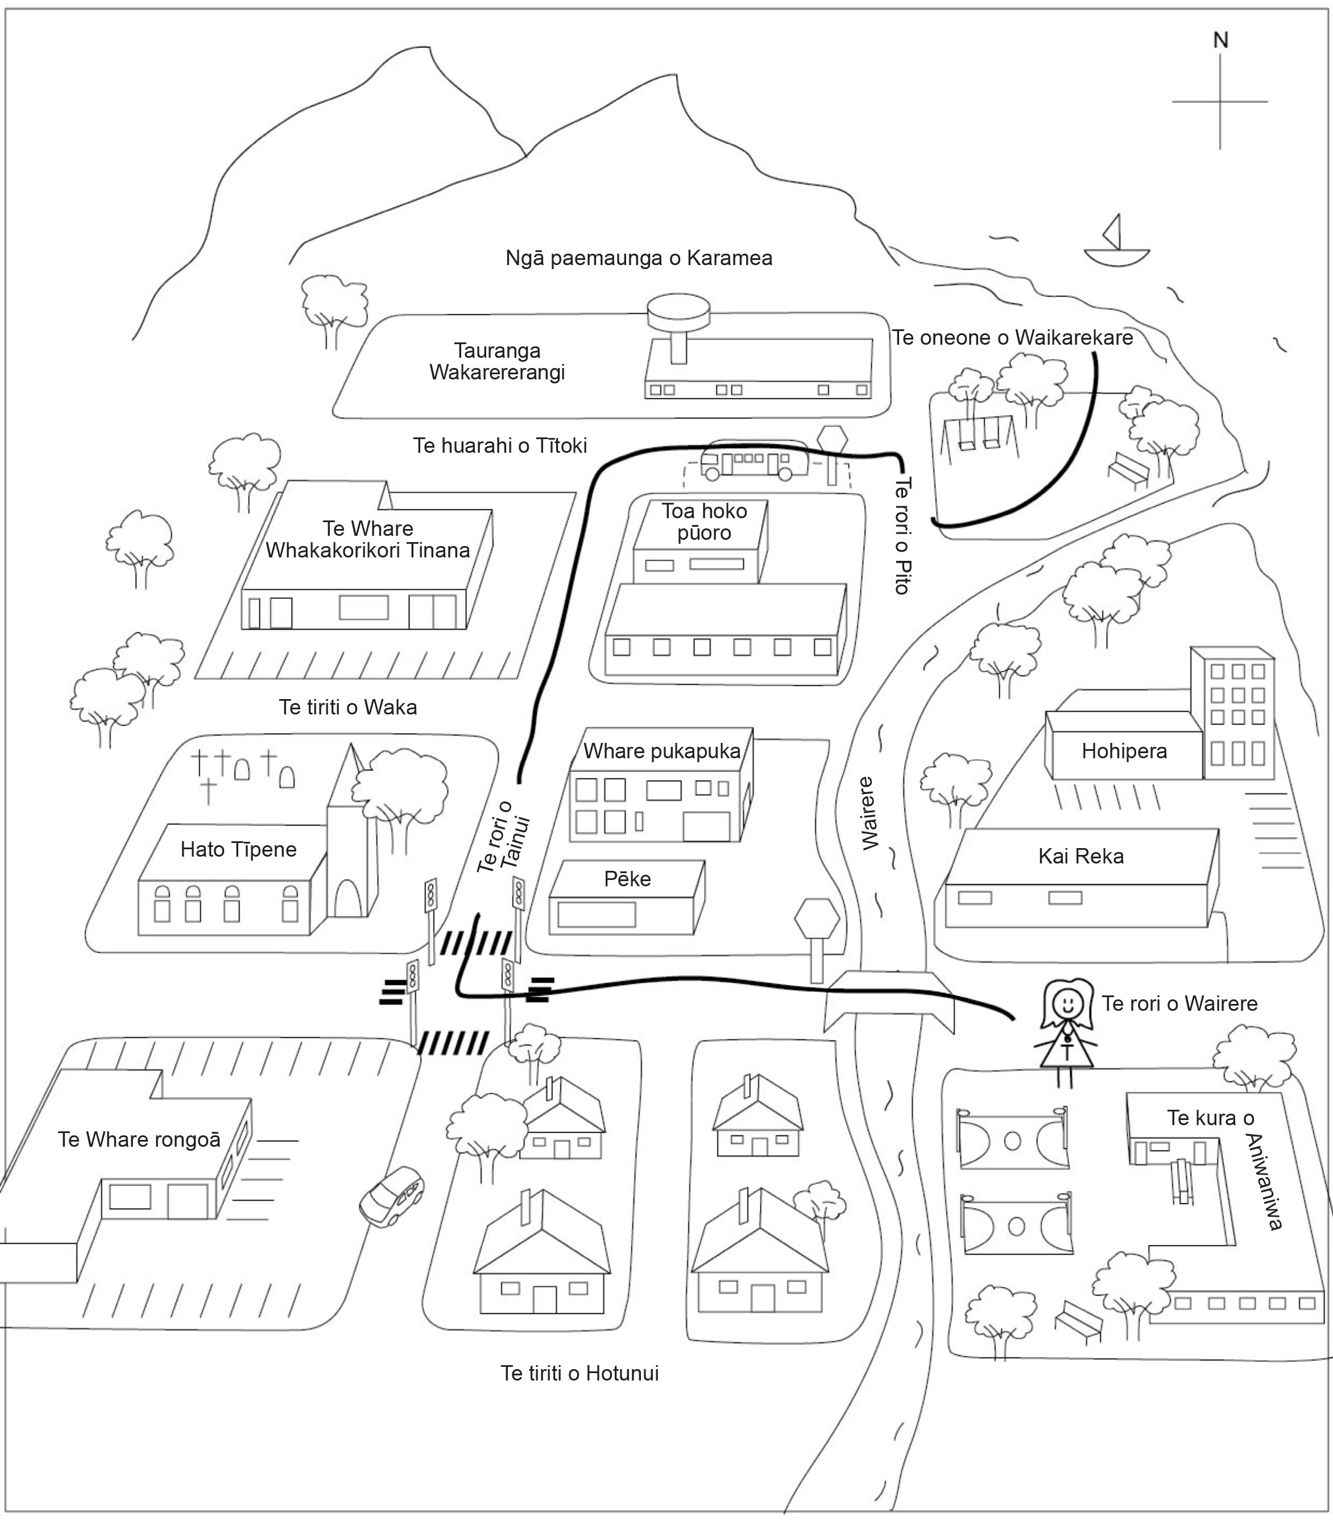

Assessment schedule: Te Reo Māori 91085 Taringa whakarongo

|  |  |  |
| --- | --- | --- |
| Evidence/Judgements for Achievement | Evidence/Judgements for Achievement with Merit | Evidence/Judgements for Achievement with Excellence |
| Whakarongo kia mōhio ki te reo o tōna ao  The student provides a minimum of two pieces of evidence of their listening skills in Māori. In the responses to the spoken texts, the student demonstrates that they:   * can recognise and understand some of the ideas * are beginning to recognise the meaning of spoken Māori up to, and including, level 6 of *Te Aho Arataki Marau mō te Ako i Te Reo Māori – Kura Auraki* / *Curriculum Guidelines for Teaching and Learning Māori in English-medium Schools: Years 1–13.* | Whakarongo kia mārama ki te reo o tōna ao  The student provides a minimum of two pieces of evidence of their listening skills in Māori. In the responses to the spoken texts, the student demonstrates that they:   * can recognise and understand most of the ideas * generally understand the meaning of spoken Māori up to, and including, level 6 of *Te Aho Arataki Marau mō te Ako i Te Reo Māori – Kura Auraki* / *Curriculum Guidelines for Teaching and Learning Māori in English-medium Schools: Years 1–13.* | Whakarongo kia mātau ki te reo o tōna ao  The student provides a minimum of two pieces of evidence of their listening skills in Māori. In the responses to the spoken texts, the student demonstrates that they:   * fully comprehend all the main ideas and the details * fully comprehend the meaning, purpose and finer points of spoken Māori up to, and including, level 6 of *Te Aho Arataki Marau mō te Ako i Te Reo Māori – Kura Auraki* /*Curriculum Guidelines for Teaching and Learning Māori in English-medium Schools: Years 1–13.* |

Final grades will be decided using professional judgement based on a holistic examination of the evidence provided against the criteria in the Achievement Standard.