

Internal Assessment Resource
Physics Level 2
This resource supports assessment against:
Achievement Standard 91168 version 2
Carry out a practical physics investigation that leads to a non-linear mathematical relationship
Resource title: Distance and time
4 credits
This resource:
- Clarifies the requirements of the standard
- Supports good assessment practice
- Should be subjected to the school’s usual assessment quality assurance process
- Should be modified to make the context relevant to students in their school environment and ensure that submitted evidence is authentic

Date version published by Ministry of Education | February 2015 Version 2  To support internal assessment from 2015
Quality assurance status | These materials have been quality assured by NZQA.  NZQA Approved number: A-A-02-2015-91168-02-5645
Authenticity of evidence | Teachers must manage authenticity for any assessment from a public source, because students may have access to the assessment schedule or student exemplar material.  Using this assessment resource without modification may mean that students’ work is not authentic. The teacher may need to change figures, measurements or data sources or set a different context or topic to be investigated or a different text to read or perform.

Internal Assessment Resource
Achievement Standard Physics 91168: Carry out a practical physics investigation that leads to a non-linear mathematical relationship
Resource reference: Physics 2.1A v2
Resource title: Distance and time
Credits: 4
Teacher guidelines
The following guidelines are designed to ensure that teachers can carry out valid and consistent assessment using this internal assessment resource.
Teachers need to be very familiar with the outcome being assessed by Achievement Standard Physics 91168. The achievement criteria and the explanatory notes contain information, definitions, and requirements that are crucial when interpreting the standard and assessing students against it.
Context/setting
This assessment requires students to take measurements, use techniques to maximise accuracy, analyse the collected data, and develop the equation that models a non-linear physical relationship.
Because of the detailed evidence given in the schedule, the experiment on which this activity is based cannot be used for assessing the standard. The activity must be adapted to another context and experiment that presents similar opportunities to meet the standard.
In this example investigation, students determine the relationship between downhill rolling distance and time.
Students record and graph data, transform the graph, use the transformed graph to find the mathematical equation relating distance and time, and produce a report, which evaluates and explains the results.
Conditions
The investigation is to be performed in class under supervised conditions, over an uninterrupted period of 2–3 hours; each student should gather and evaluate their own set of data, and produce their report independently.
Conclusions must be written; confirm the format of the report with your students. The format could be, but is not limited to a written report, computer presentation, or web page.
Analysis can be done manually, using a graphing calculator, or using a computer, but the analysis must be able to be stored by the assessor or printed for marking purposes.
Resource requirements
Students will need a ball, a timing device, and equipment to create a defined-angle slope with consistently measurable distances, for example:
- grooved timber, cut to length, or metre rules with channel/track down the centre of one side
- marbles or other suitable rolling ball
- stopwatches
- clamp stands, clamps and bosses
- protractors.
Modify the student instructions as necessary, depending on the equipment available.
Additional information
Provide this equation for students if they have not been exposed to this equation in the mechanics topic before attempting this experiment or if they may not be able to remember what the variables are.
Physics theory states that, for an object with uniform acceleration, the following equations apply:
d = v_{i}t + ½at², a = gsinθ
where v_{i} is the initial speed of the marble down the ramp, a is the acceleration of the marble down the ramp, g is the strength of gravity (10 N kg⁻¹) and θ is the angle between the ramp and the horizontal.

Internal Assessment Resource
Achievement Standard Physics 91168: Carry out a practical physics investigation that leads to a non-linear mathematical relationship
Resource reference: Physics 2.1A v2
Resource title: Distance and time
Credits: 4
Achievement | Achievement with Merit | Achievement with Excellence
Carry out a practical physics investigation that leads to a non-linear mathematical relationship. | Carry out an in-depth practical physics investigation that leads to a non-linear mathematical relationship. | Carry out a comprehensive practical physics investigation that leads to a non-linear mathematical relationship.
Student instructions
Introduction
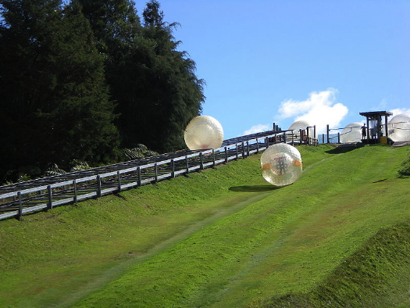
Inflatable globe riding is the sport of rolling down a hill inside a giant inflatable ball. John and Marama tried freestyle inflatable globe riding during the summer holidays. When they got back to school they decided to investigate the relationship between the distance travelled down a slope, and the time taken.
Task
Carry out your own investigation into the relationship between distance and time when a ball is rolled down a slope.
You will be given a period of 3 hours in which to collect and analyse data, and write and hand in a report. You will work independently.
Confirm the format of the report with your teacher. It could be, for example, a written report, a poster, or a computer presentation.
No material is to be taken from the laboratory.

Gather data
Set up this apparatus using equipment provided by your teacher:
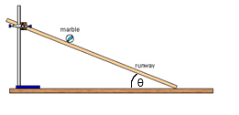
Equipment: 1 metre ruler with channel down the centre; 1 metre ruler; marble; stopwatch; clamp stand, clamp and boss; protractor.
Investigate the relationship between the distance travelled by a rolling ball down slope d, and time, t.
As you go about your investigation, you should:
- identify the dependent and independent variables
- identify any variables to be controlled
- record all raw measurements in an appropriately headed results table, using appropriate units
- make sufficient measurements to allow you to draw a graph that will help you determine the relationship
- adjust your method as necessary to maximise accuracy.
Analyse data
Plot an appropriate graph to explore the mathematical relationship between distance travelled down the slope, d, and time, t. Include a curve of best fit (the raw data will not give a straight-line graph).
d and t, are not proportional variables. Decide the type of relationship that this graph suggests.
Process the data so that you can draw a straight-line graph. Plot and draw the graph.
Using information from the straight-line graph, find and state the mathematical relationship between d and t.
Prepare your report
Write a report that evaluates and explains the results of your investigation.

Your report should include:
- the dependent and independent variables
- the techniques you used to improve accuracy of measurement
- a suitably headed table which records all raw measurements with appropriate units and to an appropriate number of decimal places
- the non-linear graph you have drawn
- the type of mathematical relationship that the non-linear graph suggests exists between the variables d and t
- a suitably headed table which records processed data in appropriate units and quoted to an appropriate number of significant figures, and the straight-line graph you have drawn
- a conclusion that states the correct mathematical relationship between d and t, based on your straight-line graph
- a discussion that validates the conclusion.
In the discussion that validates your conclusion, you should address such critical issues as:
- variables that required controlling (explain why they needed controlling and how you controlled them)
- difficulties encountered when making measurements (explain how you overcame these difficulties)
- why there was a limit to the range of values you chose for the independent variable
- any unexpected results (suggest what might have caused these and what effect if any they may have had on the validity of the conclusion)
- the relationship between your findings and physics ideas.

Assessment schedule: Physics 91168 Distance and time
Evidence/Judgements for Achievement | Evidence/Judgements for Achievement with Merit | Evidence/Judgements for Achievement with Excellence
The student carries out the specified practical physics investigation.  They correctly:  - identify the independent (time) and dependent (distance) variables  - gather at least 5 values of distance (d) and time (t), over a range of at least 0.600 metres, using the smallest scale division of the measuring instrument  - plot points on a graph showing the relationship between the independent and the dependent variables, on axes labelled properly with quantities and units, and including a curve of best fit  - describe the type of relationship that exists between d and t, with correct proportionality of variables, d α t².  Accept alternative non-linear graphs that lead to the correct relationship. For example, the student might write:  The graph below shows the relationship between distance and time. The distance the ball rolled depended on time. I recorded seven different distance-time points on a constant slope (I used an angle of 15 degrees throughout), to the nearest half second and millimetre; I found that the relationship was quadratic, with distance being proportional to the square of time.  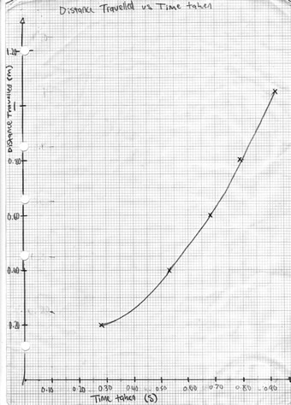 | The student carries out the specified practical physics investigation.  They correctly:  - state or imply control of the angle of ramp variable  - use techniques to improve the accuracy of the measured values, for example, they repeat and average three measurements for a particular distance, correct for parallax by lining up eye with end of ruler to accurately stop timer, or adjust the slope angle to produce a more measurable range of times  - transform values of t to t², with appropriate significant figures and units of t² (likely to be 3 significant figures of s², depending on the measuring instrument used)  - plot and linear graph showing the relationship between the independent and the dependent variables, on axes labelled properly with quantities and units, and including lines of best fit  - calculate the gradient of the linear graph  - derive the mathematical equation from graph, d = gradient x t² (value of gradient to be consistent with student data).  Accept alternative linear graphs that lead to the correct equation. For example, the student might write:  The graphs below show the relationship between distance and time. The distance the ball rolled depended on time. I measured about twenty different distance-time points on a constant slope (I tried different angles, and found that 15 degrees gave me a consistent set of measurements.) I plotted the average of three trials for each distance to improve accuracy. I found that the relationship was quadratic, with distance being proportional to the square of time. I then transformed my data and plotted a graph of d vs. t². As you can see, the t² graph is linear, with a gradient of the line of best fit of about 1.0, so my experimental relationship is d = 1.0t² + 0.12.  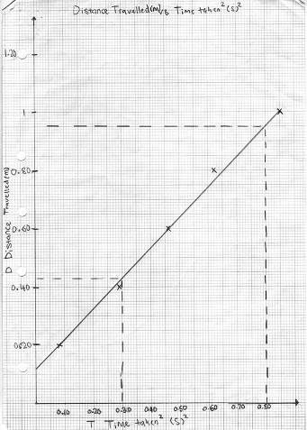 | The student carries out the specified practical physics investigation.  They conclude their report with a discussion in which they make a good attempt to do two (or a reasonable attempt to do three) of the following:  - justify their choice of the ramp angle size (for example, a larger angle makes the time too short to be measured accurately by a stopwatch)  - justify their choice of the range for the independent variable (for example, because of a limit to either end of the values chosen for the independent variable)  - describe the difficulties encountered when measuring, and link them to techniques used to improve the accuracy of the measured values (for example, they note that human reaction times can be slower than 1/10th of a second and therefore repeat and average time measurements to reduce reaction time error)  - reflect on the validity of their conclusion, with respect to physics ideas, unexpected outcomes, and/or effects of their particular experimental method.  Note that the statements the student makes in their discussion do not necessarily have to be 100% correct, but they must be reasonable, given the knowledge they are expected to have. For example, the student might write:  I measured about twenty different distance-time points on a constant slope, starting from 0.1 metre as distances less than 0.1 metre were too short to measure without reaction time becoming a large factor compared to the time measured. I also initially had difficulty measuring time as my high angle meant that the ball rolled faster than I could react. I lowered the angle to 15 degrees, at which point I could get a consistent set of measurements. I then kept the angle constant (controlled) to avoid introducing a second variable of slope into my experiment. It was hard to measure time accurately because I had to make a judgement each time I started and stopped the stopwatch. As the inaccuracy was random (just as likely that the time was too short as too long), I plotted the average of three trials for each distance to improve accuracy; I ignored the highlighted outliers on the graph at the lowest distance values because even with averaging, reaction times played a large factor, as you can see from the big variation in my raw data. I found that the relationship was indeed quadratic. I know this because when I transformed my data and plotted a graph of d vs. t², my graph was linear, with a gradient of the line of best fit of 1.0. However, there was an unexpected intercept, which indicated that it takes zero time to travel 12 cm, which is clearly impossible. I think this error could be because my technique for starting and stopping the stopwatch was such that the inaccuracy was not random but gave an error that meant all times were a bit too short. I decided it would be valid to ignore this error, so my experimental relationship is d = 1.0t². The constant acceleration equation d = v_{i}t + ½at² (v_{i} = 0) means that d = ½at² and so ½a = 1.0 or a = 2. As the ball accelerates down the slope because of gravity should be the component of gravity down the slope. a = gsinθ = 10 × sin15° = 2.6. The actual acceleration is a bit less than theory predicts so friction could be slowing the ball down. Or it could be that the angle was not accurate– it was hard to measure the angle of the metre stick, and the stick had a slight bow. However the angle would have had to be 12° to give the predicted acceleration, so perhaps it was a bit of both.
Final grades will be decided using professional judgement based on a holistic examination of the evidence provided against the criteria in the Achievement Standard.

