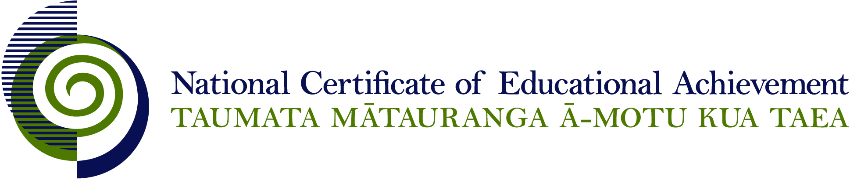

NCEA Level 2 Physical Education

Conditions of Assessment

General Information

Subject Reference | Health and Physical Education
Domain | Physical Education
Level | 2

This document provides guidelines for assessment against internally assessed standards. Guidance is provided on:
- appropriate ways of, and conditions for, gathering evidence
- ensuring that evidence is authentic
- any other relevant advice specific to an achievement standard.

NB: It is expected that teachers are familiar with additional generic guidance on assessment practice in schools published on the NZQA website. This should be read in conjunction with these Conditions of Assessment.

For All Standards

Internal assessment provides considerable flexibility in the collection of evidence. Evidence can be collected in different ways to suit a range of teaching and learning styles and a range of contexts of teaching and learning. Care needs to be taken to allow students opportunities to present their best evidence against the standard(s) that are free from unnecessary constraints.

It is recommended that the design of assessment reflects and reinforces the ways students have been learning. Collection of evidence for the internally assessed standards could include, but is not restricted to, an extended task, an investigation, digital evidence (such as recorded interviews, blogs, photographs or film) or a portfolio of evidence.

It is also recommended that the collection of evidence for internally assessed standards should not use the same method that is used for any external standards in a programme/course, particularly if that method is using a time bound written examination. This could unfairly disadvantage students who do not perform well under these conditions.

A separate assessment event is not needed for each standard. Often assessment can be integrated into one activity that collects evidence towards two or three different standards from a programme of learning. Evidence can also be collected over time from a range of linked activities (for example, in a portfolio).This approach can also ease the assessment workload for both students and teachers.

Where all, or a significant part, of the evidence for assessment is presented orally, this will need to be recorded (audio or video) and annotated for in-school and national moderation purposes. Note that the judgement made about the quality of the work is not made on the quality of the ‘oral performance’ but the meaning inherent in the verbal presentation (or in the written notes students will likely prepare to support the presentation).

Effective assessment should suit the nature of the learning being assessed, provide opportunities to meet the diverse needs of all students and be valid and fair.

Where manageable, and after further learning has taken place, students may be offered a maximum of one further opportunity for assessment against an assessment standard within a year.

Authenticity of student evidence needs to be assured regardless of the method of collecting evidence. This needs to be in line with school policy. For example, for an investigation carried out over several sessions, this could include teacher observations or the use of milestones such as meetings with students, journal or photographic entries recording progress etc.

Regular discussions and checkpoints can be used to ensure that the evidence presented for assessment is authentic. This is important in the situation where students have collaborated to collect information from surveys, interviews or gather resources from documentaries, articles, and internet research. Where a group approach is used the teacher needs to ensure that there is evidence that each student has met all aspects of the standard.

Specific Information for Individual Internal Achievement Standards

Achievement Standard Number | 91327 Physical Education 2.1
Title | Examine the role and significance of physical activity in the lives of young people in New Zealand
Number of Credits | 3
Version | 2

NB: It is important to read the section “For All Standards” at the start of this document.

Achievement Standard Number | 91328 Physical Education 2.2
Title | Demonstrate understanding of how and why biophysical principles relate to the learning of physical skills
Number of Credits | 5
Version | 2

NB: It is important to read the section “For All Standards” at the start of this document.

Achievement Standard Number | 91329 Physical Education 2.3
Title | Demonstrate understanding of the application of biophysical principles to training for physical activity
Number of Credits | 4
Version | 2

NB: It is important to read the section “For All Standards” at the start of this document.

Achievement Standard Number | 91330 Physical Education 2.4
Title | Perform a physical activity in an applied setting
Number of Credits | 4
Version | 3

NB: It is important to read the section “For All Standards” at the start of this document.

Guidelines for developing assessment activities and using the rubrics for many contexts can be found at this link:
http://www.nzqa.govt.nz/assets/qualifications-and-standards/qualifications/ncea/NCEA-subject-resources/PE/Rubrics-L2.docx

This standard could be assessed through ongoing assessment opportunities.
Evidence for this assessment is collected through teacher observation.

Achievement Standard Number | 91331 Physical Education 2.5
Title | Examine the significance for self, others and society of a sporting event, a physical activity, or a festival
Number of Credits | 4
Version | 2

NB: It is important to read the section “For All Standards” at the start of this document.

Achievement Standard Number | 91332 Physical Education 2.6
Title | Evaluate leadership strategies that contribute to the effective functioning of a group
Number of Credits | 4
Version | 2

NB: It is important to read the section “For All Standards” at the start of this document.

Achievement Standard Number | 91333 Physical Education 2.7
Title | Analyse the application of risk management strategies to a challenging outdoor activity
Number of Credits | 3
Version | 2

NB: It is important to read the section “For All Standards” at the start of this document.

Achievement Standard Number | 91334 Physical Education 2.8
Title | Consistently demonstrate social responsibility through applying a social responsibility model in physical activity
Number of Credits | 3
Version | 2

NB: It is important to read the section “For All Standards” at the start of this document.

This assessment should be completed in authentic practical situations where the teacher/coach/instructor can observe the demonstration of social responsibility.

Evidence for the level of responsibility through applying a social responsible model in physical activity will be collected through teacher/self/peer observations over a period of time.

Achievement Standard Number | 91335 Physical Education 2.9
Title | Examine the implementation and outcome(s) of a physical activity event or opportunity
Number of Credits | 3
Version | 2

NB: It is important to read the section “For All Standards” at the start of this document.

Achievement Standard Number | 91336 Physical Education 2.10
Title | Analyse group processes in physical activity
Number of Credits | 3
Version | 2

NB: It is important to read the section “For All Standards” at the start of this document.

