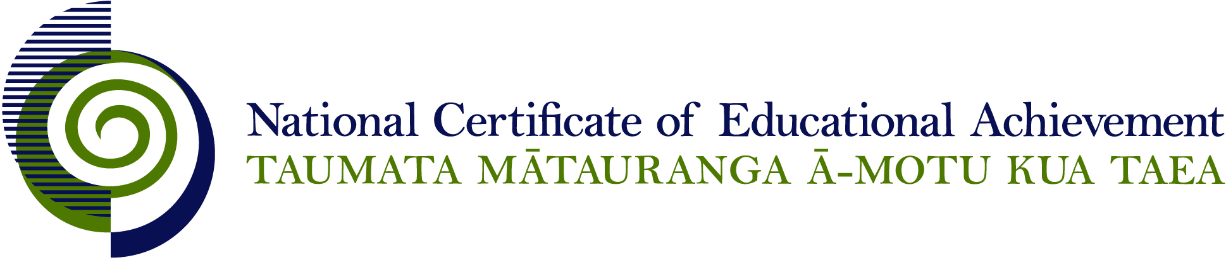

NCEA Level 3 History

Conditions of Assessment

General Information

Subject Reference | Social Science Studies
Domain | History
Level | 3

This document provides guidelines for assessment against internally assessed standards. Guidance is provided on:
- appropriate ways of, and conditions for, gathering evidence
- ensuring that evidence is authentic
- any other relevant advice specific to an achievement standard.

NB: It is expected that teachers are familiar with additional generic guidance on assessment practice in schools published on the NZQA website. This should be read in conjunction with these Conditions of Assessment.

For All Standards

Internal assessment provides considerable flexibility in the collection of evidence. Evidence can be collected in different ways to suit a range of teaching and learning styles and a range of contexts of teaching and learning. Care needs to be taken to allow students opportunities to present their best evidence against the standard(s) that are free from unnecessary constraints.

It is recommended that the design of assessment reflects and reinforces the ways students have been learning. Collection of evidence for the internally assessed standards could include, but is not restricted to, an extended task, an investigation, digital evidence (such as recorded interviews, blogs, photographs or film) or a portfolio of evidence.

It is also recommended that the collection of evidence for internally assessed standards should not use the same method that is used for any external standards in a programme/course, particularly if that method is using a time bound written examination. This could unfairly disadvantage students who do not perform well under these conditions.

A separate assessment event is not needed for each standard. Often assessment can be integrated into one activity that collects evidence towards two or three different standards from a programme of learning. Evidence can also be collected over time from a range of linked activities (for example, in a portfolio).This approach can also ease the assessment workload for both students and teachers.

Effective assessment should suit the nature of the learning being assessed, provide opportunities to meet the diverse needs of all students and be valid and fair.

Where manageable, and after further learning has taken place, students may be offered a maximum of one further opportunity for assessment against an assessment standard within a year.

Authenticity of student evidence needs to be assured regardless of the method of collecting evidence. This needs to be in line with school policy. For example, for an investigation carried out over several sessions, this could include teacher observations or the use of milestones such as meetings with students, journal or photographic entries recording progress etc.

Specific Information for Individual Internal Achievement Standards
Achievement Standard Number | 91434 History 3.1
Title | Research an historical event or place of significance to New Zealanders, using primary and secondary sources
Number of Credits | 5
Version | 1

An event can be researched in a personal, local, national, or international context.

At this level it is expected that the teacher will take on a mentoring role to provide guidance and support to the students throughout the research process. This could include providing feedback on the suitability of the research topic and the focusing questions, and guiding the student towards appropriate sources.

Evidence for this achievement standard would be expected to be gathered from in and out of class activities to be completed by students over a period of time specified by the teacher. Where a group approach is used the teacher needs to ensure that there is evidence that each student has met all aspects of the standard.

This evidence may be generated from discussion, group work, research, decision making and/or reflection and will be presented in any media that clearly communicates the student’s understanding of the inquiry.

Achievement Standard Number | 91435 History 3.2
Title | Analyse an historical event, or place, of significance to New Zealanders
Number of Credits | 5
Version | 1

Evidence for this achievement standard would be expected to be gathered from in and out of class activities to be completed by students over a period of time specified by the teacher. Where a group approach is used the teacher needs to ensure that there is evidence that each student has met all aspects of the standard.

This evidence may be generated from discussion, group work, research, decision making and/or reflection and will be presented in any media that clearly communicates the student’s understanding of the inquiry.

Students must have access to research materials in order to complete their analysis. While the format of the presentation of evidence is not assessed, teachers should ensure that any format specified provides students the opportunity to reach the standard required.

Achievement Standard Number | 91437 History 3.4
Title | Analyse different perspectives of a contested event of significance to New Zealanders
Number of Credits | 5
Version | 1

This standard could be assessed in conjunction with History 3.1.

It is appropriate for students to investigate an historical debate, not adopt an historical role. The requirements to evaluate validity would make it difficult for a task where students adopt personas to meet the achievement criteria.

Evidence for this achievement standard would be expected to be gathered from in and out of class activities to be completed by students over a period of time specified by the teacher. Where a group approach is used the teacher needs to ensure that there is evidence that each student has met all aspects of the standard.

The student must use accurate and authentic historical information as the basis of their evidence. This evidence may be generated from discussion, group work, research, decision making and/or reflection and will be presented in any media that clearly communicates the student’s understanding of the different perspectives of a contested event.

Teachers will need to provide guidance and opportunities for discussion surrounding the event and perspectives on it. Students must have access to relevant materials and teachers should provide direction on where this material can be found.

