
NZQA Approved

Internal Assessment Resource
Construction and Mechanical Technologies Level 3
This resource supports assessment against:
Achievement Standard 91620
Implement complex procedures to integrate parts using resistant materials to make a specified product
Resource title: Power tower
6 credits
This resource:
- Clarifies the requirements of the Standard
- Supports good assessment practice
- Should be subjected to the school’s usual assessment quality assurance process
- Should be modified to make the context relevant to students in their school environment and ensure that submitted evidence is authentic

Date version published by Ministry of Education | December 2012  To support internal assessment from 2013
Quality assurance status | These materials have been quality assured by NZQA. NZQA Approved number A-A-12-2012-91620-01-6190
Authenticity of evidence | Teachers must manage authenticity for any assessment from a public source, because students may have access to the assessment schedule or student exemplar material.  Using this assessment resource without modification may mean that students’ work is not authentic. The teacher may need to change figures, measurements or data sources or set a different context or topic to be investigated or a different text to read or perform.
Internal Assessment Resource
Achievement Standard Construction and Mechanical Technologies 91620: Implement complex procedures to integrate parts using resistant materials to make a specified product
Resource reference: Construction and Mechanical Technologies 3.20A
Resource title: Power tower
Credits: 6
Teacher guidelines
The following guidelines are supplied to enable teachers to carry out valid and consistent assessment using this internal assessment resource.
Teachers need to be very familiar with the outcome being assessed by Achievement Standard Construction and Mechanical Technologies 91620. The achievement criteria and the explanatory notes contain information, definitions, and requirements that are crucial when interpreting the Standard and assessing students against it.
Context/setting
This achievement standard requires the student to implement complex procedures using wood to make a power tower – a small item storage unit that also provides a charging facility for personal electronic items such as a cell phone and an iPod.
Note: this product uses a store-bought multi-plug and no wiring is required.
Two approaches are possible when using this standard for assessment:
- The students are given working drawings for a power tower. The whole class then makes the same power tower. You may select plans and the integrated features in discussion with the class. You may also allow individual students to negotiate a variation of the working drawing to include personal features.
- The students have been engaged in technological practice and are now at the point where they have fully established the specifications for their technological outcome.
The specified product must require the students to prepare parts for integration, prepare the integration environment, integrate parts, and test when manufacturing the specified products, using reference points.
The specified product for this assessment resource (the power tower) requires the integration of an inner revolving shelf unit, an electrical multi-plug, and parts that form the outer free-standing cabinet.
Manufacture of the power tower will require students to:
- test parts against central axis points when pattern shaping, and assembling to ensure the inner cabinet revolves smoothly
- use jigs and shaping blocks to accurately shape parts.
Ensure that before students begin this task, you give them an opportunity to learn and practice:
- interpreting detailed working drawings
- interpreting cutting lists
- using a range of industry recognised jointing techniques, for example, doweling, biscuit cutting, and dominos
- using a jig to router identical parts
- patterning (students to make the router jig of the shelf – see photograph)
- using a thicknesser to accurately machine the profile of the timber
- using sanding and finishing techniques to produce a high-quality finish.
Conditions
This is an individual task. The credit rating of this standard indicates that the time for learning, practice and assessment should be approximately 60 hours.
Because you are required to assess the ways in which the techniques and tests are implemented, as well as the end product itself, students should complete all their practical work in class time.
Resource requirements
Students will require access to:
- a workshop with traditional machinery including a thickenesser, bandsaw, and a portable electric router with a copy profile router bit
- suitable timber
- a multi-plug (the students are not required to do any wiring).
Additional information
Recording of evidence
As teacher, you need to be able to demonstrate that your judgements are soundly based. This means some recording of evidence is necessary.
Recording of evidence should not, however, be time-consuming or onerous. Students could be asked simply to keep a record of progress and how they have resolved problems – maybe by annotating construction plans or the equivalent. You could add your own observations to the students’ records.
Students could also provide evidence by:
- establishing a schedule of tests (that is, what tests will be done and when) and recording the outcomes of the tests as they apply them
- taking and annotating photos to show economic use of materials (for example, by photographing layout) and accuracy.
By asking your students to record evidence, you reinforce that their manner of working is also assessed in this Standard.
Ensure that all students have the opportunity to explain clearly why they did what they did.
Internal Assessment Resource
Achievement Standard Construction and Mechanical Technologies 91620: Implement complex procedures to integrate parts using resistant materials to make a specified product
Resource reference: Construction and Mechanical Technologies 3.20A
Resource title: Power tower
Credits: 6
Achievement | Achievement with Merit | Achievement with Excellence
Implement complex procedures to integrate parts using resistant materials to make a specified product. | Skilfully implement complex procedures to integrate parts using resistant materials to make a specified product. | Efficiently implement complex procedures to integrate parts using resistant materials to make a specified product.
Student instructions
Introduction
This assessment activity requires you to make a power tower – an item storage unit that also provides a charging facility for personal electronic items such as a cell phone and an iPod.
Teacher note: The outcome for this resource is a power tower, but it could equally well be a lectern, aquarium table, or a small boat. It can also be easily adapted for a product that students have trialled through technological practice and which is now ready to be constructed in its final form. Adapt the student instructions as required.
In making a power tower you will need to meet the specifications. Your teacher may provide these or you may develop them independently and have them confirmed by your teacher.
Making the specified product requires you to prepare parts for integration, prepare the integration environment, integrate parts, and test when manufacturing the specified products, using reference points.
You need to select procedures to construct your power tower that will enable you to achieve the specifications.
You will be assessed on:
- whether your power tower meets the specifications
- the manner in which you implement the plan and apply testing procedures to create the specified outcome
- your independence, accuracy, and efficiency when working.
Task
Preparation
Practice different procedures so that you are able to select complex procedures that are suitable for the precise integration of parts into your specified product.
Determine the jigs and patterns you will need to construct and shape parts.
Develop a construction plan (schedule) that specifies where testing will occur to ensure your product meets specifications, and addresses relevant health and safety regulations and legal requirements.
Make sure that your plan identifies how and when you will test your developing power tower.
Make the power tower
Manufacture your power tower, integrating parts according to your construction plan (schedule).
As you go about your work, annotate your plan so that you have a record of what you did and the problems you solved. Make sure that this record identifies where all testing occurred and compliance with health and safety regulations. You could include annotated photographs and a completed testing checklist as evidence of your testing procedures.
Teacher note: Modify these instructions as necessary.
When making your power tower, you will need to show independence and accuracy, and work in a way that makes good use of time, effort, and materials.
Photograph your power tower to show the detail of its integrated features, and that it meets all specifications.
Hand in:
- your completed power tower together with detailed photographs, which show how you integrated the various components to meet all specifications
- your annotated construction plan, photographs of jigs and templates used, written comments or explanations, and any other evidence of the techniques and the testing procedures you have used (for example, checklists).

Assessment schedule: Construction and Mechanical Technologies 91620 Power tower
Evidence/Judgements for Achievement | Evidence/Judgements for Achievement with Merit | Evidence/Judgements for Achievement with Excellence
The student implements complex procedures to integrate parts using resistant materials to make a specified product.  The student prepares parts for integration.  The student prepares the outer cabinet components, the shelves, and the slats.  For example, the student prepares the boards for the outer cabinet components by selecting boards, docking these to oversize length, achieves the correct thickness, and then planes the edges and glues these together.  The student prepares the environment to enable parts to be integrated.  The student:  - creates an MDF pattern of the shelf layer and attaches this to a piece of waste wood to act as a holding block in the jaws of a vice to mark out and cut the rest of the shelves  - ensures they have an angled holding box to use in the thicknesser to angle both edges of the slat  - ensures they have prepared a shelf and acquired masking tape to check that the 20 mm slices of the bevelled slats match the flat recesses on the shelf pattern, before they complete the machining of the slats  - ensures they have several 6 mm spacers available to centralise the inner unit, prior to screwing the outer core and inner revolving shelf unit together.  The student integrates parts to ensure product meets specifications.  The student:  - integrates the slats with the shelves by laying out the slats, marking out the position of the shelves on the slats, temporarily joining the slats with masking tape and folding, then gluing the slats around the shelf layers to form the core unit  - integrates the sides to the lower base and top to create the outer unit using a concealed joining technique such as biscuit cutting or dominos  - integrates the core unit and the outer unit by screwing the outer core and inner core unit together using the spacers to centralise the unit.  The student undertakes ongoing testing against reference points in integration of parts to reduce error.  The student checks measurements to ensure that they meet the tolerances shown in the working drawings.  The student undertakes preparation, integration and testing to comply with relevant health and safety regulations.  The student follows classroom rules ensuring both their own safety and that of others. They use the protective gear provided (for example, glasses, visors, ear muffs) and carry out procedures in a safe manner. For example, they only operate machines after being trained in their use.  They make sure that the multi-plug cable will not be damaged from the repetitive opening and closing of the tower as part of regular use.  The examples above relate to only part of what is required, and are just indicative. | The student skilfully implements complex procedures to integrate parts using resistant materials to make a specified product.  The student has shown independence and accuracy in undertaking the following procedures:  - preparing parts for integration  - preparing the environment to enable parts to be integrated  - integrating parts to ensure product meets specifications  - undertaking ongoing testing against reference points in integration of parts to reduce error  - undertaking preparation, integration, and testing to comply with relevant health and safety regulations  - executing the preparation, integration, and testing.  For example, the student independently prepares parts for integration, and prepares the integration environment and integrated parts to ensure the power tower meets specifications. The student undertakes ongoing testing against reference points in integration of parts to reduce error.  Response to testing is accurate and the student ensures that:  - the accuracy of the central axis point runs consistently throughout the construction of the entire cabinet and all shelves are identical  - the bevelled slats are accurate to the flat recesses in the shelves before machining them all  - the angled holding box used in the thickenesser creates angled edges on the slats that are relative to the radial lines on the shelf pattern  - the finish results in coverage and there are no unsightly blemishes  - the power cord is installed to enable it to move and not jam or pinch as the power tower revolves.  The examples above relate to only part of what is required, and are just indicative. | The student efficiently implements complex procedures to integrate parts using resistant materials to make a specified product.  The student has shown independence and accuracy in undertaking the following procedures, and undertaken procedures in a manner that economises time, effort, tooling, and materials:  - preparing parts for integration  - preparing the environment to enable parts to be integrated  - integrating parts to ensure product meets specifications  - undertaking ongoing testing against reference points in integration of parts to reduce error  - undertaking preparation, integration, and testing to comply with relevant health and safety regulations  - executing the preparation, integration, and testing.  For example, the student independently and accurately prepares parts for integration, prepares the integration environment, and integrates parts to ensure that the power tower meets specifications.  The student constructs the power tower in a straightforward manner without using trial and error, as they are familiar with all of the techniques.  The student takes into the account the size of the timber available at school when determining the size of the power tower and ensures minimal wastage.  The student is mindful of resource use, plans out the cutting to minimise wastage and follows it. There is minimal wastage of materials, as they are cut once and from a length of board and sheets to keep wastage to a minimum.  The student does not over-apply finishes and cleans up, returning unused finish to the container.  The student creates/acquires jigs that save time and result in a more accurate finished product.  The student is organised with their materials and in their workspace, and easily picks up their work from class-to-class.  The examples above relate to only part of what is required, and are just indicative.
Final grades will be decided using professional judgement based on a holistic examination of the evidence provided against the criteria in the Achievement Standard.

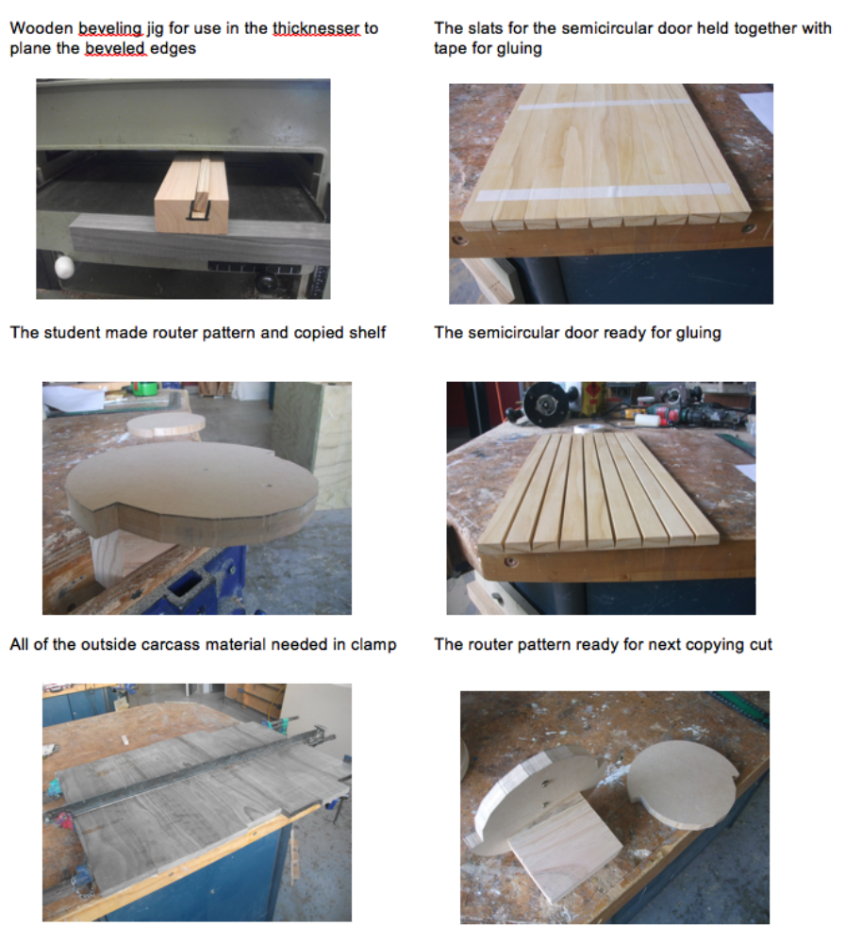
Appendix A: Suggestions for working drawings
Establish required diameter and height of the internal revolving power tower.
Draw up a detailed working drawing showing a cross-section of the plan view of the power tower, beginning with the central axis point.
The working drawings need to show the exact details of the following:
- The diameter of the revolving power tower. At least 180 mm is recommended for overall stability of the final product and also effective storage space.
- An indication of exactly how much of the power tower will be covered by vertical slats and how much will be exposed when it is in the open position.
- A second smaller diameter drawn around half of the circle showing exactly where the 15 mm vertical slats are recessed into the circle.
- Radial lines coming out from the centre, through the inner diameter, showing where the slats will sit flat onto cut out faces rather than being flat slats against a curved shelf with unsightly gaps.
- The drawing needs also to show the sides and back of the outer cabinet, flat surfaces by design, and an allowance for the overhang of the cabinet top.
- A vertical handle strip, which will also serve as a stop when the revolving core of the power tower is in the fully open position.
- It will also be necessary to have at least a side elevation drawing of the power tower from which to complete an accurate cutting list.
- It is recommended that both the cross-sectional plan and the side view be drawn full size onto cardboard.

