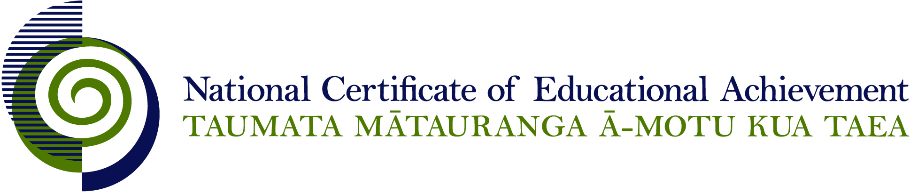

NCEA Level 2 Religious Studies

Conditions of Assessment

General Information

Subject Reference | Religious Studies
Domain | Understanding Religion
Level | 2

This document provides guidelines for assessment against internally assessed standards. Guidance is provided on:
- appropriate ways of, and conditions for, gathering evidence
- ensuring that evidence is authentic
- any other relevant advice specific to an achievement standard.

NB: It is expected that teachers are familiar with additional generic guidance on assessment practice in schools published on the NZQA website. This should be read in conjunction with these Conditions of Assessment.

For All Standards

Internal assessment provides considerable flexibility in the collection of evidence. Evidence can be collected in different ways to suit a range of teaching and learning styles and a range of contexts of teaching and learning. Care needs to be taken to allow students opportunities to present their best evidence against the standard(s) that are free from unnecessary constraints.

It is recommended that the design of assessment reflects and reinforces the ways students have been learning. Collection of evidence for the internally assessed standards could include, but is not restricted to, an extended task, an investigation, digital evidence (such as recorded interviews, blogs, photographs or film) or a portfolio of evidence.

It is also recommended that the collection of evidence for internally assessed standards should not use the same method that is used for any external standards in a programme/course, particularly if that method is using a time bound written examination. This could unfairly disadvantage students who do not perform well under these conditions.

A separate assessment event is not needed for each standard. Often assessment can be integrated into one activity that collects evidence towards two or three different standards from a programme of learning. Evidence can also be collected over time from a range of linked activities (for example, in a portfolio).This approach can also ease the assessment workload for both students and teachers.

Effective assessment should suit the nature of the learning being assessed, provide opportunities to meet the diverse needs of all students and be valid and fair.

Where manageable, and after further learning has taken place, students may be offered a maximum of one further opportunity for assessment against an assessment standard within a year.

Authenticity of student evidence needs to be assured regardless of the method of collecting evidence. This needs to be in line with school policy. For example, for an investigation carried out over several sessions, this could include teacher observations or the use of milestones such as meetings with students, journal or photographic entries recording progress etc.

Specific Information for All Internal Achievement Standards

Students should be given the opportunity to present evidence in a format that suits their individual learning style or the context of the assessment activity. Suggested formats include: computer-assisted presentation, timeline, journal, essay, brochure, poster, photo-essay, debate, role-play, drama performance, video, model, web 2.0 tools, and prepared speech.

Students may work on assessments individually or in groups. The contribution of each student needs to provide sufficient evidence for the assessment of that student and allow that student the opportunity to gain the standard with Achieved, Merit, or Excellence grades.

It is expected that students source some of the material that will inform the explanation, with direction and support from a teacher or supervisor. Some material may be supplied by the teacher or supervisor as part of the delivery package, e.g. textbooks, lessons, scholarly works, or other teaching tools.

Students should have opportunities to work on assessments both in and out of class time.

Specific Information for Individual Internal Achievement Standards

Achievement Standard Number | 91724 Religious Studies 2.1
Title | Explain a significant theme in a sacred text within a religious tradition
Number of Credits | 6
Version | 1

Teachers or supervisors may assist students by stipulating the sacred text, the theme, and the religious tradition to be used for the assessment activity, and by guiding the early direction of the student’s work. They need to ensure that students identify the religious tradition and the sacred text being addressed for their assessment activity.

Achievement Standard Number | 90821 Religious Studies 2.2
Title | Explain the changes in an expression(s) of a religious tradition
Number of Credits | 6
Version | 2

Teachers or supervisors may assist students by stipulating the expression of a religious tradition to be used for the assessment activity, and by guiding the early direction of the student’s work. Students should be guided to identify the changes from source material. They need to ensure that students identify the religious tradition and the expression being addressed for their assessment activity.

Achievement Standard Number | 90822 Religious Studies 2.3
Title | Explain how a contemporary social action derives from the ethical principles of a religious tradition
Number of Credits | 6
Version | 2

Teachers or supervisors may assist students by stipulating the contemporary social action and the religious tradition to be used for the assessment activity, and by guiding the early direction of the student’s work. Students should be guided to identify the relevant ethical principles from source material. They need to ensure that students identify the religious tradition and the contemporary social action being addressed for their assessment activity.

Achievement Standard Number | 90823 Religious Studies 2.4
Title | Explain the key beliefs within two religious traditions in relation to a significant religious question
Number of Credits | 6
Version | 2

Teachers or supervisors may assist students by stipulating the two religious traditions and the significant religious question to be used for the assessment activity, and by guiding the early direction of the student’s work. Students should be guided to identify the relevant key beliefs from source material. They need to ensure that students identify the religious traditions and the significant religious question being addressed for their assessment activity.

