NZQA
Approved

Achievement standard: 91296 Version 2
Standard title: Produce a landscape plan
Level: 2
Credits: 4
Resource title: The corner section
Resource reference: Agricultural and Horticultural Science VP-2.8 v2
Vocational pathway: Construction and Infrastructure

Date version published | February 2015 Version 2  To support internal assessment from 2015
Quality assurance status | These materials have been quality assured by NZQA.  NZQA Approved number A-A-02-2015-91296-02-8140
Authenticity of evidence | Assessors/educators must manage authenticity for any assessment from a public source, because learners may have access to the assessment schedule or exemplar material.  Using this assessment resource without modification may mean that learners’ work is not authentic. Assessors/ educators may need to change figures, measurements or data sources or set a different context or topic to be investigated or a different text to read or perform.

Vocational Pathway Assessment Resource
Achievement standard: 91296
Standard title: Produce a landscape plan
Level: 2
Credits: 4
Resource title: The corner section
Resource reference: Agricultural and Horticultural Science VP-2.8 v2
Vocational pathway: Construction and Infrastructure
Learner instructions

Introduction
This assessment activity requires you to produce a landscape plan and explain how user needs, environmental factors, and local government regulations are met.
You are going to be assessed on how comprehensive the landscape plan you produce is. The plan needs to be visually appealing and to take into account anticipated future user needs, environmental factors, and local government regulations.
The following instructions provide you with a way to structure your work so you can demonstrate what you have learnt and achieve success in this standard.
Assessor/educator note: It is expected that the assessor/educator will read the learner instructions and modify them if necessary to suit their learners.

Task
A new house is to be built in your local area. The owner of the property has requested assistance with a landscape design. The section is on a corner at the edge of a large subdivision, and the road on the east side currently stops at the end of the section. There are plans to develop the land beyond the section on the northern fence into a small subdivision (which will have another access to the main road).
Go to Resource A and look at the a schematic plan of the house, which measures 12m x 19m, in Diagram 1, and the location of the house on the section in Diagram 2. The diagrams are not drawn to scale.
The property owner has specifically requested that the landscape plan include a vegetable garden, flower garden (roses), fence, lawn, clothesline, a barbeque area, and at least one tree, which will provide shade in the summer. See Resource B for standard industry design symbols.

Produce a landscape plan
Produce a visually appealing planting diagram to scale on A3 paper that shows hard features (fences, decks, retaining walls, paved areas, raised gardens, paths, etc.) and named soft features (plant cultivar/variety name). ‘Visually appealing’ means that it shows that you have considered aspects such as proportion, unity, balance, transition, and symmetry.
For explanations of these terms refer to Resource C.

Produce a report that explains your landscape plan
Produce a report in which you justify your choice and positioning of features by providing a detailed explanation of how the landscape plan satisfies current and future user needs, environmental factors, and local government regulations.
To help you when you are writing your report, keep a log book which contains:
- all of your rough notes and sketches of the site
- any research notes you make when gathering information
- your research sources.
In your report:
- explain significant environmental factors of the site
- explain how these environmental factors affect the use of the site
- explain the significant needs of the current users of the site
- show consideration of the possible change of needs for future users of the site
- show you have researched local government regulations including those that relate to relevant city/district plans and safety legislation: http://www.legislation.govt.nz/
- show you have researched plants which will survive well in the environmental conditions of the site, fulfill user needs, and have the potential to be visually appealing when mature.

Resource A
Living
Bed 4
Bed 3
Kitchen
Entry
Bed 2
Bath
Master
Bedroom
Garage
Dining
Diagram 1

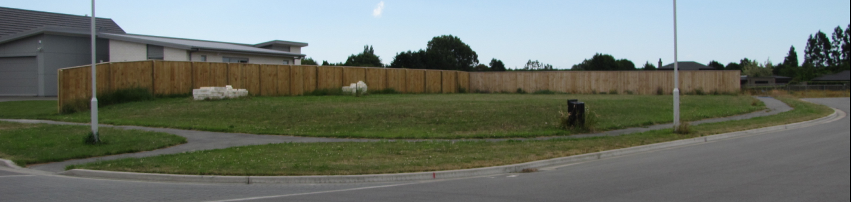

N
45m
24 m

Diagram 2

Resource B

Design symbols
Use these standard industry symbols as necessary in your landscape plan.
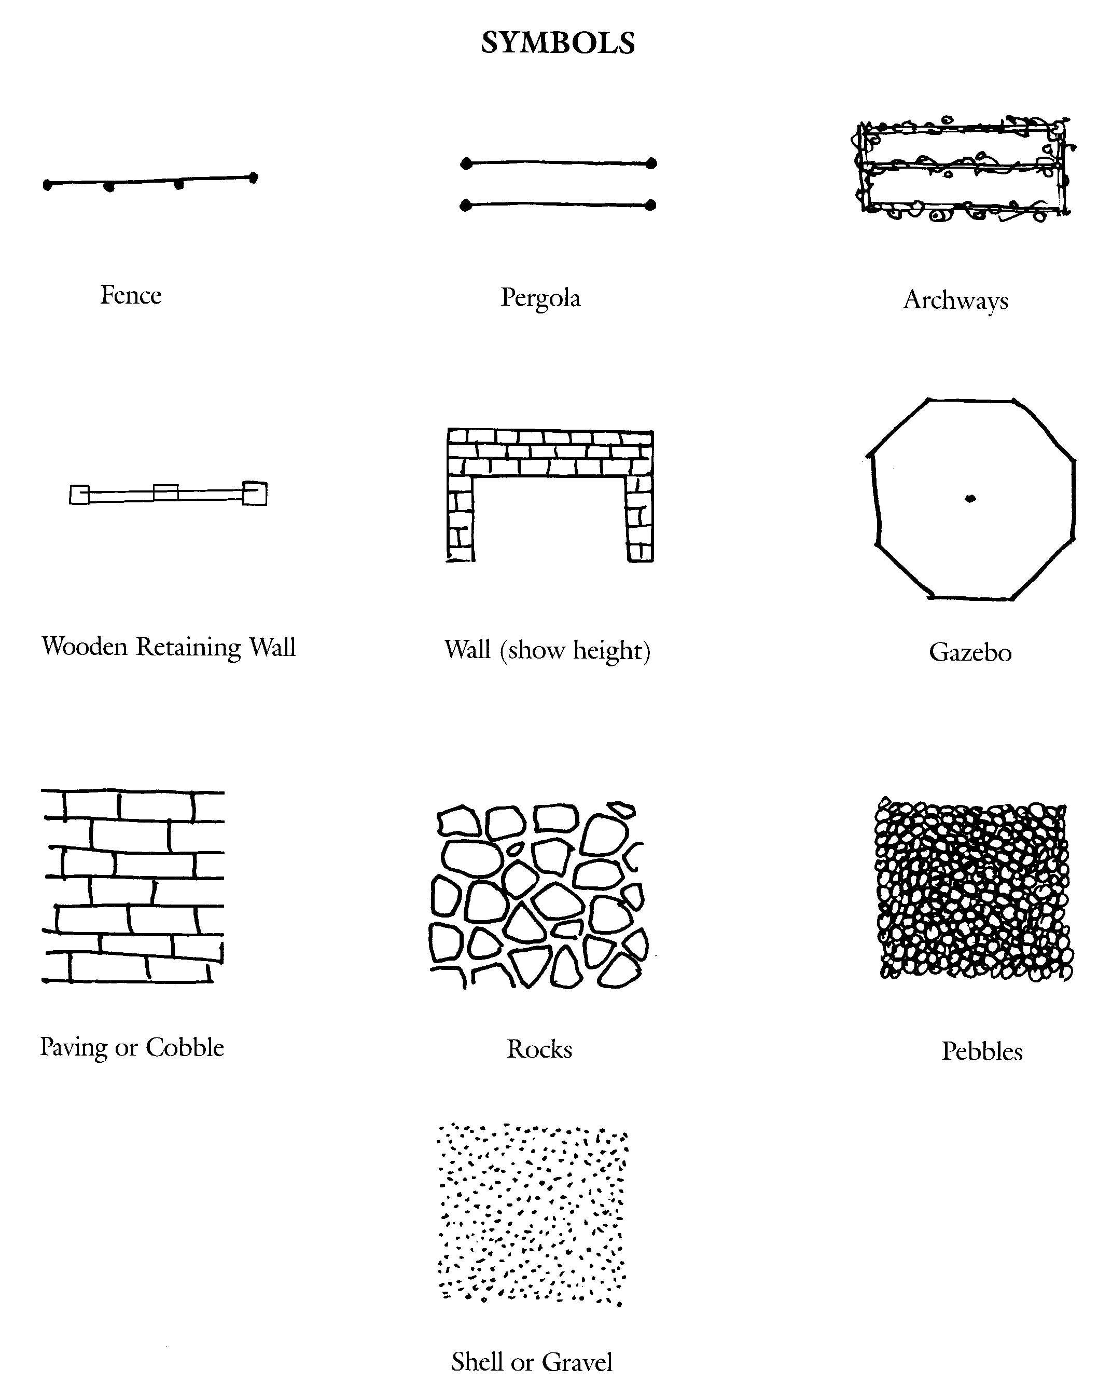

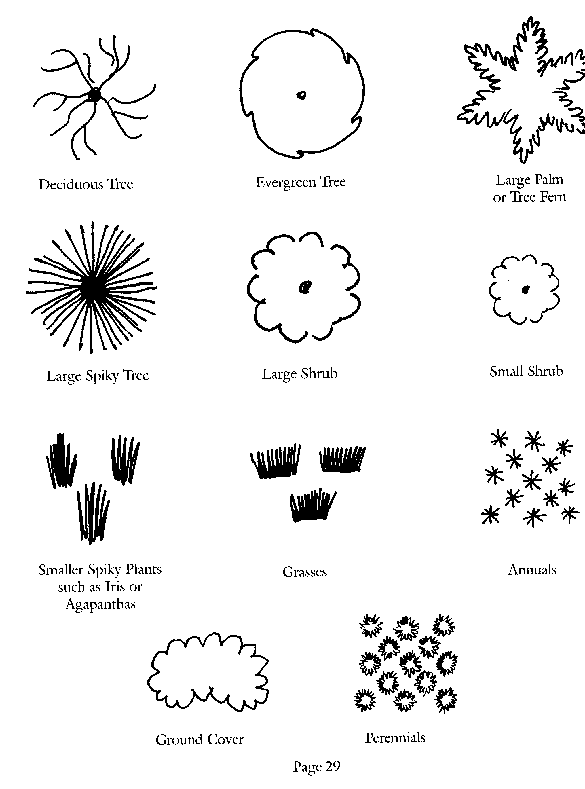

Design symbols sourced from The Ellerslie Flower Show – An introduction to Garden Design.

Resource C

Researching information for your plan and report
- Hard landscape features are non-living features, for example paths, fences, walls, buildings, and water features.
- Soft landscape features are living features, for example trees, shrubs, climbers, annuals, perennials, lawns, ground cover.
- Research plants which will survive well in the environmental conditions of the site, fulfill the user’s needs, and have the potential to be visually appealing when mature.
- Environmental factors could include climatic factors such as wind, light, rainfall, and temperature, as well as topography, aspect, soil type, waterways.
- User needs could include access, privacy, safety, shelter, shade, aesthetics, recreation, entertainment, production, and utility.
- Future user needs could relate to changing family situations, impact of mature shape and size. Future maintenance of soft landscape features should be considered and could relate to future building plans.
- Local government regulations include those pertaining to relevant city/district plans and safety legislation. These could relate to closeness of planting to boundaries, consideration of height of trees close to power lines, and removal of heritage trees.

Vocational Pathway Assessment Resource
Achievement standard: 91296
Standard title: Produce a landscape plan
Level: 2
Credits: 4
Resource title: The corner section
Resource reference: Agricultural and Horticultural Science VP-2.8 v2
Vocational pathway: Construction and Infrastructure
Assessor/Educator guidelines

Introduction
The following guidelines are supplied to enable assessors/educators to carry out valid and consistent assessment using this internal assessment resource.
As with all assessment resources, education providers will need to follow their own quality control processes. Assessors/educators must manage authenticity for any assessment from a public source, because learners may have access to the assessment schedule or exemplar material. Using this assessment resource without modification may mean that learners' work is not authentic. The assessor/educator may need to change figures, measurements or data sources or set a different context or topic. Assessors/educators need to consider the local context in which learning is taking place and its relevance for learners.
Assessors/educators need to be very familiar with the outcome being assessed by the achievement standard. The achievement criteria and the explanatory notes contain information, definitions, and requirements that are crucial when interpreting the standard and assessing learners against it.

Context/setting
This activity requires learners to produce a visually appealing landscape plan using hard and soft features for an existing site. The plan must show how user needs, environmental factors, and local government regulations have been considered.

Conditions
Learners need to work independently to complete this activity. Confirm the time frame with your learners.

Resource requirements
A workbook could be developed to guide learner responses.
Samples of drawing conventions used in the landscape industry should be provided, for example the use of symbols for plants and hard landscaping features.
Learners may need equipment for production of landscape plans, which could include:
- clipboards
- plain white A3 paper and graph paper
- class set of 2B pencils for sketching and HB pencils for design work
- coloured pencils with a range of shades for each colour
- pencil sharpeners, rulers, set squares, compasses, and plastic circle stencils
- measuring tapes.

Additional information
Use of PowerPoint and DVDs showing a variety of landscapes and designs can be very helpful for guiding learners.
A plan of a subdivision may help in the production of site plans to scale.
Plans produced electronically (for example using CAD design) are acceptable.
Useful websites include:
http://www.lianz.org.nz/
http://blog.landscapedesign.co.nz/
http://www.dbh.govt.nz/rma-guide-index
http://www.mfe.govt.nz/publications/rma/aee-guide-aug06/

http://www.mfe.govt.nz/publications/rma/everyday/consent-consultation/

Other possible contexts for this vocational pathway
Other possible contexts for producing a landscape plan include the following:
- retirement village landscaping
- outdoor dining area for café
- vegetable and flower gardens for school
- large feature roundabout
- redevelopment of local park
- supermarket car park.

Assessment schedule: Agricultural and Horticultural Science 91296 – The corner section
Evidence/Judgements for Achievement | Evidence/Judgements for Achievement with Merit | Evidence/Judgements for Achievement with Excellence
The learner produces a landscape plan by:  - including a planting diagram of the site plan  For example:  The plan is drawn to scale using landscape conventions and fully labelled, including associated keys to soft and hard landscaping features, and possibly includes the position of soft and hard landscape features, and consideration of user needs, significant environmental factors and local government regulations.  - providing a report that accompanies the plan  For example:  The report explains how the choice and positioning of hard and soft landscaping features meets the needs of the property owner, environmental factors, and local government regulations.  The above expected learner responses are indicative only and relate to just part of what is required. | The learner produces an in-depth landscape plan by:  - including a planting diagram of the site plan  For example:  - the plan is drawn to scale using landscape conventions and fully labelled, including associated keys to soft and hard landscaping features  - the plan includes the position of soft and hard landscape features, named plants, and shows consideration of user needs, significant environmental factors, and local government regulations.  - providing a detailed report that accompanies the plan  For example:  The report explains how the choice and positioning of hard and soft landscaping features meets the needs of the property owner, environmental factors, and local government regulations. The report explains environment factors and how they impact on the site, giving supporting evidence.  The above expected learner responses are indicative only and relate to just part of what is required. | The learner produces a comprehensive landscape plan by:  - including a planting diagram of the site plan  For example:  - the plan is drawn to scale using landscape conventions and fully labelled, including associated keys to soft and hard landscaping features  - the planting diagram is visually appealing, and clearly shows sensitivity to and/or awareness of some aspects of proportion, unity, balance, transition and symmetry  - the planting diagram includes the position of soft and hard landscape features, named plants, and shows consideration of user needs, significant environmental factors, and local government regulations.  - providing a detailed report that accompanies the plan  For example:  - the report explains how the choice and positioning of hard and soft landscaping features meets current and future user needs, environmental factors, and local government regulations  - the report explains environment factors and how they impact on the site, with supporting evidence. The learner might discuss how the design will look when the plants mature and possible changes to the site’s use.  The above expected learner responses are indicative only and relate to just part of what is required.
Final grades will be decided using professional judgement based on an examination of the evidence provided against the criteria in the Achievement Standard. Judgements should be holistic, rather than based on a checklist approach.

