NZQA
Approved

Achievement standard: 91101 Version 2
Standard title: Produce a selection of crafted and controlled writing
Level: 2
Credits: 6
Resource title: Colour and light
Resource reference: English VP-2.4 v2
Vocational pathway: Construction and Infrastructure

Date version published | February 2015 Version 2  To support internal assessment from 2015
Quality assurance status | These materials have been quality assured by NZQA.  NZQA Approved number A-A-02-2015-91101-02-8158
Authenticity of evidence | Assessors/educators must manage authenticity for any assessment from a public source, because learners may have access to the assessment schedule or exemplar material.  Using this assessment resource without modification may mean that learners’ work is not authentic. Assessors/ educators may need to change figures, measurements or data sources or set a different context or topic to be investigated or a different text to read or perform.

Vocational Pathway Assessment Resource
Achievement standard: 91101
Standard title: Produce a selection of crafted and controlled writing
Level: 2
Credits: 6
Resource title: Colour and light
Resource reference: English VP-2.4 v2
Vocational pathway: Construction and Infrastructure
Learner instructions

Introduction
This assessment activity requires you to produce two pieces of crafted and controlled writing that develops, sustains, and structures ideas about interior decoration. In these pieces you will use language features appropriate to audience and purpose to create effects.
You are going to be assessed on how effectively you develop, sustain, and structure ideas about interior décor in both pieces of writing, using language features appropriate to audience and purpose to command attention.
The following instructions provide you with a way to structure your work so you can demonstrate what you have learnt and achieve success in this standard.
Assessor/educator note: It is expected that the assessor/educator will read the learner instructions and modify them if necessary to suit their learners.

Task
There are ongoing product changes in the interior design sector. Your first piece of writing will be for an interior décor website. Promote a theory relating to new research or technologies within the painting and decorating profession. This may relate to colour, technique, lighting, materials, etc.
For your second piece of writing, you will use the information you found, supported by other research, to prepare a feature article for an interior design magazine.
Part 1: Promote a theory related to painting and decorating
Produce your writing on a particular theory by doing the following:
- identify a current theory, or technology that interests you
  - for example, colour systems and the effect on peoples’ state of mind, effects of lighting on colour (for example colour, intensity, efficiency, absorption, reflection) or sustainable practices and non-toxic materials. You may choose your own topic in negotiation with your assessor/educator.
- gather information about the theory or technology. These could include the business’ own promotional materials, interviews with the operator, employees, or customers, and books, magazines, and internet information about the business in general
- clearly identify:
  - the nature of the theory (scientific principles and research findings)
  - the benefits of the approach (for example costs, environment, mood, maintenance)
  - comparison with existing practices
  - opinions that are negative about the theory (i.e. prepare counter arguments)
  - case studies and/or personal anecdotes.
- organise your findings. Choose a particular approach to the theory, or technology (as the summary of the key theory or technology is not sufficient) and then build a sustained and convincing argument to support your position
  - make a list of the main features and benefits of the new approach, then develop, sustain and structure your ideas to convince people to adopt this practice, for example it is not enough just to say that ‘Non-toxic paints are better’
  - explain why and support your reasoning with evidence, the most compelling arguments are supported by a range of different perspectives, for example ‘We use to use lead in our paint, and asbestos in our ceilings. Then we used turpentine based paints which emit fumes that are unpleasant in the short term and significantly harmful over time. Now non-toxic paints are more pleasant to use, and will not cause headaches or worse illnesses.’
- construct your draft and swap it with another learner. Comment about each other’s work, including:
  - what do you like most?
  - how could they improve the message?
  - what else could they include?
- produce your first piece of writing:
  - use at least 500 words
  - check that your piece of writing develops, sustains, and structures ideas appropriately for the text type, makes connections between ideas, and uses language features that are appropriate to the audience and purpose to command attention
  - make sure your spelling, grammar and punctuation are all correct.

Part 2: Feature article for interior design magazine
Write an article which features the design principle and solutions of a new project. Check the following websites for examples of design features articles:
www.interiordesign.net
http://urbismagazine.com
www.homeanddesign.com
www.interiorsmagazine.net
Produce your article by doing the following:
- identify a specific project. It is best if you can visit an actual project and take your own photographs. It needs to be more complex than a single box room, for example the space may be the entrance foyer and office for a small business, or it may be an open plan lounge, kitchen and dining room of a house. Talk to your assessor/educator, family and friends to identify a suitable space for this purpose
- gather the following information about your chosen space:
  - dimensions: length, width and height and spatial relationships of each section
  - natural light sources: window sizes, glass type (for example clear, tinted, frosted, louvered) compass orientation
  - materials, colours, fitting, paint type, floorings, lighting, ceiling materials, etc
  - function: private, public, traffic areas, etc. (for example what do people do in this space, when do they do it, how many people occupy the space)?
- ask the occupants of the space how they feel about it and what they might do differently. What do they like most about the space? Talk to the owners and contractors if possible. What issues were important to them (cost, durability, sustainability)?
- research and/or visit other spaces with a similar function. Note what you like and dislike, or what works and doesn’t work, about these spaces
- evaluate the strengths and weaknesses of your chosen space. Formulate a conclusion about how successful this project is. Present a sustained argument to support your findings, including:
  - the overall effect and/or success of the space
  - physical layout (for example walls, dimensions, levels, ceiling height, etc.): explain their effect of the occupants and how it supports to function of the space
  - colours for walls, ceiling, flooring and trims: explain their effect on the occupants and how it supports to function of the space
  - types of materials used (paints, carpet, drapes, etc.), what are their special properties (for example cost, durability, ease of maintenance, environment) and why they have been used? Explain their effect of the occupants and how it supports to function of the space
  - types of lighting used (for example natural, recessed, neon, LED), what are their special properties (for example cost, durability, ease of maintenance, environment) and why have you selected them? Explain their effect of the occupants and how it supports to function of the space
  - identify specific problems with the space and how these have been overcome (or what needs to happen to resolve these problems)
  - how the design of the space relates to its specific function and character, for example how it relates to the business philosophy of stylishness for a design company, or creates a feeling of warmth and security for a domestic environment.
- sources of information may include books, magazines, and the internet. Arrange to interview the occupants, owners and customers if the space is commercial. If possible interview the designers and contractors as well. Use their response to support your central idea
- find clear and compelling reasons to support your theory, for example a convincing argument will go beyond ‘Grey paint is nice on this wall’, instead you might say how and why this colour and material creates a specific affect, for example ‘The rear wall is finished with Dulux Interior Avalon. The light tone reflects natural light but is not as glaring as a white wall would be. The neutral colour allows art works to become the central feature of this part of the room.’
- make a mind-map of all the main ideas (see Resource A for an example)
  - link each reason and supporting evidence to the central idea. What is the overall effect the designer is trying to achieve? How does each element support this outcome? How does the outcome align with the needs and preferences of the client?
  - think about which information should come first. Look for convincing ways to support your ideas.
- organise your ideas into a coherent argument, structure your findings carefully, then develop and sustain a strong central idea about this particular space. Write your first draft peer critique. Swap your first draft with another learner. Comment about each other’s work:
  - what do you like most?
  - how could they improve the message?
  - what else could they include?
- produce your second piece of writing:
  - use at least 500 words
  - use unexpected and evocative words, images and reasons, and use text conventions accurately so that the writing contains only minor errors
  - check that your piece of writing develops, sustains, and structures ideas appropriately for the text type, makes connections between ideas, and uses language features that are appropriate to the audience and purpose to command attention
  - make sure your spelling, grammar and punctuation are all correct.

Resource A
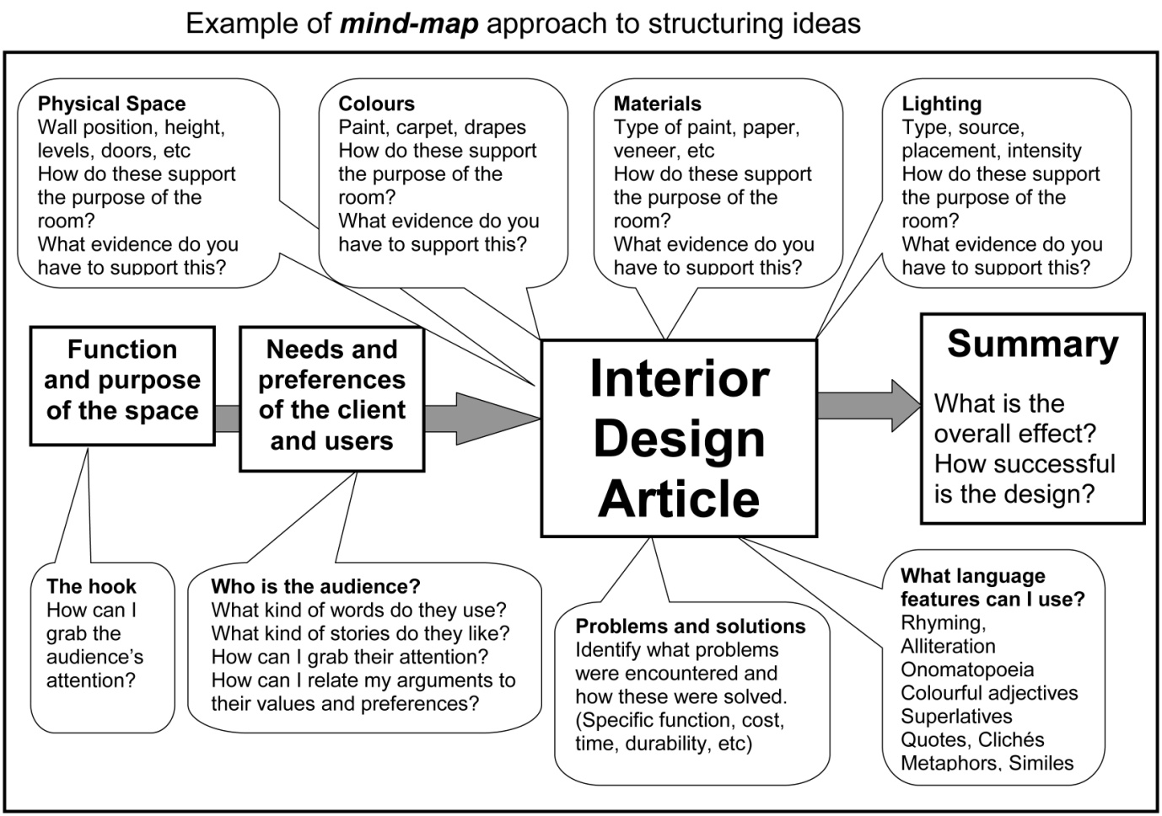

Vocational Pathway Assessment Resource
Achievement standard: 91101
Standard title: Produce a selection of crafted and controlled writing
Level: 2
Credits: 6
Resource title: Colour and light
Resource reference: English VP-2.4 v2
Vocational pathway: Construction and Infrastructure
Assessor/Educator guidelines

Introduction
The following guidelines are supplied to enable assessors/educators to carry out valid and consistent assessment using this internal assessment resource.
As with all assessment resources, education providers will need to follow their own quality control processes. Assessors/educators must manage authenticity for any assessment from a public source, because learners may have access to the assessment schedule or exemplar material. Using this assessment resource without modification may mean that learners' work is not authentic. The assessor/educator may need to change figures, measurements or data sources or set a different context or topic. Assessors/educators need to consider the local context in which learning is taking place and its relevance for learners.
Assessors/educators need to be very familiar with the outcome being assessed by the achievement standard. The achievement criteria and the explanatory notes contain information, definitions, and requirements that are crucial when interpreting the standard and assessing learners against it.

Context/setting
This assessment activity requires learners to produce two pieces of crafted and controlled writing related to interior design. Learners will develop, sustain, and structure effective ideas in writing for a web page and magazine article. Both pieces will use language features, appropriate to this audience and purpose, to command attention.

Conditions
Learners can individually read texts, collect information, and develop ideas for their writing both in and out-of-class time.
The learners should have the opportunity to receive feedback, edit, revise, and polish their work before submitting their final work. The assessor/educator can validly make suggestions about areas where further development is needed, guide learners through the writing process, and might demonstrate how the techniques used in samples and exemplars can be applied to learners’ own writing.
Writing should not be treated as one or two short assessment events. Instead, programme design should ensure that a learner’s writing is developed over the year, and then their best is submitted for summative assessment.

Resource requirements
Learners may need to:
- visit local painting and decorating tradesmen, and interior design professionals
- access appropriate books and magazines, and the internet.

Additional information
Useful websites relating the interior design and/or painting and decorating content include:
www.dulux.co.nz
www.resene.co.nz/
www.wattyl.co.nz
www.decoratenz.org.nz
www.smarterhomes.org.nz/materials/painting-and-decorating/

Assessment schedule: English 91101–Colour and light
Evidence/Judgements for Achievement | Evidence/Judgements for Achievement with Merit | Evidence/Judgements for Achievement with Excellence
The learner produces two pieces of crafted and controlled writing which develop, sustain, and structure ideas, using language features appropriate to audience and purpose to create effects by:  - building on ideas by adding comments, explanations, details or examples appropriate to the selected text type and audience  - making connections between ideas throughout the writing  - deliberately using language features appropriate to the selected text type and purpose to create meaning and effects  - using text conventions accurately so that the writing contains only minor errors  For example, in the feature article the learner:  - uses language structures and vocabulary appropriate to magazine article. This is a space where paint choices need to maximise the natural world. A neutral sand shade in a matt finish would do this.  - outlines and builds on ideas about the qualities of the particular colours, materials and lighting which may include costs, durability, functionality. The selection of paint shade, texture and finish is so important. White was chosen because it seemed to work well. Yet there are over 150 shades of white available…  The above expected learner responses’ are indicative only and relate to just part of what is required. | The learner produces two pieces of crafted and controlled writing which develop, sustain, and structure ideas convincingly, using language features appropriate to audience and purpose to create convincing effects by:  - building on ideas, adding comments, explanations, details, or examples appropriate to the selected text type and audience  - making connections between ideas throughout the writing  - developing ideas and structure that are reasoned, clear, and relevant to the purpose of the text  - deliberately using language features appropriate to the selected text type and purpose to create meaning, effects, and audience interest  - using text conventions accurately so that the writing contains only minor errors  For example, in the feature article the learner:  - uses a variety of language structures and effective vocabulary to tailor the message to the interests and values of the reader. It’s the combination of subtly natural paint choices and flow into the outdoor space that makes this a winner.  - makes direct and convincing links between the specific features of the colours, materials and lighting with the purpose of the space and responses of the users. The selection of paint shade, texture and finish is so important. The client’s request, that the entrance be filled with light, means that white is the first choice. Yet there are over 150 shades of white available…  The above expected learner responses are indicative only and relate to just part of what is required. | The learner produces two pieces of crafted and controlled writing which develop, sustain, and structure ideas effectively, using language features appropriate to audience and purpose to command attention by:  - building on ideas, adding comments, explanations, details, or examples appropriate to the selected text type and audience  - making connections between ideas throughout the writing  - using ideas and structure to create texts that are compelling, persuasive, innovative, and/or striking  - deliberately and consistently using inventive or articulate language features, vocabulary selection, distinctive personal voice, dimensions or viewpoints to create meaning, effects, and audience engagement  - using text conventions accurately so that the writing contains only minor errors  For example, in the feature article the learner:  - uses innovative structures, evocative and innovative vocabulary choices to engage the reader. The integration of landscape and paint selections, with the ‘slubby’ colours and textural contrasts, creates an inviting space. There’s a kind of magic that’s woven.  - uses persuasive and innovative arguments to generate a compelling evaluation of the identified space. The selection of paint shade, texture and finish is vital. The client’s request, that the entrance be filled with light, means that white is the first choice. However, there are over 150 shade and tint variations of white alone. And that’s before consideration of finishes and textures. The final choice, ‘Sliced vanilla’, meets the…  The above expected learner responses are indicative only and relate to just part of what is required.
Final grades will be decided using professional judgement based on an examination of the evidence provided against the criteria in the Achievement Standard. Judgements should be holistic, rather than based on a checklist approach.

