NZQA
Approved

Achievement standard: 91101 Version 2
Standard title: Produce a selection of crafted and controlled writing
Level: 2
Credits: 6
Resource title: Arguing for a cause
Resource reference: English VP-2.4 v2
Vocational pathway: Primary Industries

Date version published | February 2015 Version 2  To support internal assessment from 2015
Quality assurance status | These materials have been quality assured by NZQA.  NZQA Approved number A-A-02-2015-91101-02-8156
Authenticity of evidence | Assessors/educators must manage authenticity for any assessment from a public source, because learners may have access to the assessment schedule or exemplar material.  Using this assessment resource without modification may mean that learners’ work is not authentic. Assessors/ educators may need to change figures, measurements or data sources or set a different context or topic to be investigated or a different text to read or perform.

Vocational Pathway Assessment Resource
Achievement standard: 91101
Standard title: Produce a selection of crafted and controlled writing
Level: 2
Credits: 6
Resource title: Arguing for a cause
Resource reference: English VP-2.4 v2
Vocational pathway: Primary Industries
Learner instructions

Introduction
This assessment activity requires you to produce two pieces of crafted and controlled writing that develop, sustain and structure ideas related to a primary industry. In these pieces you will use language features appropriate to audience and purpose to create effects.
You are going to be assessed on how effectively you develop, sustain and structure ideas related to primary industries in both pieces of writing, using language features appropriate to audience and purpose to command attention.
The following instructions provide you with a way to structure your work so you can demonstrate what you have learnt and achieve success in this standard.
Assessor/educator note: It is expected that the assessor/educator will read the learner instructions and modify them if necessary to suit their learners.

Task
For your first piece of writing, select and research an issue for a primary industry of your choice. Act like a reporter and find out the positive and negative aspects of the issue, and then write a report that either supports or challenges a significant or topical issue for the industry.
For your second piece, write a webpage for a primary food product website that identifies and gives an opinion on which primary food source, such as milk, beef, lamb, or specific seafood species, is best. The goal of this piece of writing is to persuade people that your chosen food source is superior to all others. Your arguments can include nutritional values, economic returns, sustainable practices, or all three. The style of writing of this piece needs to be carefully crafted to engage a general and knowledgeable audience.
Part 1: Report on a significant or topical issue in a primary industry
Produce your writing on a particular issue by doing the following:
- identify a primary industry that interests you, for example aquaculture, agriculture (beef, cropping, dairying, sheep, deer), horticulture, fishing, forestry.
- identify an issue that is related to that primary industry. The example used in this resource is the expansion of the salmon farming industry
- decide on your position in arguing for or against it. Build upon a central idea, and support this with relevant evidence identifying:
  - the basic facts, contact details, costs, equipment, locations, history, training and skills needed, environmental impact, etc.
  - how the industry is perceived by the public. For example, search for news stories in the local or national papers or on TV, find interviews with people in the industry, research how the general public feels about the industry using internet blogs and websites
  - the key positive and negative aspects of the particular issue. For example, a salmon fish farm is positive in that it provides affordable food but negative in that it is seen as cruel to the fish, and pollutes the environment.
- plan your report (see Resource A for an example of planning using a mind-map). Include two main parts:
  - the general overview of the industry, what it is, how it operates, how it came to be, and why it is essential to the country?
  - what is the significant issue facing the industry, why is it contentious, what needs to change, what is your position, why does it need to change, how does it need to change?
- choose a particular approach to the issue (as the summary of the key issue is not sufficient) and then build a sustained and convincing argument to support your position:
  - explain the main unique features of each part, then develop, sustain and structure your ideas to convince people about your position. For example, it is not enough to state ‘Salmon farms are good for the economy’
  - explain why and support your reasoning with evidence. The most compelling arguments are supported by a range of different perspectives, for example ‘Salmon farms provide employment for fifty five workers in the Northland region, and bring two point four million dollars into the Northland economy according to Ministry for Primary Industries statistics. My aunt serves salmon once a week, and says that it’s a healthy and cheaper alternative to other high protein foods like porterhouse steak.’
- give consistent examples throughout your argument. For example, in the case of salmon farming you might emphasise the regional economic benefits. This means your ideas will build upon each other and become more convincing
- use your planning to construct your first draft and swap it with another learner. Comment about each other’s work, including:
  - what do you like most?
  - how could they improve the message?
  - what else could they include?
- review and revise your draft
- produce your first piece of writing:
  - use at least 500 words
  - check that your piece of writing develops, sustains, and structures effective ideas appropriately for the text type, makes connections between ideas, and uses language features that are appropriate to the audience and purpose to command attention
  - make sure your spelling, grammar and punctuation are all correct.

Part 2: Which primary food source is king?
Produce a second piece of writing to present your argument by doing the following:
- identify a primary food source in New Zealand. For example you may choose fisheries in general, salmon farm fishing, or just snapper
- write an article that promotes this type of food as essential to New Zealand society. Arguments to support this position can include economic, nutritional, sustainable, or other compelling reasons. Gather a variety of evidence to support your position, and build upon this central idea
  - what is the food source?
  - how is this food source managed?
  - what are the personal benefits of the food source to customers, value, health, etc.?
  - what is the wider impact of this food source on the food industry (for example economic and/or environmental impacts)?
  - what scientific evidence is there to support your position?
  - sources of information may include promotional materials, scientific reports, and interviews with the operator, employees, or customers, and books, magazines, or internet information about the business in general.
- Structure your argument for your audience. The audience will include experts in the primary industry so your facts need to be correct, and will also include the general public so technical terms will need to be explained:
  - why is your chosen food source the best – this is your ‘central idea’
  - key benefits of this food source – you need to make complex links between the industry, customers and society in general to be convincing
  - how the food source compares favourably to other options
  - prepare counter arguments to perceived problems, for example where a vegetarian suggests that eating fish is cruel, you can say that the fish are killed humanely, and that we are biologically designed to eat their flesh.
- Find clear and compelling reasons to support your food type. For example, a convincing argument will go beyond statements such as ‘Fish is good for you because it has omega 3, and build on them by making connections, such as ‘We have an ageing population, the country’s health care system is struggling to cope with their illnesses and injuries. Omega 3 is the miracle substance to combat the effects of ageing and omega 3 is most concentrated in fish’:
  - support your arguments with reasons. Think of new, unexpected, or persuasive ways to support your case
  - make links between personal, social, and economic evidence
  - think about which information should come first. Look for convincing ways to support your ideas. (See Resource B for an example of a way you can organise your ideas.)
- use your planning to construct your first draft and swap it with another learner. Comment about each other’s work, including:
  - what do you like most?
  - how could they improve the message?
  - what else could they include?
- review and revise your draft
- produce your second piece of writing:
  - use at least 500 words
  - check that your piece of writing develops, sustains, and structures effective ideas appropriately for the text type, makes connections between ideas, and uses language features that are appropriate to the audience and purpose to command attention
  - make sure your spelling, grammar and punctuation are all correct.

Resource A
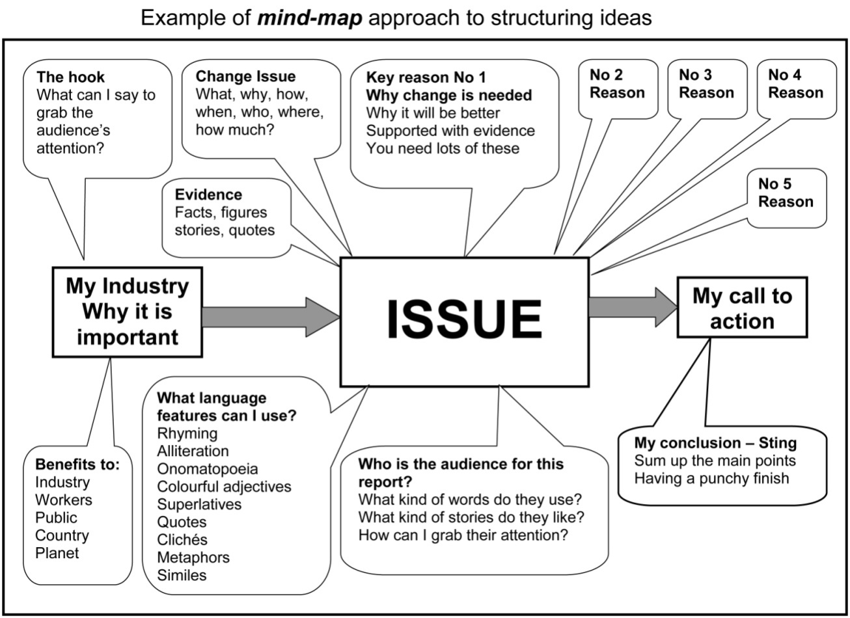

Resource B
Vocational Pathway Assessment Resource
Achievement standard: 91101
Standard title: Produce a selection of crafted and controlled writing
Level: 2
Credits: 6
Resource title: Arguing for a cause
Resource reference: English VP-2.4 v2
Vocational pathway: Primary Industries
Assessor/Educator guidelines

Introduction
The following guidelines are supplied to enable assessors/educators to carry out valid and consistent assessment using this internal assessment resource.
As with all assessment resources, education providers will need to follow their own quality control processes. Assessors/educators must manage authenticity for any assessment from a public source, because learners may have access to the assessment schedule or exemplar material. Using this assessment resource without modification may mean that learners' work is not authentic. The assessor/educator may need to change figures, measurements or data sources or set a different context or topic. Assessors/educators need to consider the local context in which learning is taking place and its relevance for learners.
Assessors/educators need to be very familiar with the outcome being assessed by the achievement standard. The achievement criteria and the explanatory notes contain information, definitions, and requirements that are crucial when interpreting the standard and assessing learners against it.

Context/setting
This assessment activity requires learners to produce two pieces of crafted and controlled writing. The first piece will be about an issue that is faced by a primary industry, the expansion of the salmon farming industry is used as an example in this resource. The second requires learners to write a webpage for a primary food product website that identifies and gives an opinion on which primary food source, such as milk, beef, lamb, or specific seafood species, is best. Learners will develop, sustain and structure effective ideas in writing for a web page and newspaper report. Both pieces will use language features appropriate to this audience and purpose, to command attention.

Conditions
Learners should have the opportunity to receive feedback, edit, revise, and polish their work before submitting their final work. The assessor/educator can validly make suggestions about areas where further development is needed, guide learners through the writing process, and might demonstrate how the techniques used in samples and exemplars can be applied to the individual learners’ own writing.
Writing should not be treated as one or two short assessment events. Instead, programme design should ensure that a learner’s writing is developed over the year, and then their best is submitted for summative assessment.

Resource requirements
Learners may need access to local primary industry operations, appropriate books and magazines, and the internet.

Additional information
Useful websites relating to the primary industries include:
Ministry for Primary Industries: www.mpi.govt.nz
Agriculture: www.agito.ac.nz
Forestry: www.insights.co.nz and www.fitec.org.nz
Horticulture: www.hortito.org.nz and www.hortnz.co.nz
Seafood: www.seafoodito.co.nz

Assessment schedule: English 91101 – Arguing for a cause
Evidence/Judgements for Achievement | Evidence/Judgements for Achievement with Merit | Evidence/Judgements for Achievement with Excellence
The learner produces two pieces of crafted and controlled writing which develop, sustain, and structure ideas, using language features appropriate to audience and purpose to create effects by:  - building on ideas by adding comments, explanations, details, or examples appropriate to the selected text type and audience  - making connections between ideas throughout the writing  - deliberately using language features appropriate to the selected text type and purpose to create meaning and effects  - using text conventions accurately so that the writing contains only minor errors  For example, in the ‘issues’ report the learner:  - uses language structures and vocabulary appropriate to the formal context. The other side of the argument is that the feed needed for salmon farming pollutes the sea  - shows knowledge of the industrial practices, nutritional benefits and economic advantages, and makes links between this information. In 2006, the total value of salmon farming was 101 million dollars. Today, New Zealand’s salmon industry produces half of the salmon in the world. The economic benefits of this growth industry are substantial.  The above expected learner responses’ are indicative only and relate to just part of what is required. | The learner produces two pieces of crafted and controlled writing which develop, sustain, and structure ideas convincingly, using language features appropriate to audience and purpose to create convincing effects by:  - building on ideas, adding comments, explanations, details, or examples appropriate to the selected text type and audience  - making connections between ideas throughout the writing  - developing ideas and structure that are reasoned, clear, and relevant to the purpose of the text  - deliberately using language features appropriate to the selected text type and purpose to create meaning, effects, and audience interest  - using text conventions accurately so that the writing contains only minor errors  For example, in the ‘issues’ report the learner:  - uses a variety of language structures and effective vocabulary to appeal directly to the audience. On the other hand, salmon farming requires large volumes of additional feed. The result is surplus nitrogen and other nutrients, all which end up in the sea.  - makes direct and convincing links between a range of industrial, personal, economic, environmental and social benefits. In 2006, the total value of salmon farming was 101 million dollars. Today, New Zealand’s salmon industry accounts for half of the world’s production. In the Northland region alone this brings 2.4 million dollars into the local economy.  The above expected learner responses are indicative only and relate to just part of what is required. | The learner produces two pieces of crafted and controlled writing which develop, sustain, and structure ideas effectively, using language features appropriate to audience and purpose to command attention by:  - building on ideas, adding comments, explanations, details, or examples appropriate to the selected text type and audience  - making connections between ideas throughout the writing  - using ideas and structure to create texts that are compelling, persuasive, innovative, and/or striking  - deliberately and consistently using inventive or articulate language features, vocabulary selection, distinctive personal voice, dimensions, or viewpoints to create meaning, effects, and audience engagement  - using text conventions accurately so that the writing contains only minor errors  For example, in the ‘issues’ report the learner:  - uses innovative structures and a targeted evocative vocabulary to connect effectively with the audience. Who pays? Somehow we must balance the certainty of the individual and societal benefits that come with long-term employment with the environmental unknowns of finfish aquaculture.  - uses wide research and personal insight to make unexpected and compelling connections that support the central idea. Money talks. There is overwhelming evidence of the impact the salmon farming industry has on New Zealand’s economic and social wellbeing. In Northland, a region struggling with generational unemployment, there is steady job growth through salmon farming. For a region that has the highest rate of unemployment in the country (9.9% in June 2012), such development is vital to the community. The 2.4 million dollars brought in by the industry results in…  The above expected learner responses are indicative only and relate to just part of what is required.
Final grades will be decided using professional judgement based on an examination of the evidence provided against the criteria in the Achievement Standard. Judgements should be holistic, rather than based on a checklist approach.

