NZQA
Approved

Achievement standard: 91085 Version 3
Standard title: Whakarongo kia mōhio ki te reo o tōna ao
Level: 1
Credits: 6
Resource title: Te ao hurihuri
Resource reference: Te Reo Māori VP-1.1 v3
Vocational Pathway: Social and Community Services

Date version published | January 2017 Version 3  To support internal assessment from 2017
Quality assurance status | These materials have been quality assured by NZQA.  NZQA Approved number A-A-01-2017-91085-03-7395
Authenticity of evidence | Assessors/educators must manage authenticity for any assessment from a public source, because learners may have access to the assessment schedule or exemplar material.  Using this assessment resource without modification may mean that learners’ work is not authentic. Assessors/ educators may need to change figures, measurements or data sources or set a different context or topic to be investigated or a different text to read or perform.

Vocational Pathway Assessment Resource
Achievement standard: 91085
Standard title: Whakarongo kia mōhio ki te reo o tōna ao
Level: 1
Credits: 6
Resource title: Te Ao Hurihuri
Resource reference: Te Reo Māori VP-1.1 v3
Vocational Pathway: Social and Community Services
Learner instructions

Introduction
This assessment activity requires you to complete at least two listening tasks based on experiences in social and community services contexts to demonstrate your understanding of spoken te reo Māori.
You are going to be assessed on how you demonstrate comprehensive understanding of what you hear. You will do this by:
- selecting and expanding on relevant ideas, information, and opinions from the listening texts, with supporting detail or evidence
- showing understanding of possible implied meanings or conclusions
- providing a fully explained response.
The following instructions provide you with a way to structure your work so you can demonstrate what you have learnt and achieve success in this standard.
Assessor/educator note: It is expected that the assessor/educator will read the learner instructions and modify them if necessary to suit their learners.

Task
Complete at least two listening tasks to demonstrate comprehensive understanding of spoken te reo Māori related to the experiences in social and community services contexts.
For each task, you will answer in English. Your assessor/educator will consider your responses as a whole to determine the overall quality of your work.

Part 1: He Aituā!

Wāhanga 1:
You are at the hospital in your ambulance. Listen to directions and plot the route to the accident on your map. Draw the red car in the correct place:
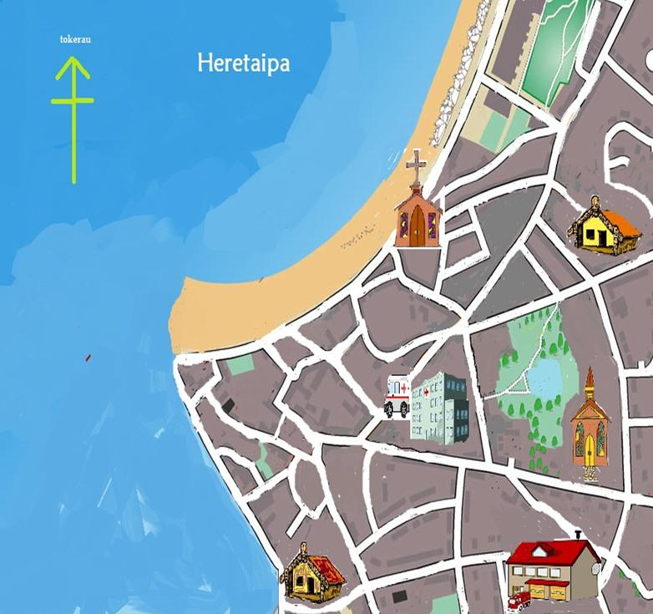

Wāhanga 2:
Listen to the report given about the health status of the accident victims and fill out the patient forms attached in English.

Wāhanga 3:
Plot the return route of the ambulance on your map.

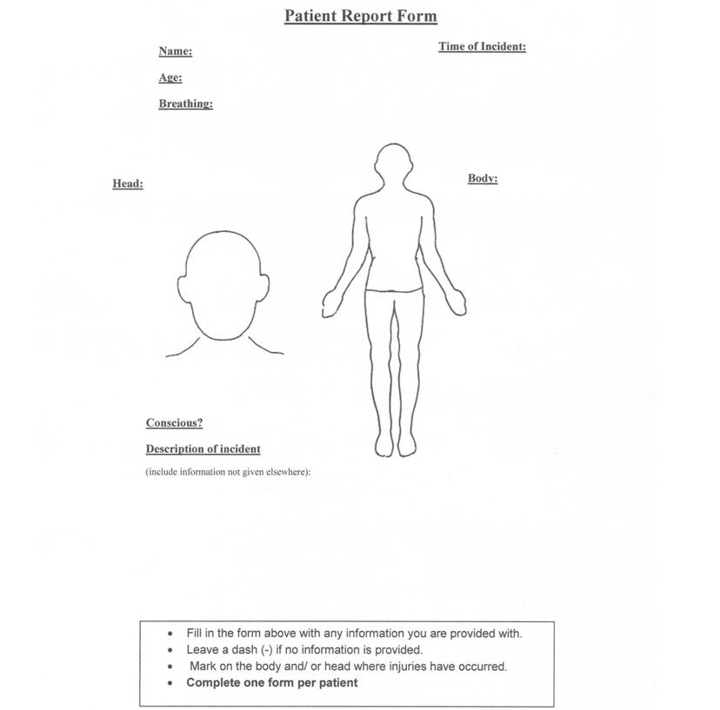

Part 2: Nau Mai
Listen to the passage and answer the following questions in English. (unless otherwise stated):
- What is one thing the kaumātua talks about in his tauparapara?
- What is one thing the kaumātua talks about in his mihi ki ngā hunga mate?
- Fill in the gaps (in Māori) of the kaumātua’s pepeha below:
- Ko Wāhietapu te (3) …
- Ko (4) … te awa
- Ko Ngāti (5) … te hapū
- Ko (6) … te marae
- Ko Tānehuia te (7) …
- Ko (8) … Rangi tēnei e tū mai nei
- Create the kaumātua’s whakapapa. (Note: not all the information will be given at the same time.)
- What is one reason the kaumātua gives for being the right person to talk about the marae? What year was the wharenui built?
- In what order do people speak at a pōwhiri at the kaumātua’s marae?
- What reason does Henare Rangi give for the manuhiri coming inside during a pōwhiri?
- Where does the body lie during a tangihanga at the marae?
- Write out (in Māori) the words of the pepeha the kaumātua talks about.
- In English, explain what the pepeha is about, according to the kaumātua. Be as detailed as possible.
Vocational Pathway Assessment Resource
Achievement standard: 91085
Standard title: Whakarongo kia mōhio ki te reo o tōna ao
Level: 1
Credits: 6
Resource title: Te ao hurihuri
Resource reference: Te Reo Māori VP-1.1 v3
Vocational Pathway: Social and Community Services
Assessor/Educator guidelines

Introduction
The following guidelines are supplied to enable assessors/educators to carry out valid and consistent assessment using this internal assessment resource.
As with all assessment resources, education providers will need to follow their own quality control processes. Assessors/educators must manage authenticity for any assessment from a public source, because learners may have access to the assessment schedule or exemplar material. Using this assessment resource without modification may mean that learners' work is not authentic. The assessor/educator may need to change figures, measurements or data sources or set a different context or topic. Assessors/educators need to consider the local context in which learning is taking place and its relevance for learners.
Assessors/educators need to be very familiar with the outcome being assessed by the achievement standard. The achievement criteria and the explanatory notes contain information, definitions, and requirements that are crucial when interpreting the standard and assessing learners against it.

Context/setting
This activity requires learners to complete at least two listening tasks over the course of the year to demonstrate comprehensive understanding of spoken te reo Māori from social and community services contexts.

Conditions
This is an individual activity.
Responses need to be in English.

Resource requirements

Part 1: He Aituā!
This activity requires each learner to imagine that they are an ambulance driver. They will listen to a passage in three parts that includes where the route to and from an accident is described and details are given about the accident and the victims. The learners fill in the routes on the map and complete the patient forms in English on the learner response sheet provided. The learners will have the response sheets in front of them as they listen. They will need a red pen or pencil. It is preferable that you pre-record the passage.
Read the following to the learners:
You are about to hear a passage called “He Aituā!” in which you imagine that you are an ambulance driver. You will listen to a passage where the route to and from an accident is described to you and details are given about the accident and the victims. There are three parts to the passage:
Wahanga 1: Plot the route of the ambulance to the accident site on your map.
Wahanga 2: In English, fill in the two patient report forms provided.
Wahanga 3: Plot the route of the ambulance from the accident site on your map.
You will hear the passage three times.
Between each part of the passage there will be a one minute pause.
After the third reading, you will have five minutes to complete the tasks.
Script: He Aituā
Wahanga 1:
Kei roto koe i tō waka tūroro. Mai i te hōhipera, e huri ki te taha mauī. Haere mā tēnei rori tae noa ki te pito. Haere whakatehauāuru. Haere tonu tae noa ki te tiriti tuatahi ki te taha mauī. E huri ki tēnei huarahi. Haere whakatetonga, kāore e roa, ka kite koe i tētahi marae. E huri ki tēnei ara, haere whakatehauāuru, ā, ka tae koe ki te taha moana. Haere whakateraki tae noa ki te huringa tuarua ki te taha matau. Kei konei, kei runga i tēnei huarahi te motokā i tutuki. He motokā whero kei waenganui i te ara, e tāpapa ana me ōna wīra ki runga.
Wahanga 2:
E rua ngā tūroro, he tāne, e whā tekau ōna tau, me tētahi kōtiro, e toru pea ōna tau. Ko te āhua nei, he matua me tāna tamāhine. I te haurua mai i te toru karaka i kite te kaitiaki o te marae i tētahi motokā kōwhai e ahu tere ana ki te motokā whero, i te taha hē o te huarahi. Ka pā atu ngā motokā e rua nei, ka takahuri te motokā whero, e toru pea ngā wā, engari ka haere tonu tērā atu motokā.
Te āhua nei, he pai te kōtiro. I kī mai ia ko Ana tōna ingoa. He mamae iti kei tōna ringa matau me tōna rae. Ko te mea tino waimarie, e mau ana i a ia tōna tātua haumaru. Engari, mō te tāne, kāhore anō ia kia oho. He pai te hā, engari he mamae tino nunui kei tōna mātenga. I whiua hoki ia i te motokā, ā, kāhore e mōhiotia ana mehemea kua whati tōna tuarā
Wahanga 3:
Mō tō hokinga ki te hōhipera, ka haere koe mā ngā huarahi e whai ana i te one, ā, tae noa ki te whare karakia. Kātahi ka hoki ki te hōhipera mā te rori ki te taha o te whare karakia. E tū ki waho i te hōhipera.

Part 2: Nau Mai
This activity requires learners to listen to a passage and provide certain information on your response sheet. You will respond in English. It is preferable that you pre-record the passage.
Read the following to the learners:
You are about to hear a passage called “Nau Mai”. A kaumātua from a marae is talking to you at the pōwhiri for a hui you are attending for your course.
You are to listen carefully to the passage. As you listen, you can make notes or begin to answer the questions if you wish. I’ll play the recording three times.
On the second play through there will be a 30 second pause between sections.
After playing the passage a final time, you will have five minutes to finish completing the tasks.
Script: Nau Mai
Tuhia ki te rangi
Tuhia ki te whenua
Tuhia ki te ngākau o te tangata
Ko te mea nui ko te aroha
Tihei wā mauri ora
Ko te mihi tuatahi ki te Atua
Nāna nei ngā mea katoa
E ngā mate kua whetūrangitia, kua haere ki te pō
Haere
Haere
Haere
Haere ki Hawaiki nui, Hawaiki roa, Hawaiki pāmamao
Āpiti hono, tātai hono, te hunga mate ki te hunga mate
Āpiti hono, tātai hono, te hunga ora ki te hunga ora,
Tēnā koutou e te hunga ora kua tae mai i tēnei rā.
Kei te pīrangi tō koutou kaiwhakahaere, kia whakamārama au i ētahi o ngā tikanga, ngā kawa me ngā kōrero mō tēnei marae, a Terehīkoi. Nō reira e ngā ākonga, nau mai, piki mai, areare mai ō koutou taringa!
Ko Wāhietapu te maunga
Ko Waitere te awa
Ko Ngāti Huna te hapū
Ko Terehīkoi te marae
Ko Tānehuia te tangata
Ko Kereopa Rangi tēnei e tū mai nei.
Ko ahau tētahi o ngā kaumātua o tēnei marae. Āe, āe, kei te mōhio ahau, he taitama tonu tōku āhua. Nā, ko au te mātāmua o tōku whānau, Tokorima o mātou, ngā tamariki. Ko māua anake, ko taku teina a Toki, e ora tonu ana. Ko Toki te pōtiki o te whānau. Mai anō, mai anō, i noho ahau ki te taha o te marae nei. Nō reira, he tika māku te kōrero ki a koutou mō tēnei marae ātaahua, a Terehīkoi.
I hangaia te wharenui nei, ko Rangihuia te ingoa, i te tau kotahi mano, iwa rau tekau mā rima, i te wā he tamaiti tonu tōku pāpā, a Rīhari. I tūtaki rāua ko tōku māmā, a Pare ki te tūwheratanga o tēnei marae. Nō Ngāti Porou tōku māmā.
He rerekē te kawa o ia marae o ia marae. Engari ko te kawa o tēnei marae ko te tau-utuutu, arā ka tū mai te tangata whenua ki te kōrero, ā, ka tū atu ngā manuhiri. Kātahi ka hoki mai ki te haukāinga hei whakakapi. Ka kuhu mai te manuhiri ki roto i te wharenui mō te pōwhiri. I kī mai tōku koro, a Hēnare Rangi, ko te take mō tēnei kia kore ngā manuhiri e mākū, nā te mea, anō nei te mahi o te ua ki konei!
Mō ngā tangihanga, ka haria te tūpāpaku ki roto hoki. Ki ētahi atu marae, ka takoto te kāwhena hāngai tonu ana ki te kūaha matua. Engari ki tēnei marae, ka takoto kē ki te taha mauī o te whare.
Ko tētahi pepeha rongonui mō tēnei marae ko tēnei, “He whai huia, he whai hua, ka oti ka whairawa”.
Ko te tikanga o tēnei whakataukī: Ko te huia tētahi manu kaingākautia e ngā tūpuna, mō ōna raukura. He uaua te whaiwhai i te manu huia nō te mea he itiiti noa e ora tonu ana i te wā o tōku tūpuna, a Tānehuia. Nō reira ko tōna tikanga, ki te pukumahi koe, ki te ngana kaha koe, ka mau i a koe te huia, arā, ngā hua o tō mahi, ā, ka whai hua, ka whai rawa.
Heoi, e rau rangatira mā, kua pau te wā ki a au, kua karanga mai tōku hoa rangatira, a Ani, kua reri te kapu tī. Me whakanoa mai te tapu o tēnei wāhanga o te hui, nē rā?
Nō reira, tēnā koutou, tēnā koutou, tēnā rā tātou katoa.

Additional information
This assessment resource contains assessor transcripts of the listening tasks, unless modified learners work may not be authentic.
Learner response sheets for the listening tasks in this resource will require formatting for learner use.
Each task will require the development of evidence statements.
Formative feedback may be provided after each individual task. Final grades will be decided using professional judgement based on an examination of the evidence provided by the two listening tasks against the criteria in the Achievement Standard.

Assessment schedule: Te Reo Māori 91085 – Te ao hurihuri
Evidence/Judgements for Achievement | Evidence/Judgements for Achievement with Merit | Evidence/Judgements for Achievement with Excellence
Whakarongo kia mōhio ki te reo o tōna ao.  The learner demonstrates their knowledge of spoken te reo Māori by:  - providing at least two pieces of evidence of their listening skills in te reo Māori  - showing a basic understanding/being able to make meaning of the text  - understanding the gist of the text without being able to develop explanatory responses/answers or giving fine details  - giving some valid information/details  For example, for Nau Mai:  The meeting house was built in 1915. The huia was a special bird. The feathers are special.  The above expected learner responses are indicative only and relate to just part of what is required. Each task will require the development of evidence statements for each level of achievement. | Whakarongo kia mārama ki te reo o tōna ao.  The learner demonstrates their understanding of spoken te reo Māori by:  - providing at least two pieces of evidence of their listening skills in te reo Māori  - selecting relevant information, ideas and opinions from the text and communicating them unambiguously  - developing an explanatory response/answer without indicating a grasp of fine detail and/or nuance  - giving a range of valid information/details  For example, for Nau Mai:  There were not many birds left in Tānehuia’s time.  The bird was very special according to the ancestors.  The above expected learner responses are indicative only and relate to just part of what is required. Each task will require the development of evidence statements for each level of achievement. | Whakarongo kia mātau ki te reo o tōna ao.  The learner demonstrates their comprehensive understanding of spoken te reo Māori by:  - providing at least two pieces of evidence of their listening skills in te reo Māori  - selecting and expanding on relevant information, ideas and opinions from the text, with supporting evidence or detail  - showing comprehensive understanding of possible implied meanings or conclusions within the text  - giving a fully explained and detailed response/answer  For example, for Nau Mai:  The huia were hard to hunt and therefore the feathers were very special. If you work hard, try hard, you can catch the huia, that is, you will gain rewards/riches (or equivalent).  The above expected learner responses are indicative only and relate to just part of what is required. Each task will require the development of evidence statements for each level of achievement.
Final grades will be decided using professional judgement based on an examination of the evidence provided against the criteria in the Achievement Standard. Judgements should be holistic, rather than based on a checklist approach.

